**IFT 458: MIDDLEWARE PROG & DATABASE SEC (2022 FALL)**

HARSHAL ARUN YEOLE

MODULE 4 ASSIGNMENT: DATABASE DESIGN

DINESH STHAPIT

SUNDAY OCT 8 BY 11:59 PM

**Step 1**: **Git Link:**

<https://github.com/harshalyeole/544-M4A4>

**Part 1: Requirements:**

**Update, alter or change the ERD diagram to meet the following requirement.**

**a) The entity for the Customer must have the following properties:**

* **ID**
* **NAME**
* **FIRST NAME**
* **MIDDLE NAME,**
* **LAST NAME**
* **DATE OF BIRTH**
* **GENDER**
* **CREATED DATE ( *for logging and auditing*)**
* **MODIFIED DATE( *for logging and auditing*)**
* **IS DELETED ( *for logging and auditing*)**

**b) The entity for the LOAN must have the following properties:**

* **ID**
* **LOAN_TYPE (Home, Auto, Boat, Life)**
* **LOAN NUMBER**
* **AMOUNT**
* **INTEREST_RATE**
* **LOAN_TERM( Years)**
* **START DATE**
* **CREATED DATE ( *for logging and auditing*)**
* **MODIFIED DATE( *for logging and auditing*)**
* **IS DELETED ( *for logging and auditing*)**

**c) The LOAN_LEDGER table**

* **ID**
* **PAYMENT_AMOUNT**
* **INTEREST**
* **PRINCIPAL**
* **CREATED DATE ( *for logging and auditing*)**
* **MODIFIED DATE( *for logging and auditing*)**
* **IS DELETED ( *for logging and auditing*)**

**You need to present a new ERD Diagram that meets all these requirements.**

**You also need to specify what data type you use to store these data.**



ER Diagram description:  
  
Customer Table: The customer table consists of customer attributes such as the customer's name, date of birth, gender, and create and modified date. _id is the primary key.  
  
Loan Table: The loan table consists of loan attributes such as loan type, number, amount of loan, the interest charged, and create, and modified date.  
_id is the primary key.  
  
Loan_Ledger Table: This table is a snapshot of payments paid by the customer to pay their loan. The table consists of two foreign keys from the Customer(_Id) and Loan(_Id) tables mapped as LoanId and CustomerID. This helps in keeping track of payments made by customers towards their loans.  
  
Mapping between Customer and Loan_Ledger tables: A customer can have 0-Many mapping (rows) in Loan_Ledger. A record in Loan_ledger must have 1-1 mapping with a customer.  
  
Mapping between Loan and Loan_Ledger tables: A loan can have 1-Many mapping (rows) in Loan_Ledger. A record in Loan_ledger must have 1-1 mapping with a customer.

**Part 2: Requirement Storage Design Implementation: (DATABASE) (**Points 100)**

Create a new database in NoSQL MongoDB

DataBase Name: LOANS

Creates the MODELS as per your ERD Design

The following Attributes/Fields in all the tables must be auto-populated:

* ID ( IDENTITY)
* CREATED DATE ( ***for logging and auditing***) Default (CURRENT DATE or SQL GETDATA())
* MODIFIED DATE( ***for logging and auditing***). Default (CURRENT DATE or SQL GETDATA())

Insert Records for 10 Customers

Insert Records for 3 LoanTypes

Insert Records 2 Payments for 5 Customers with complete loan payments.

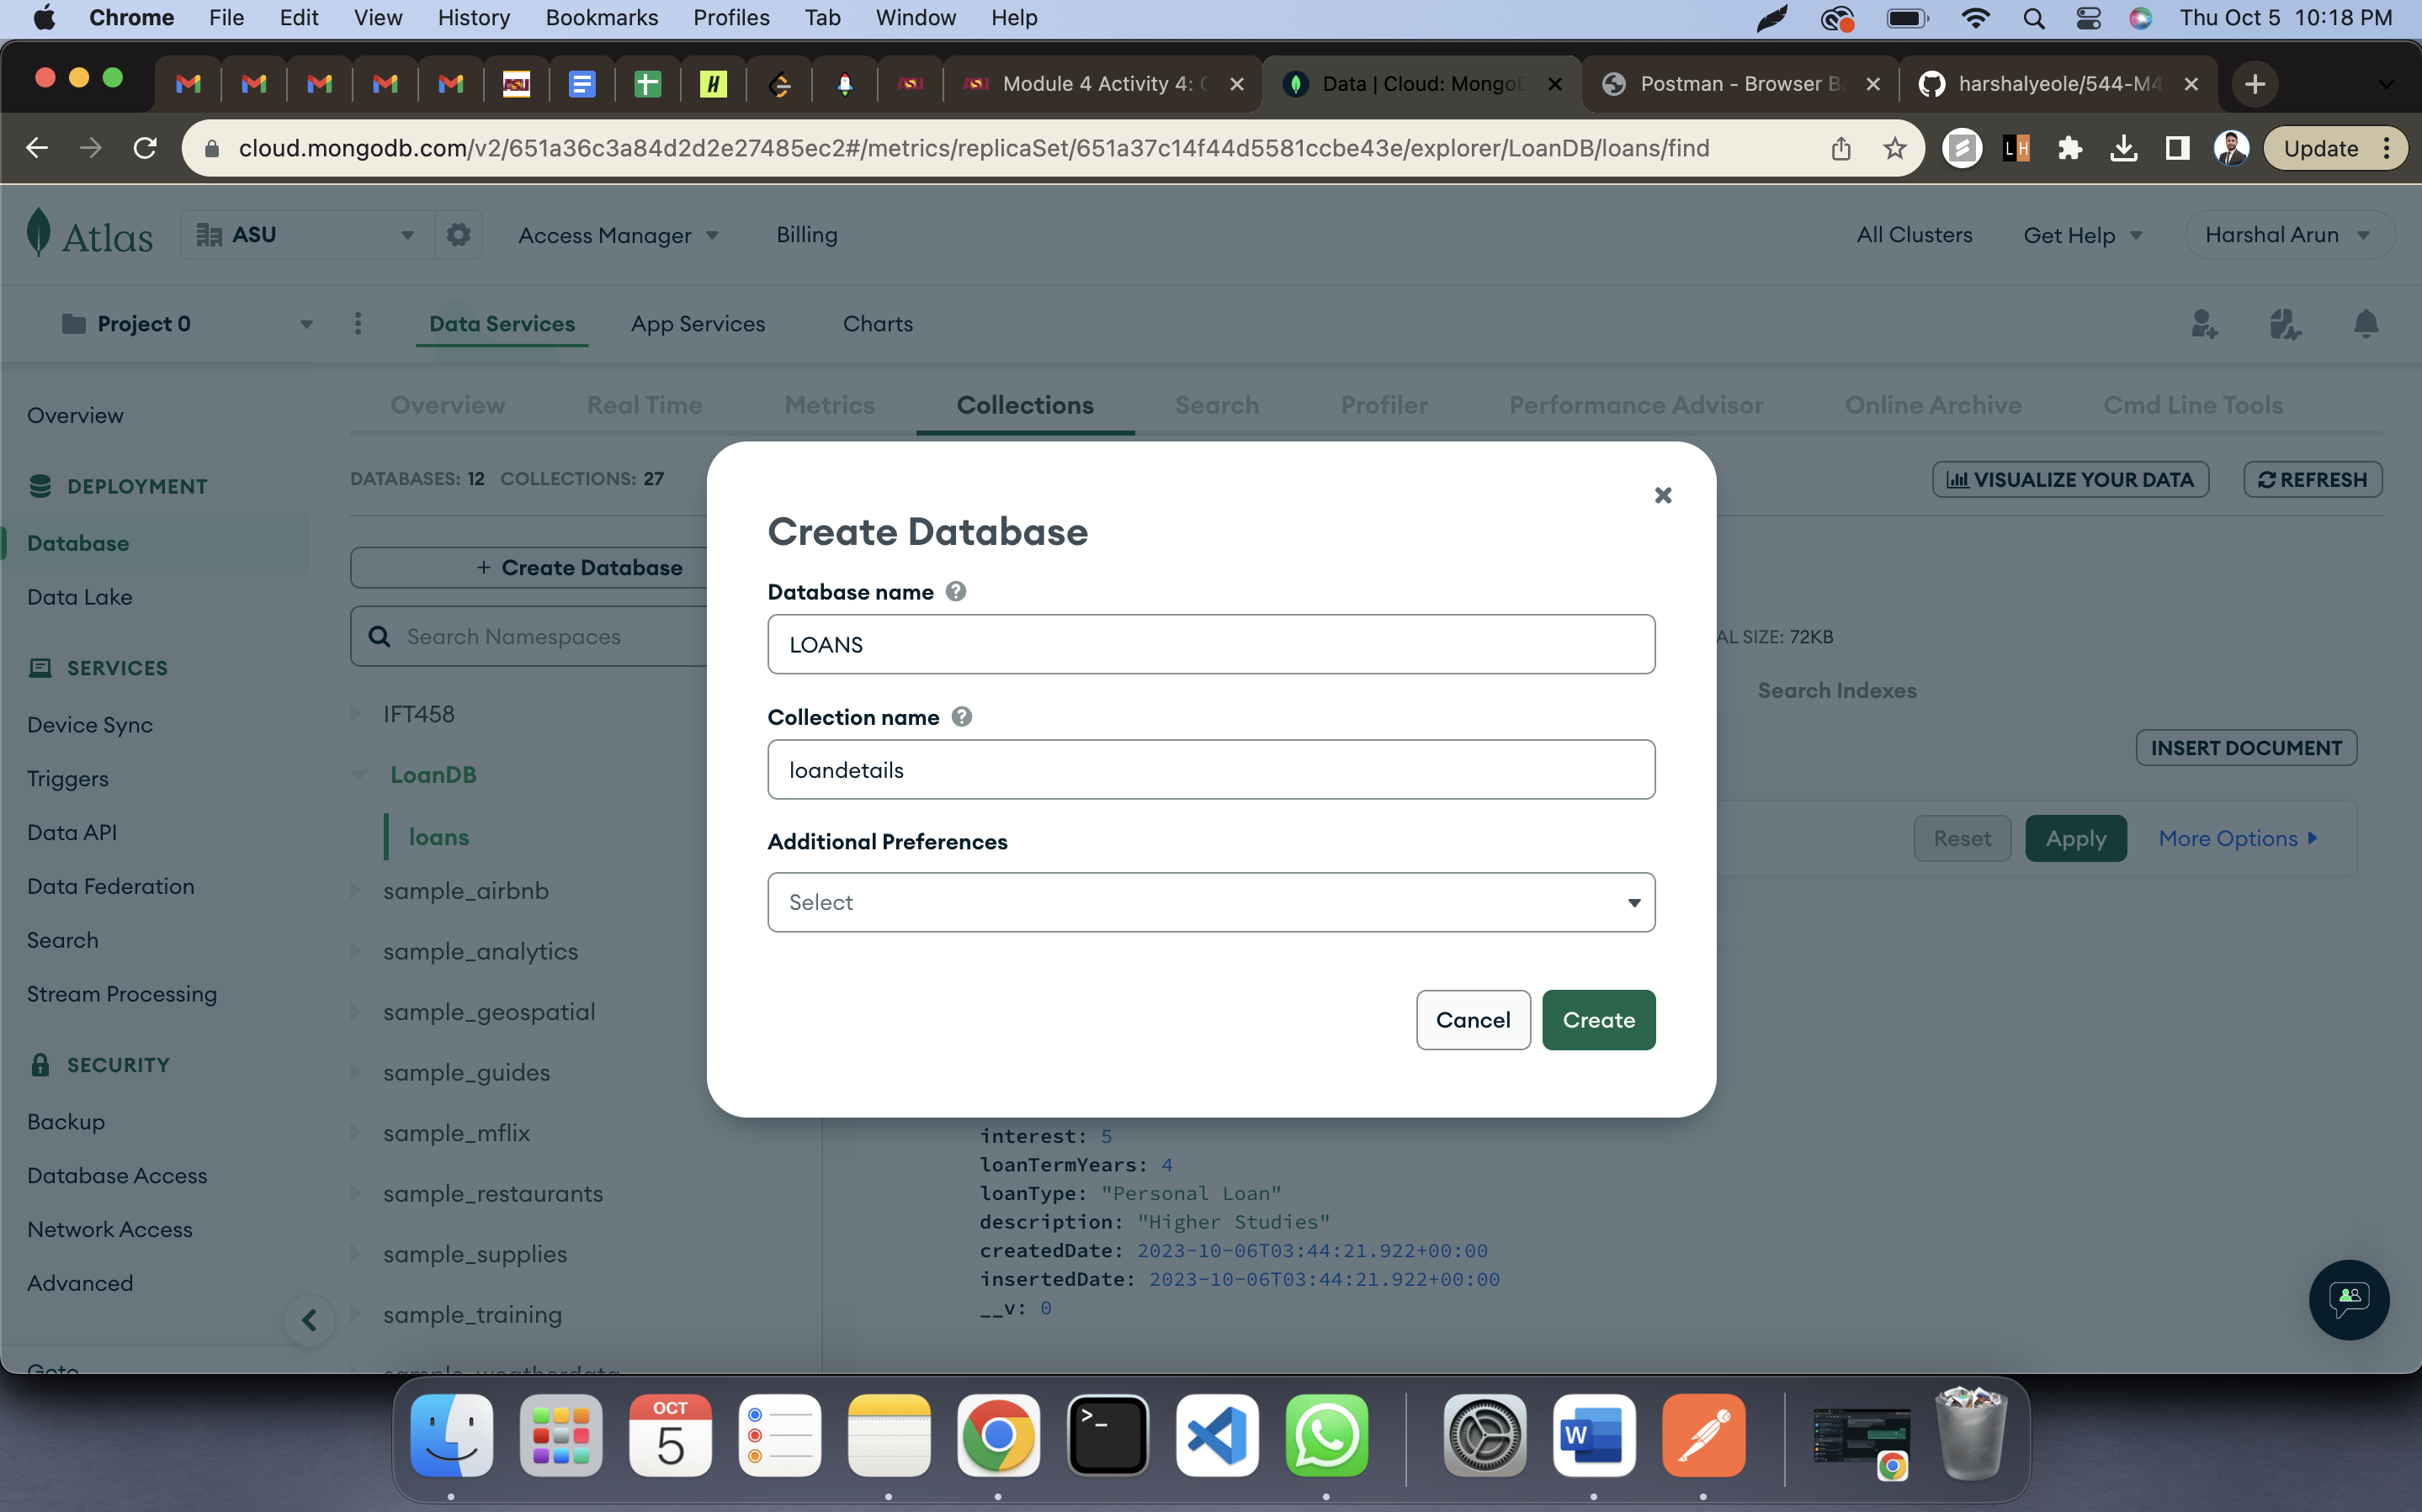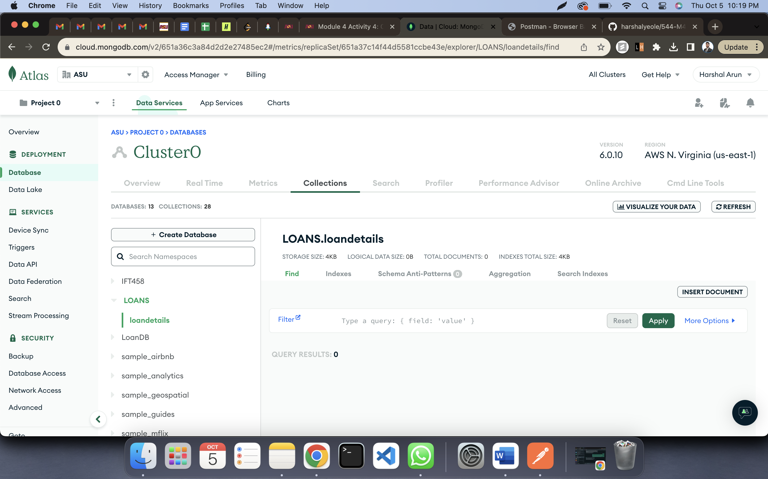

Code Screenshots:

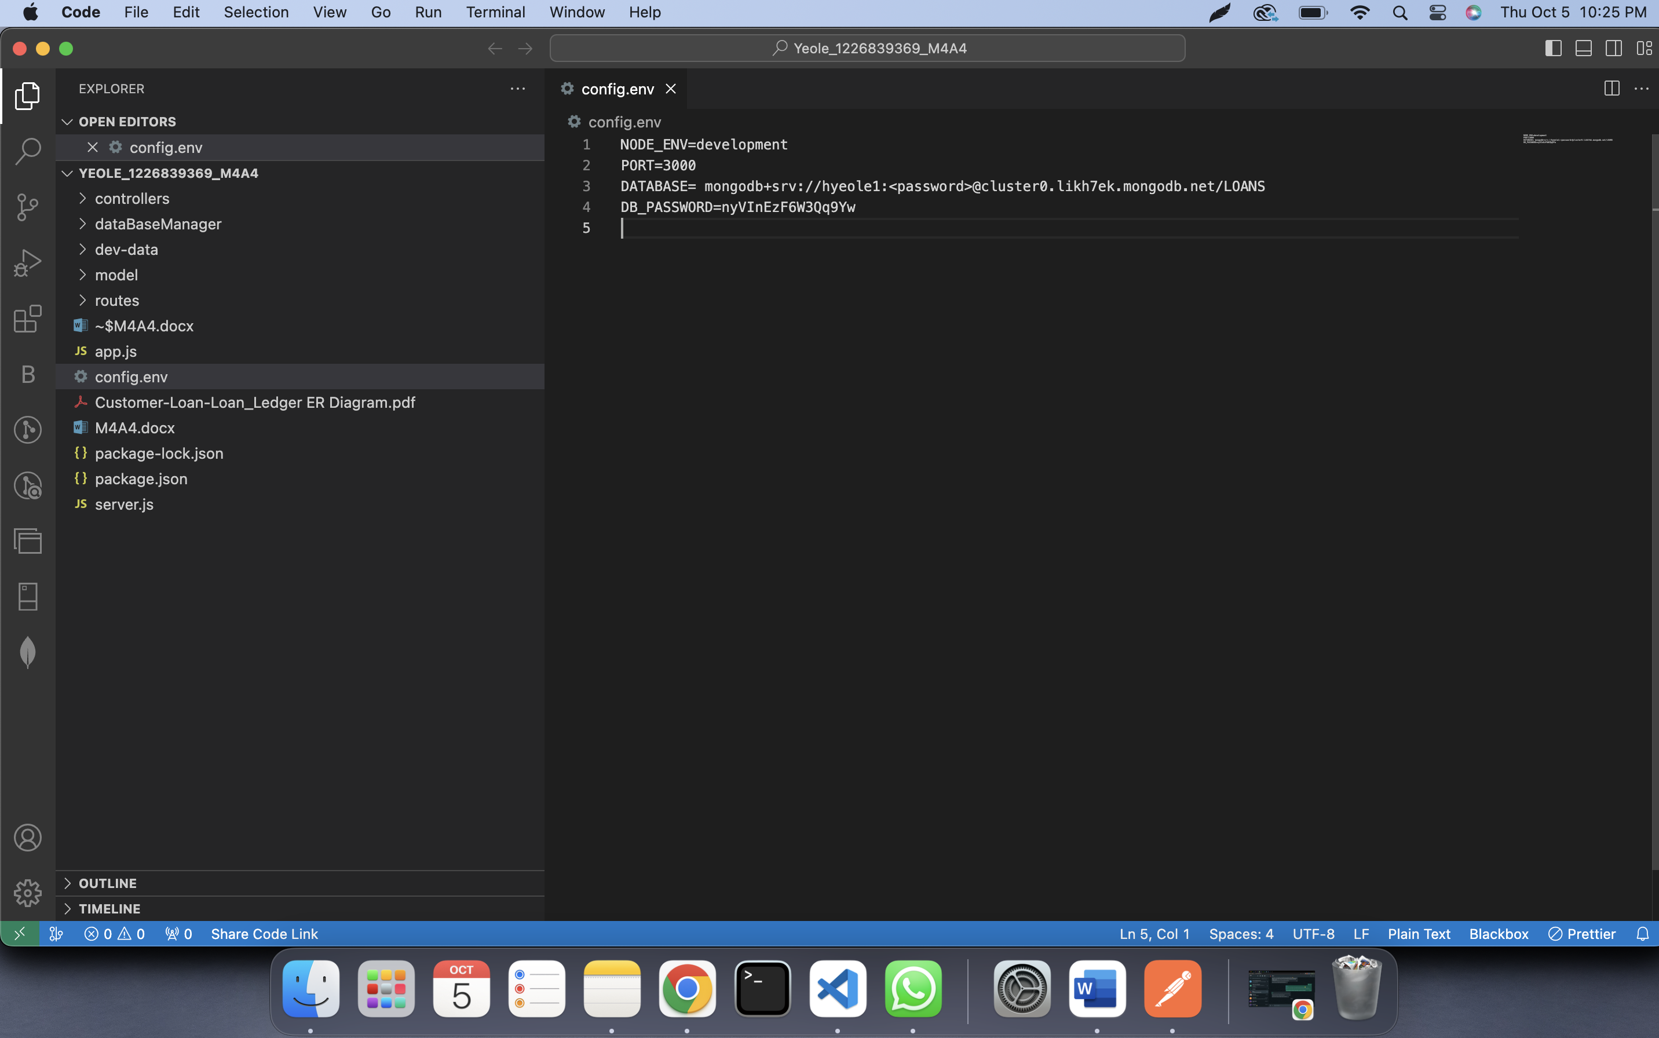

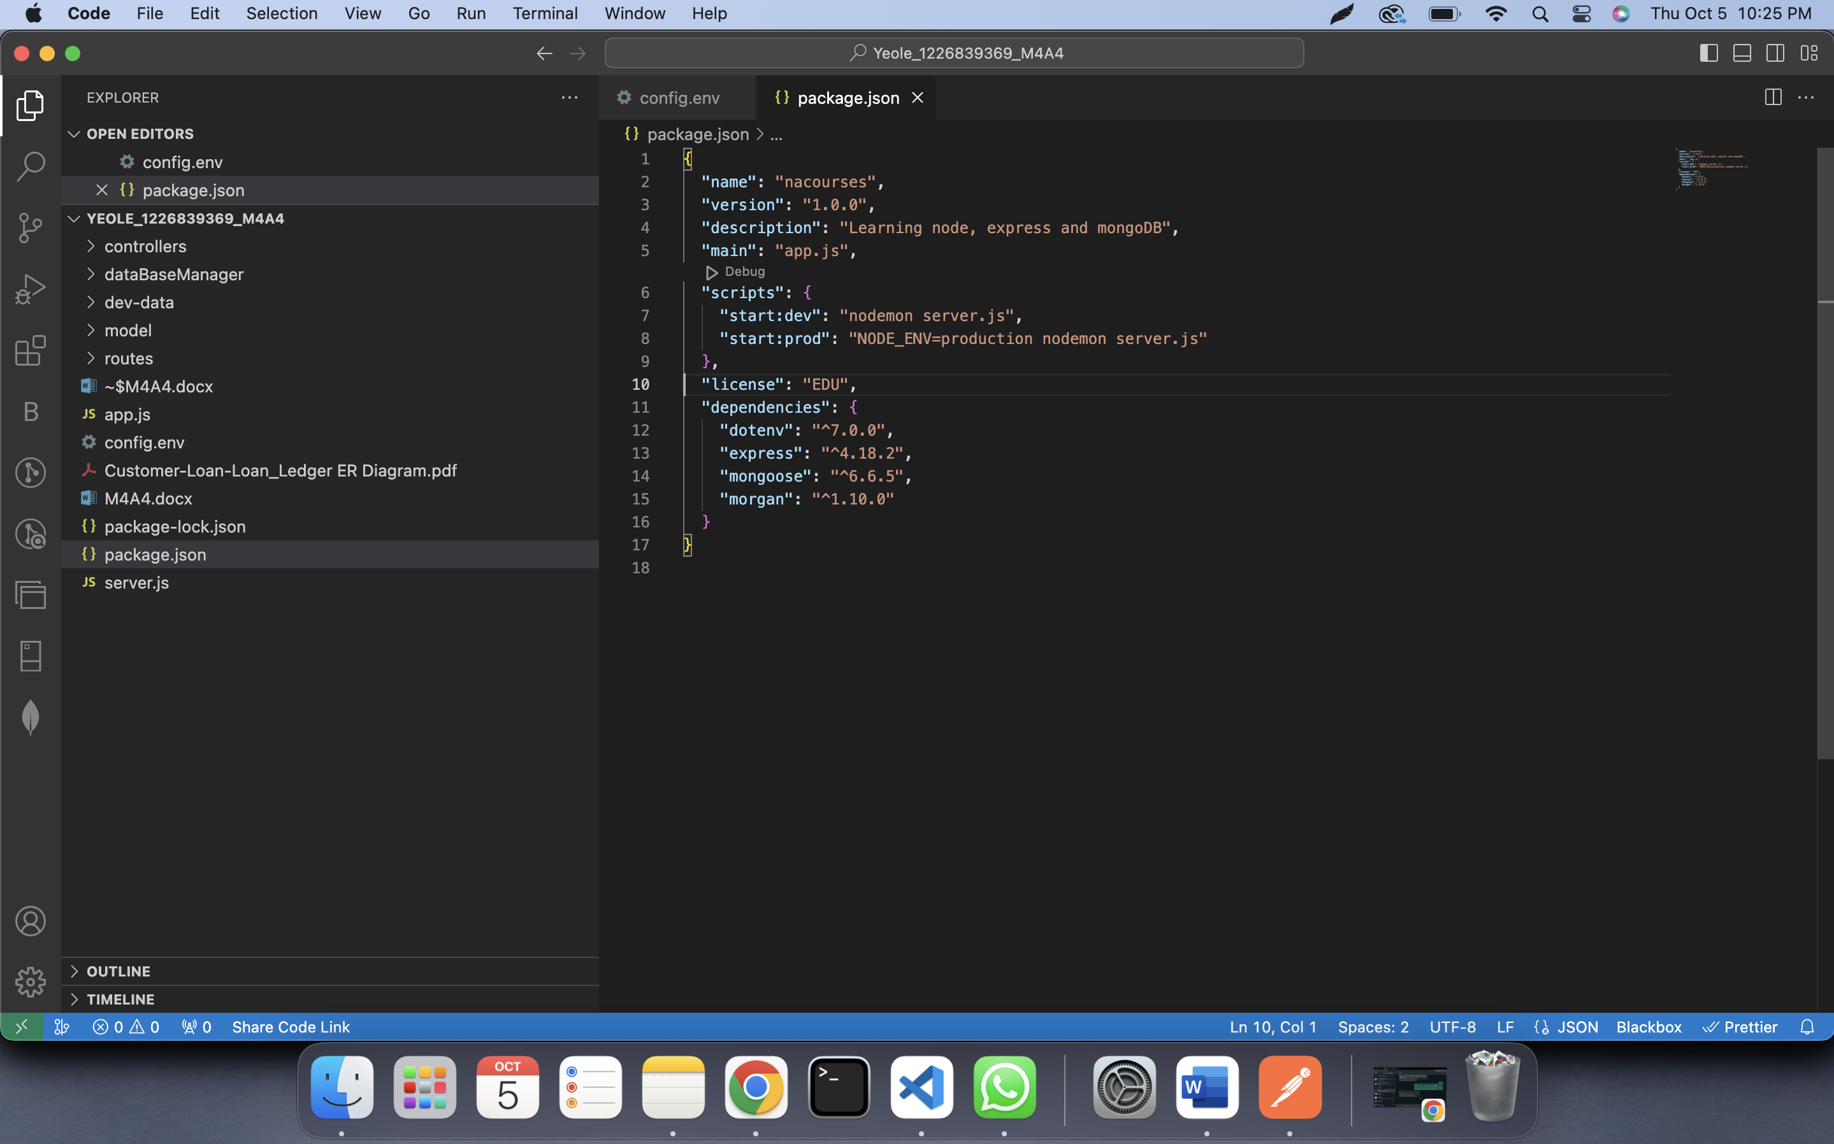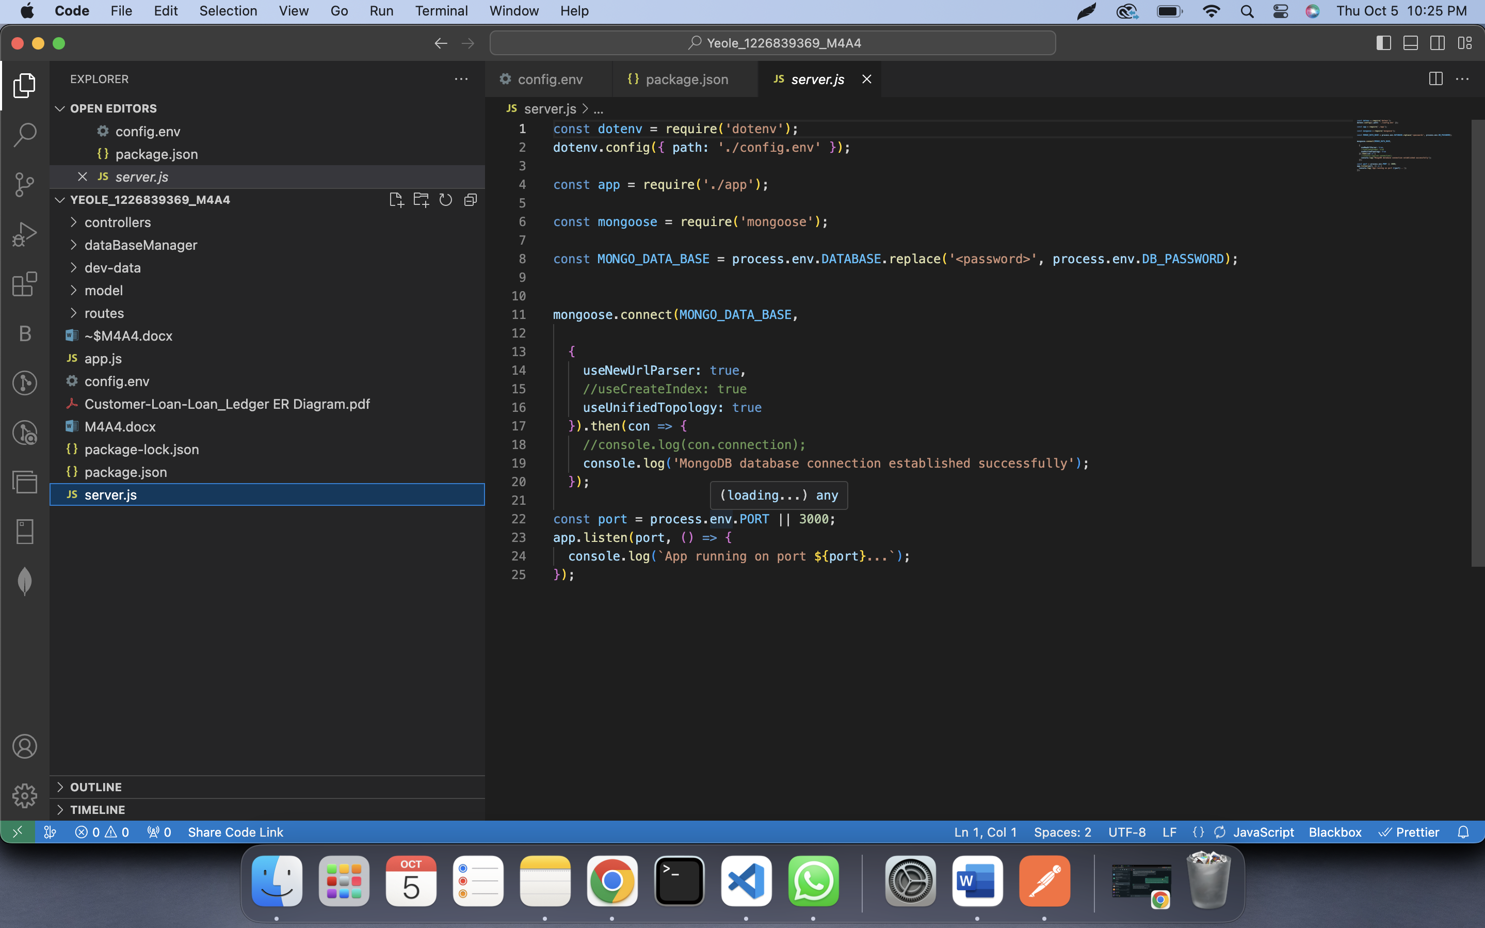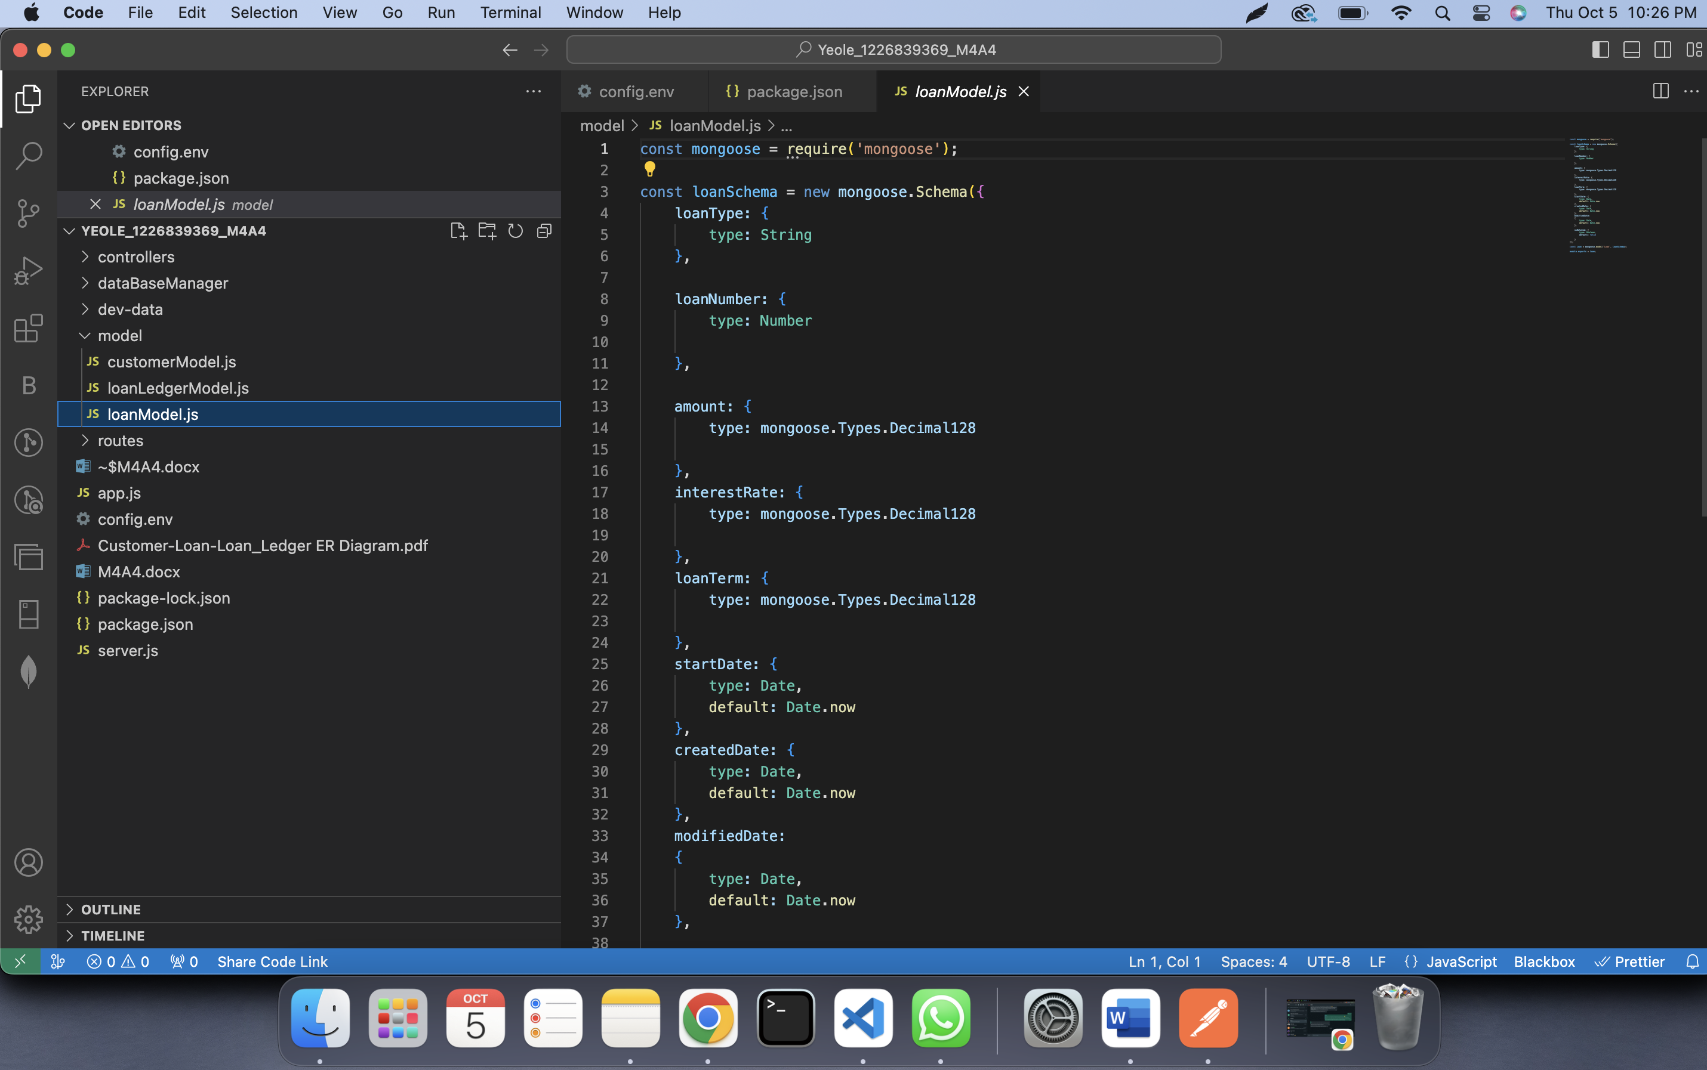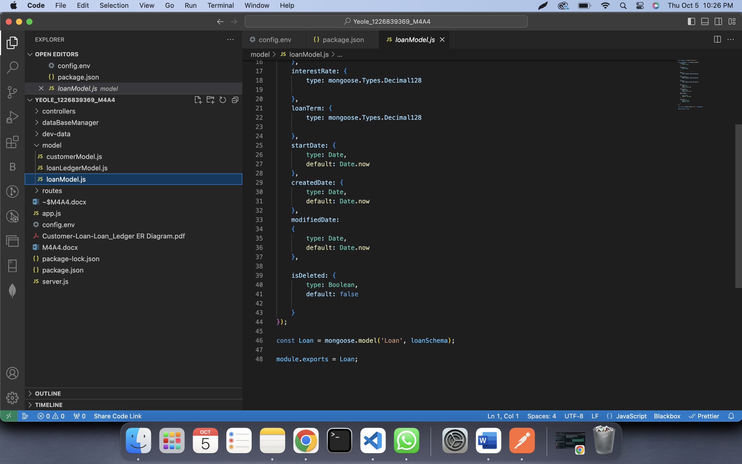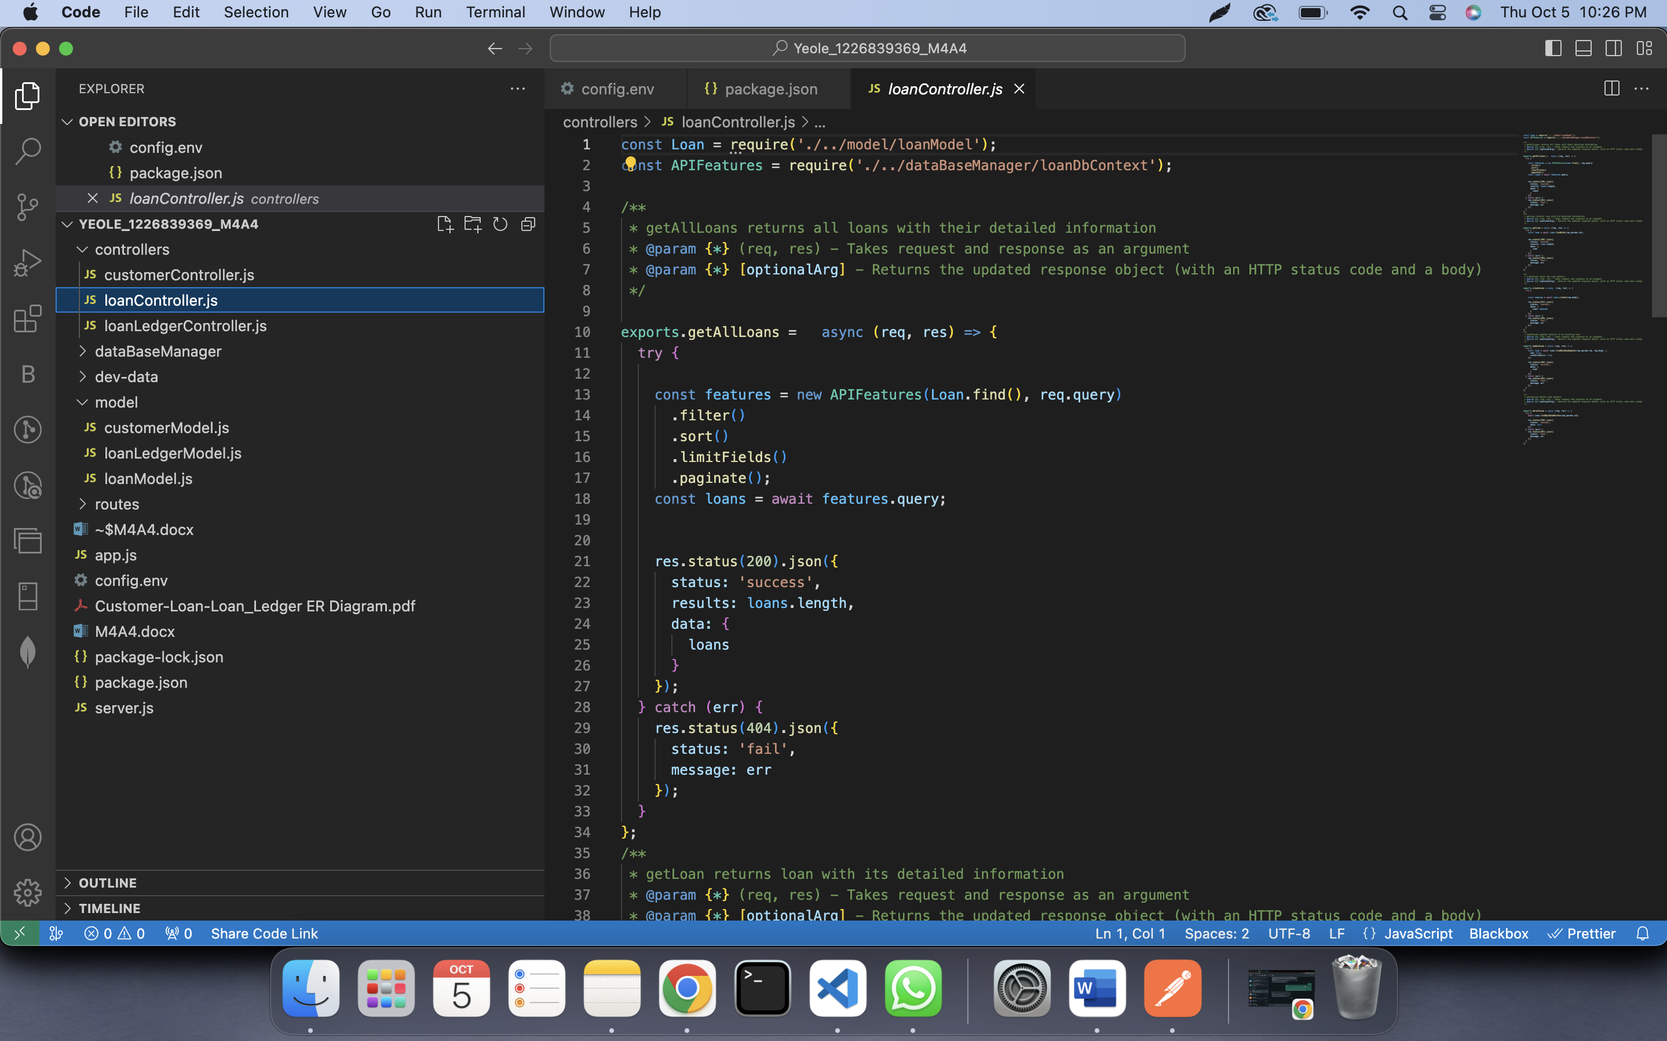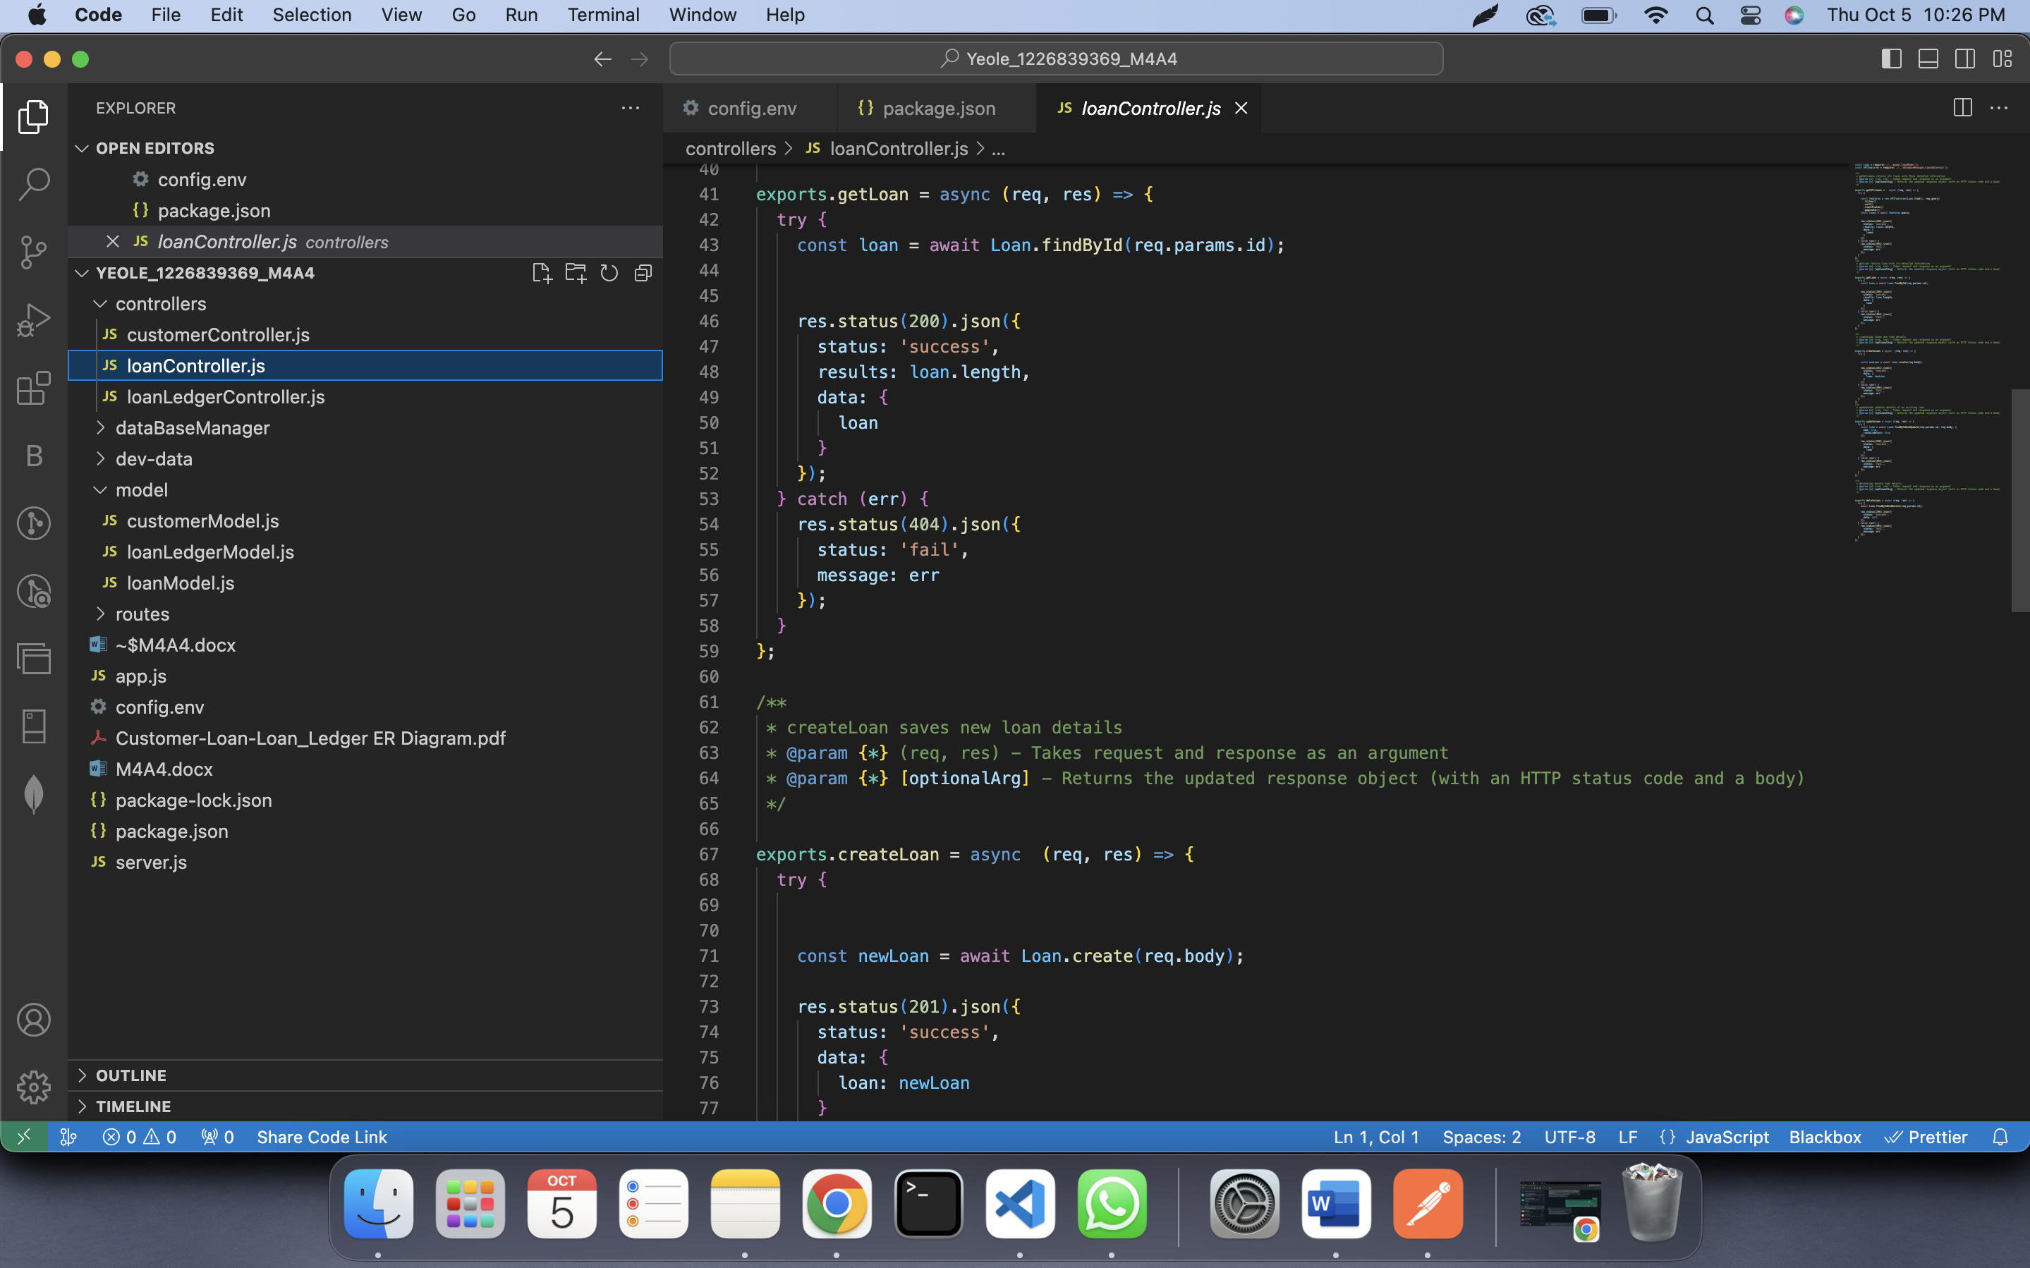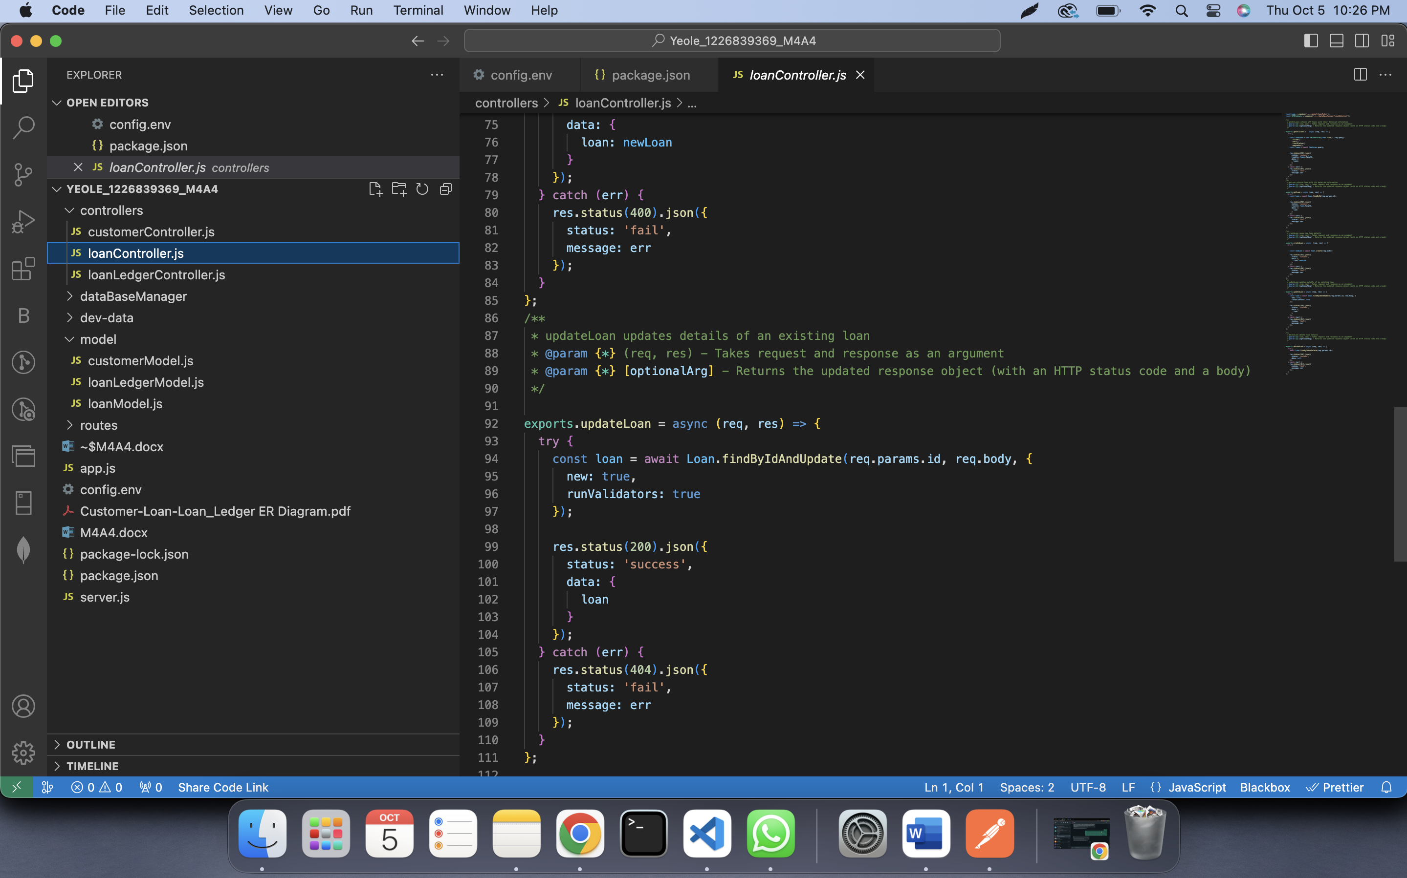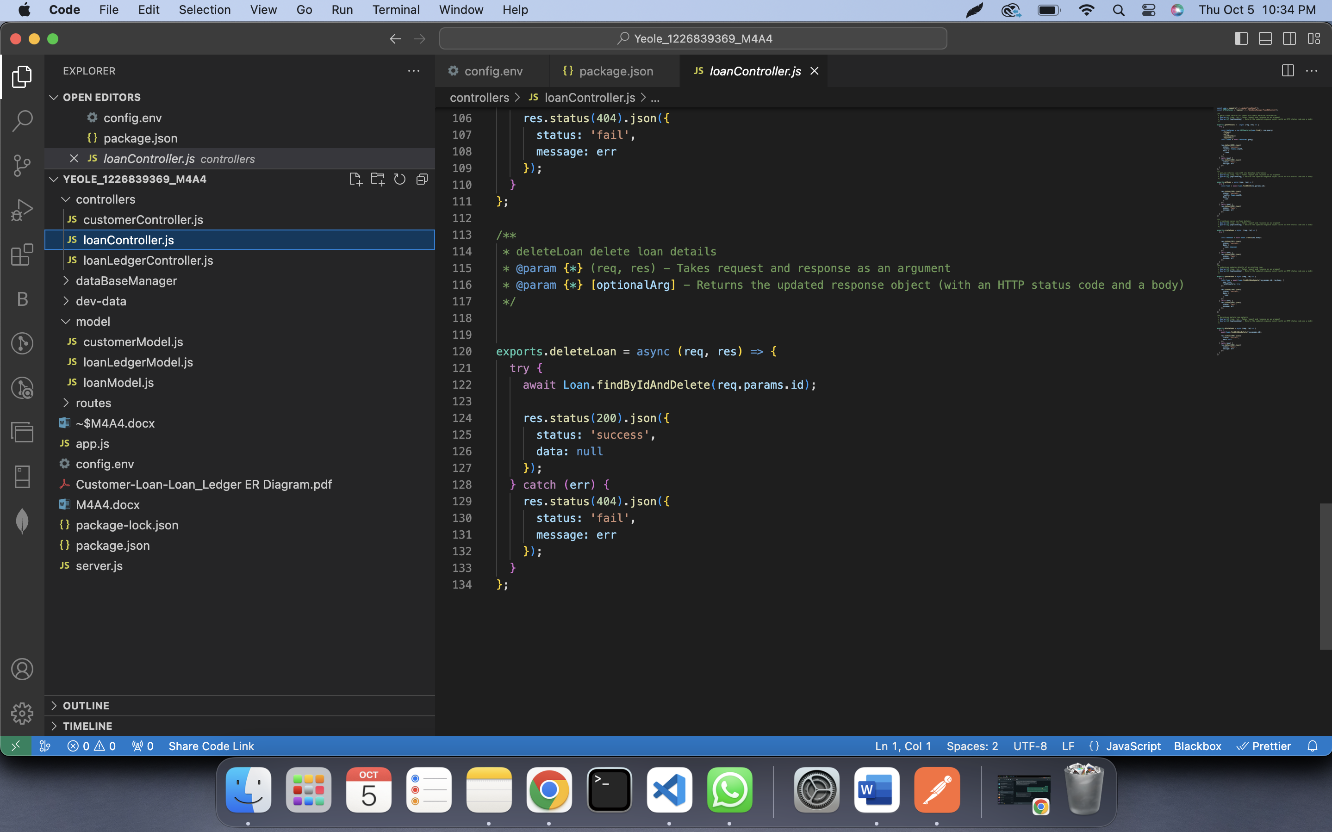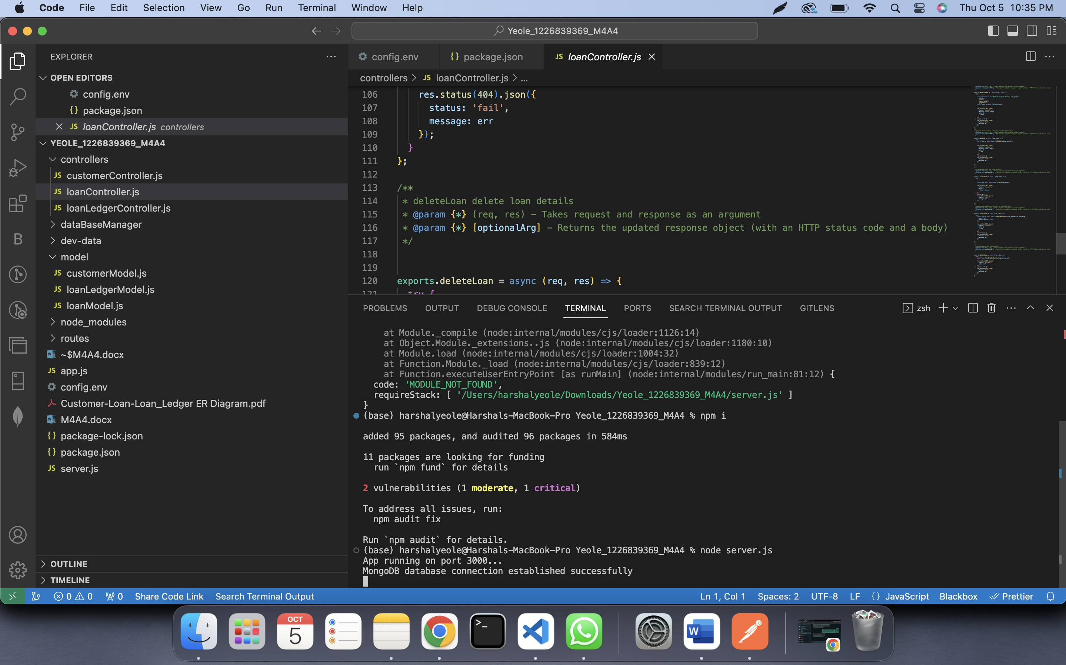

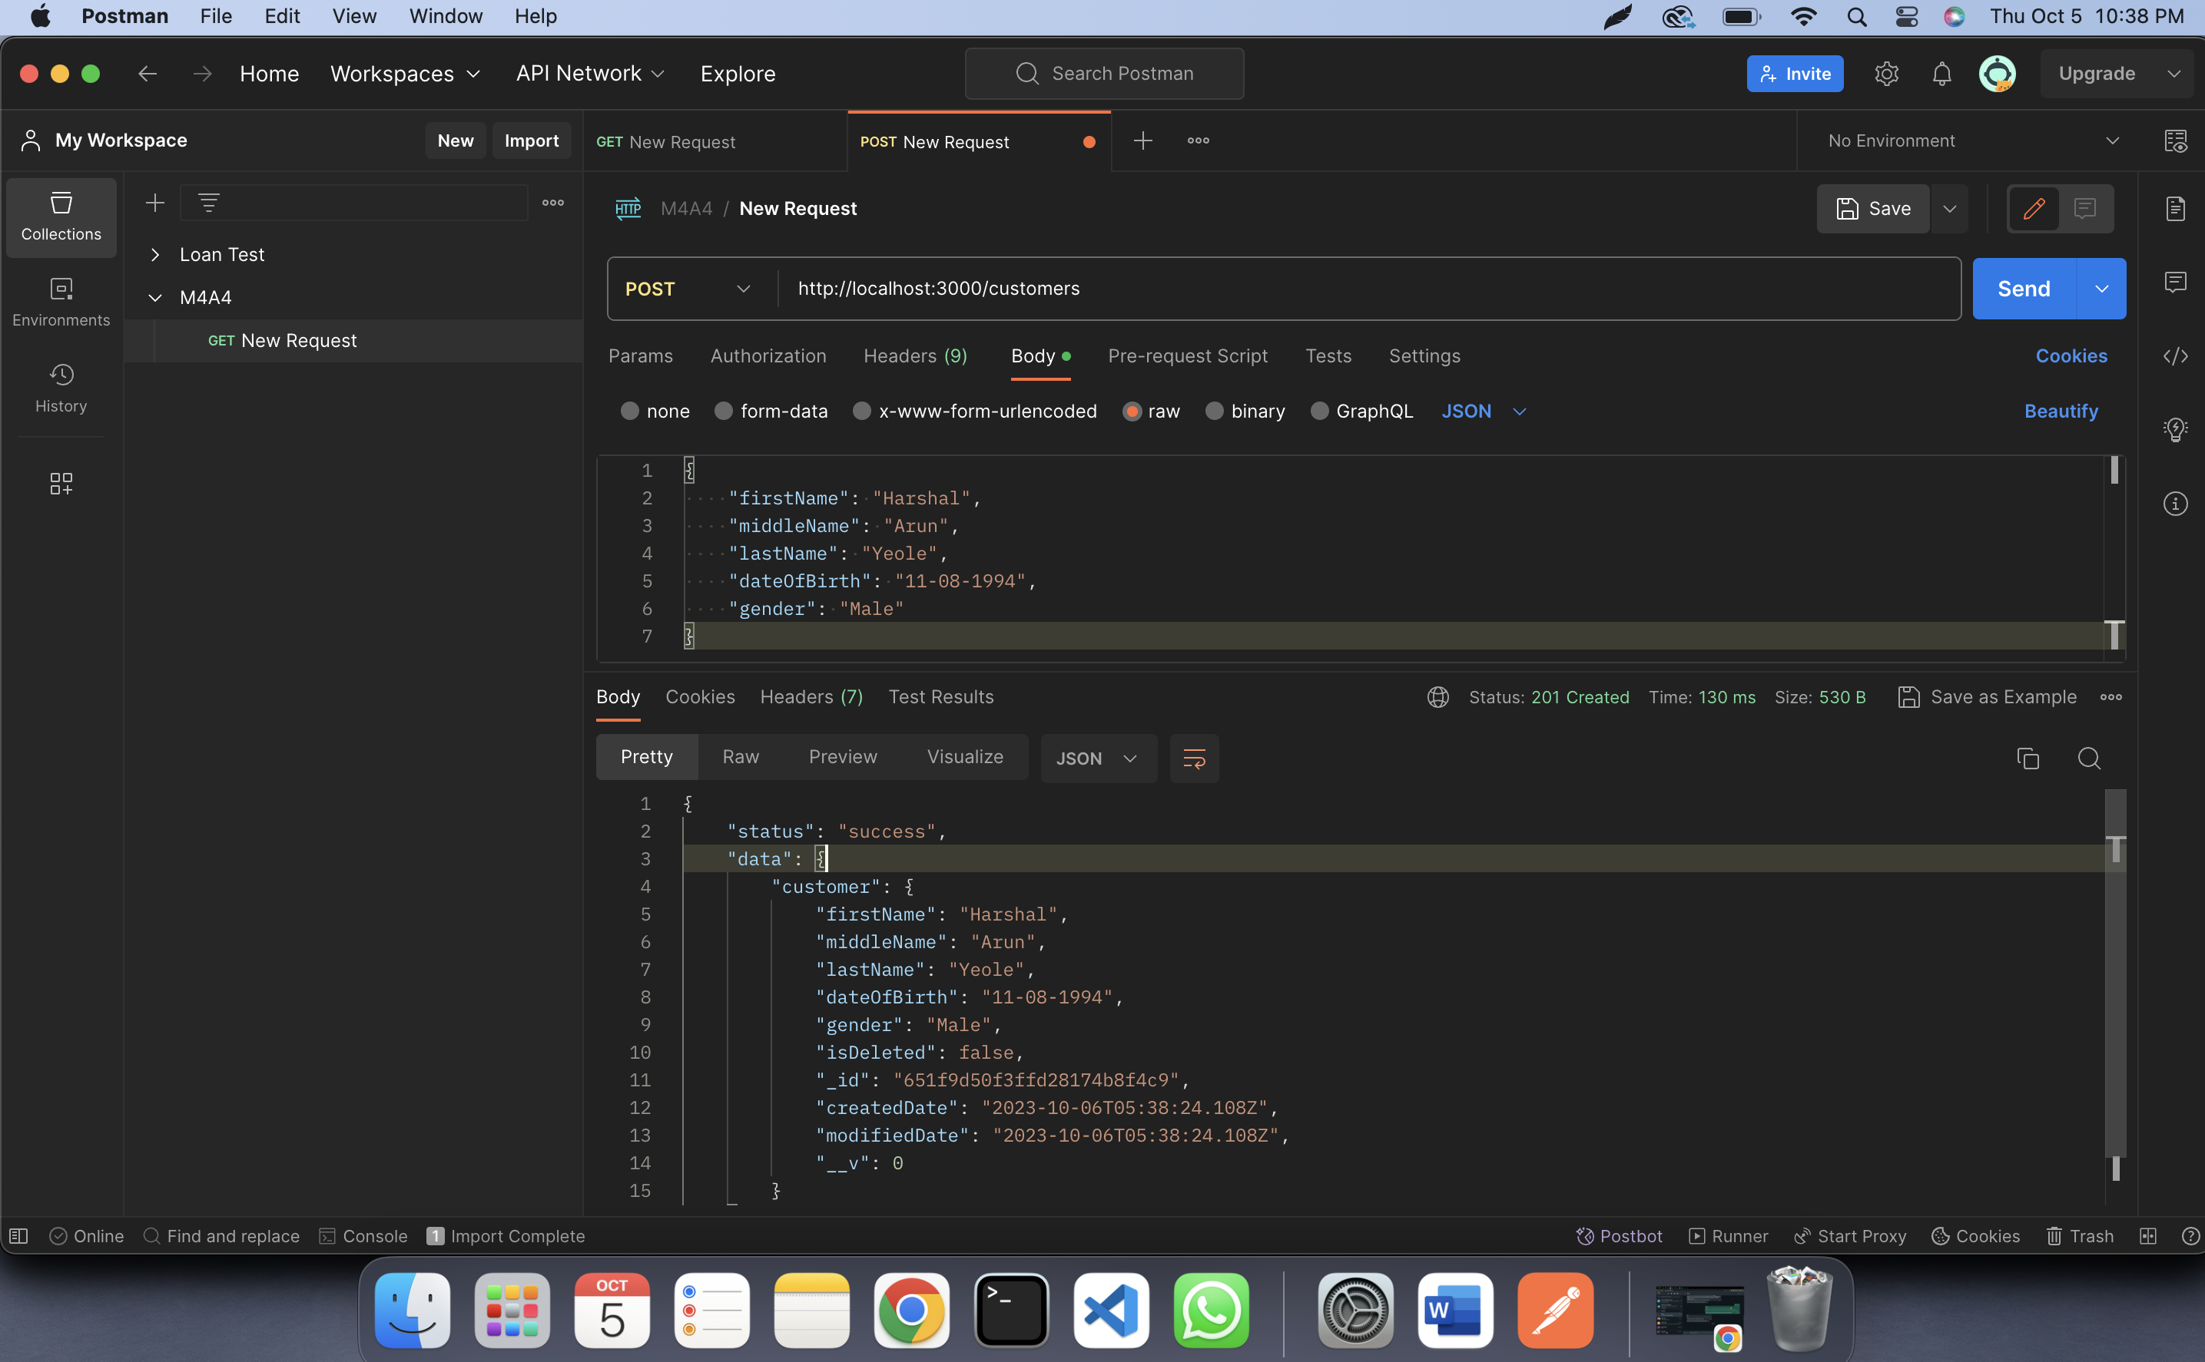

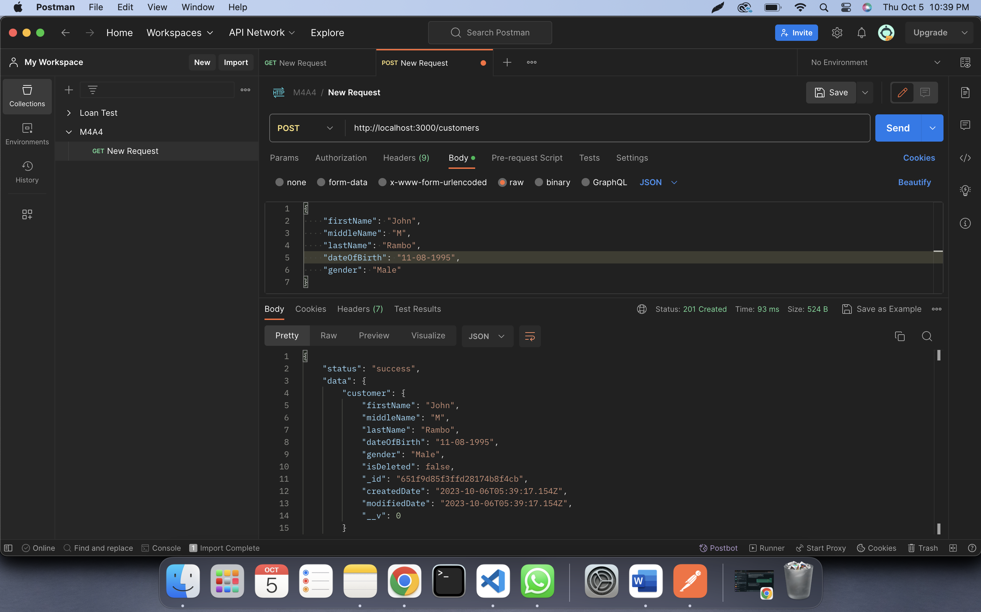

Multiple entries at a time:

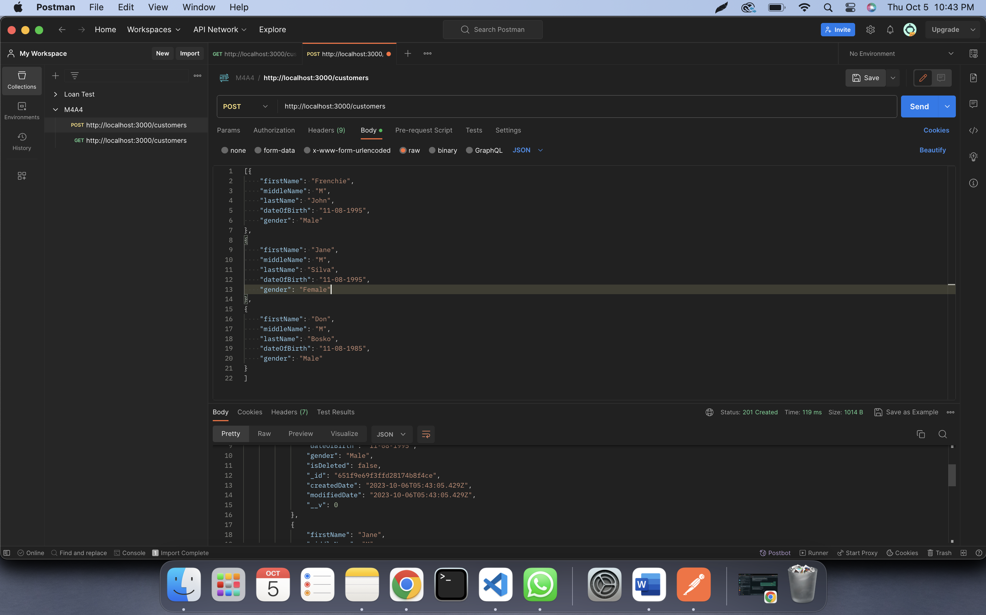

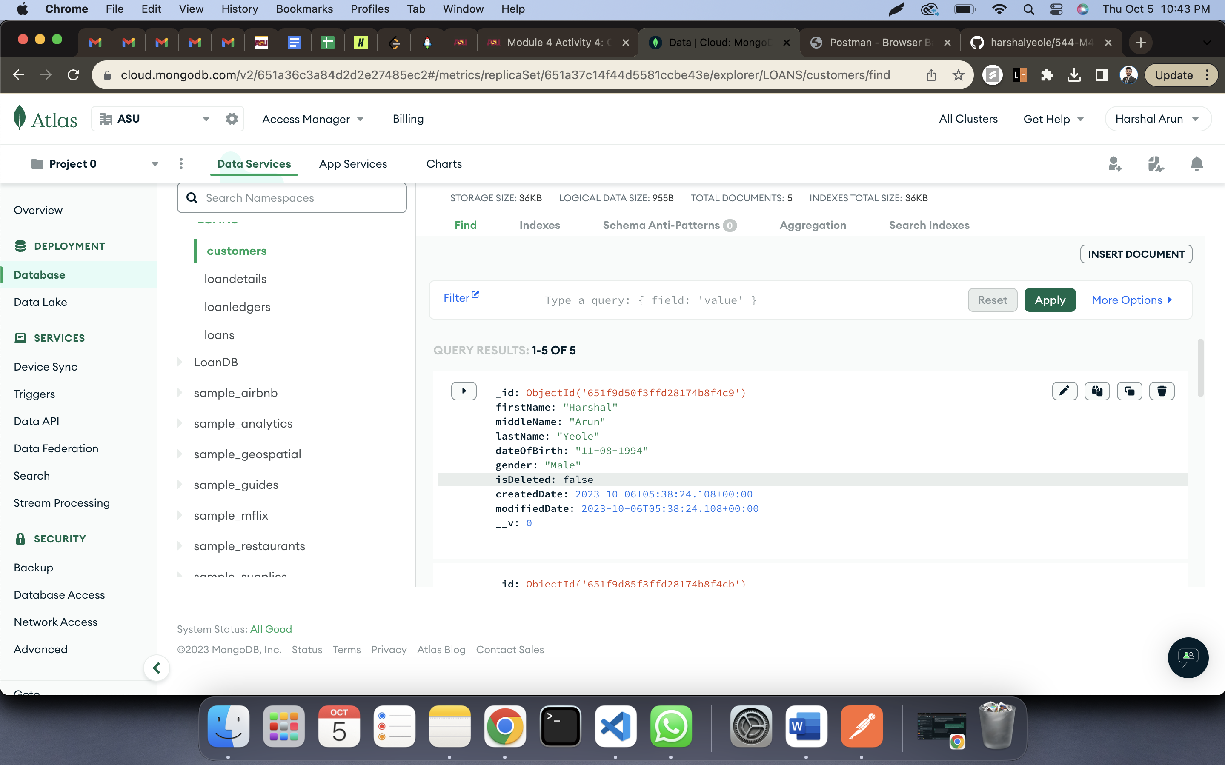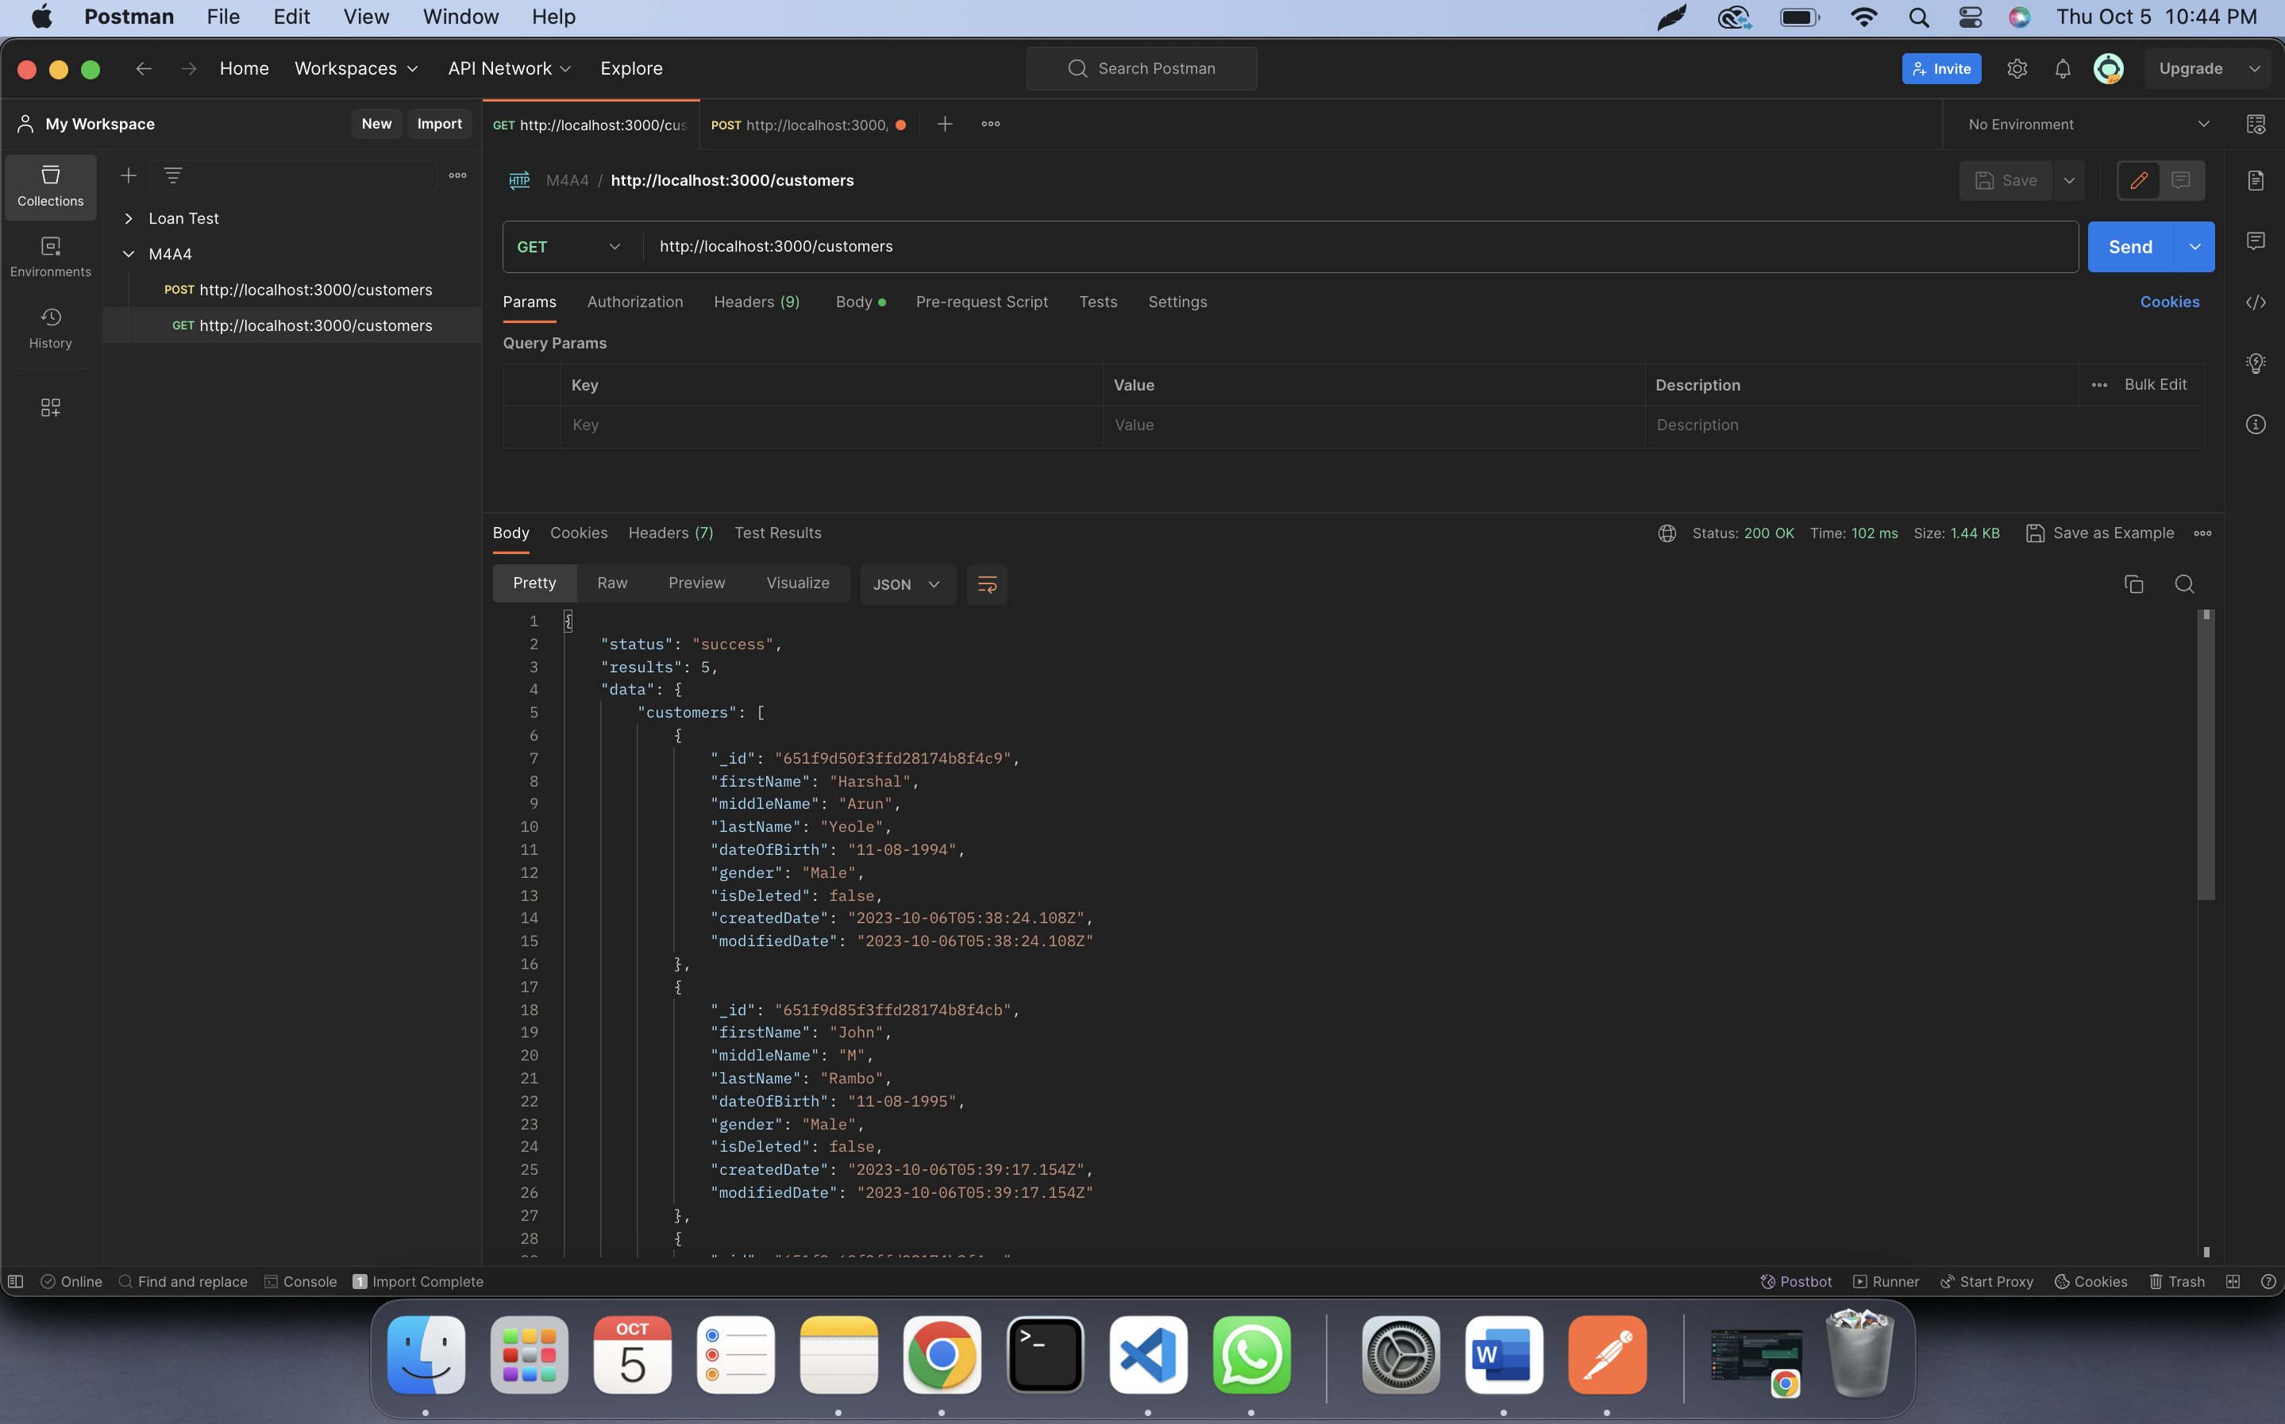

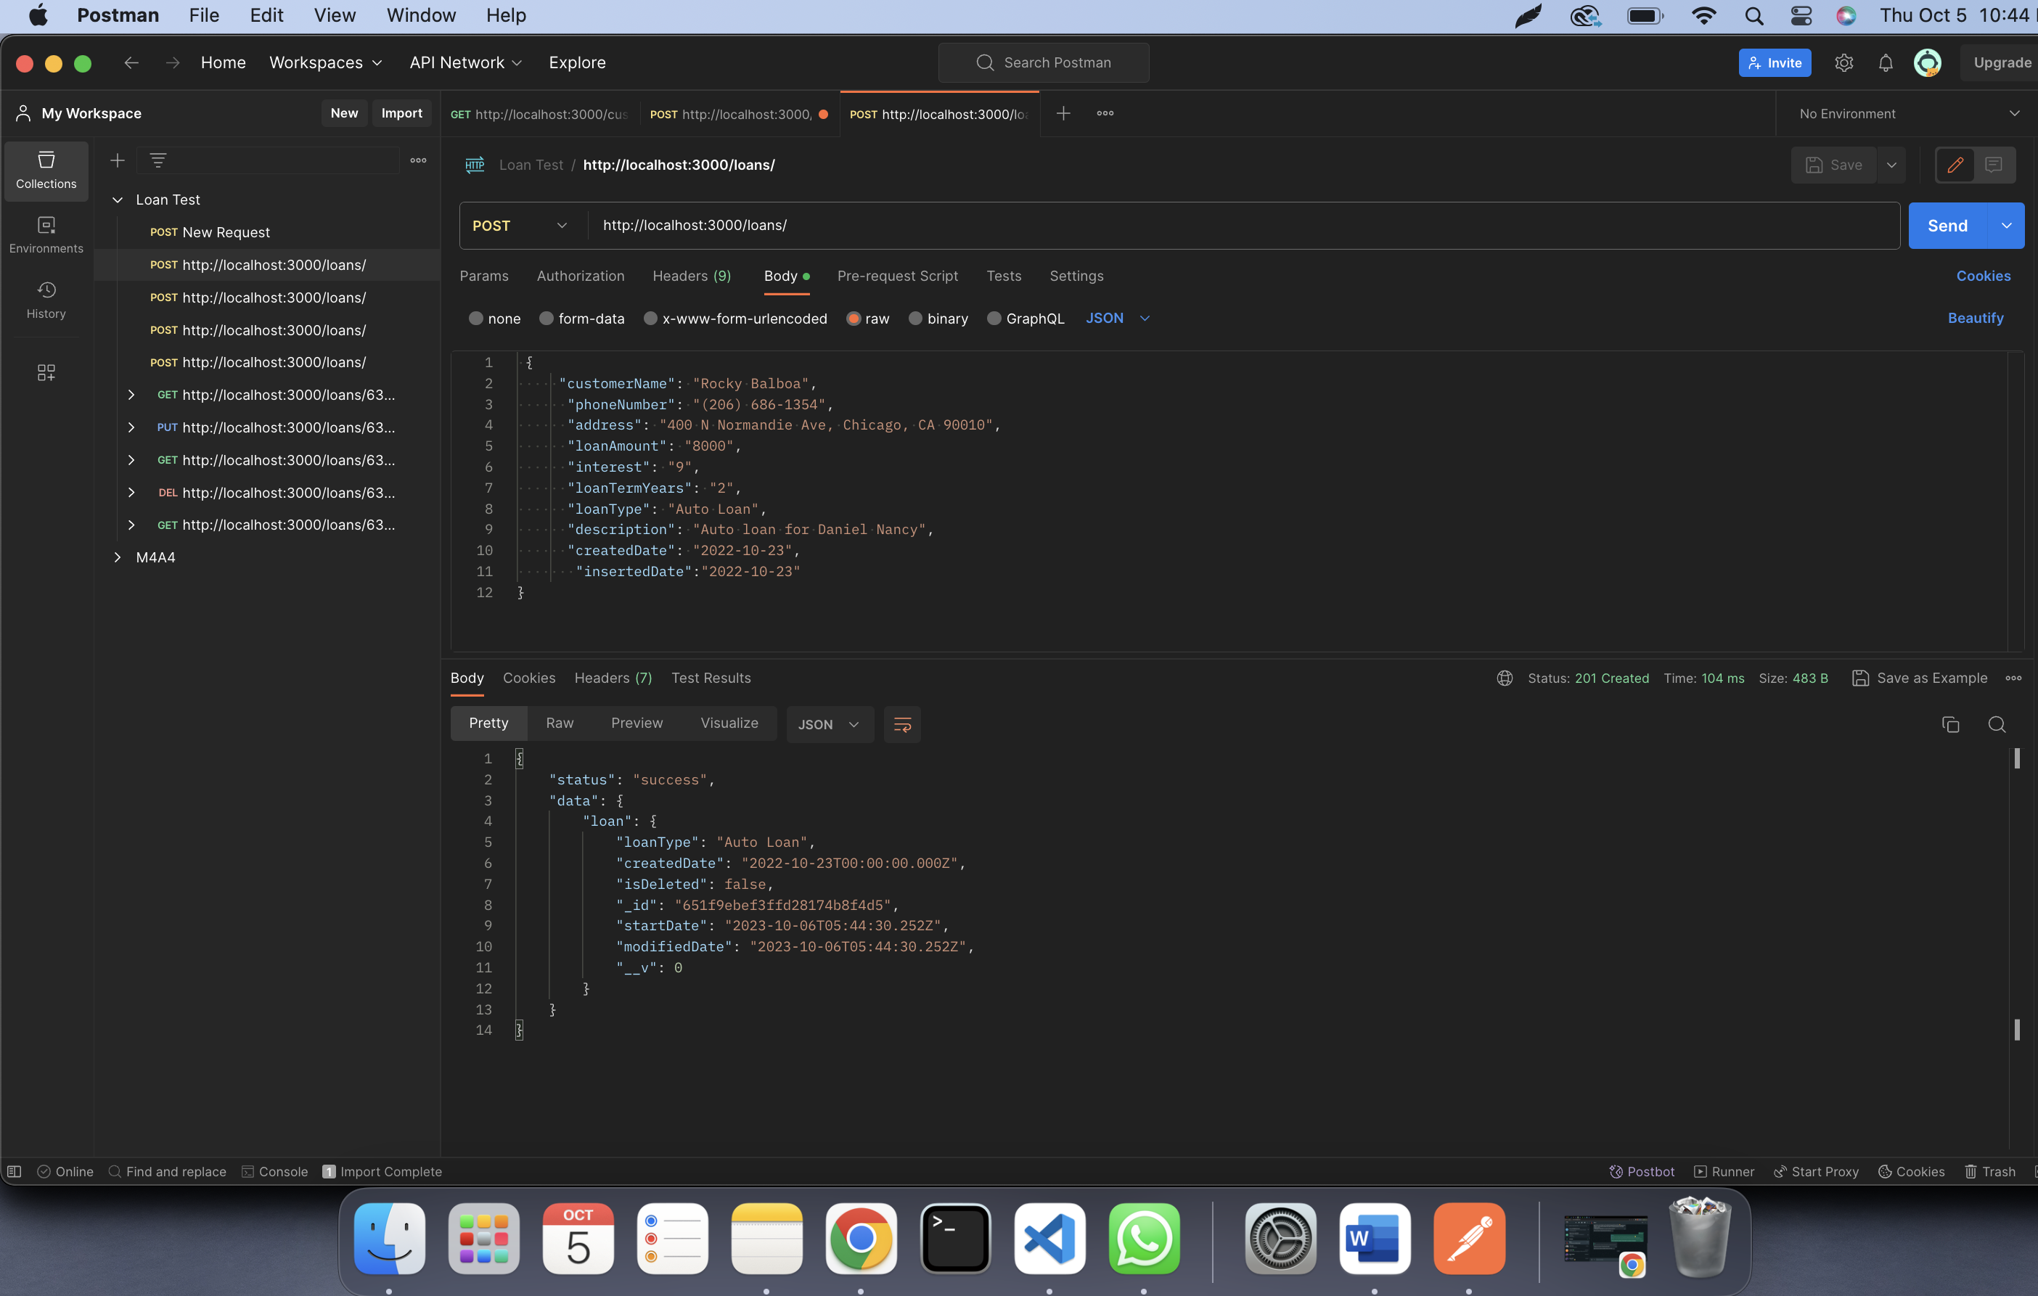

Multiple Loans:

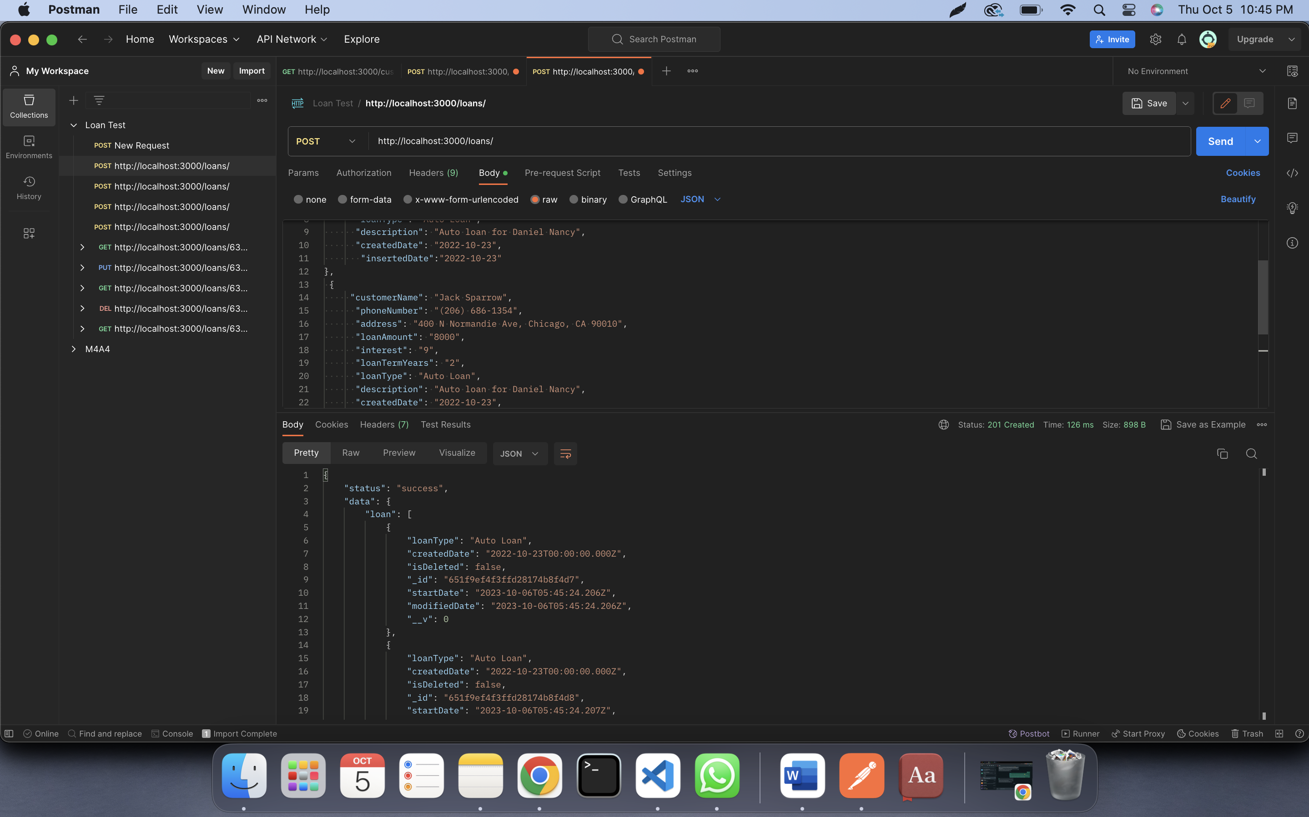

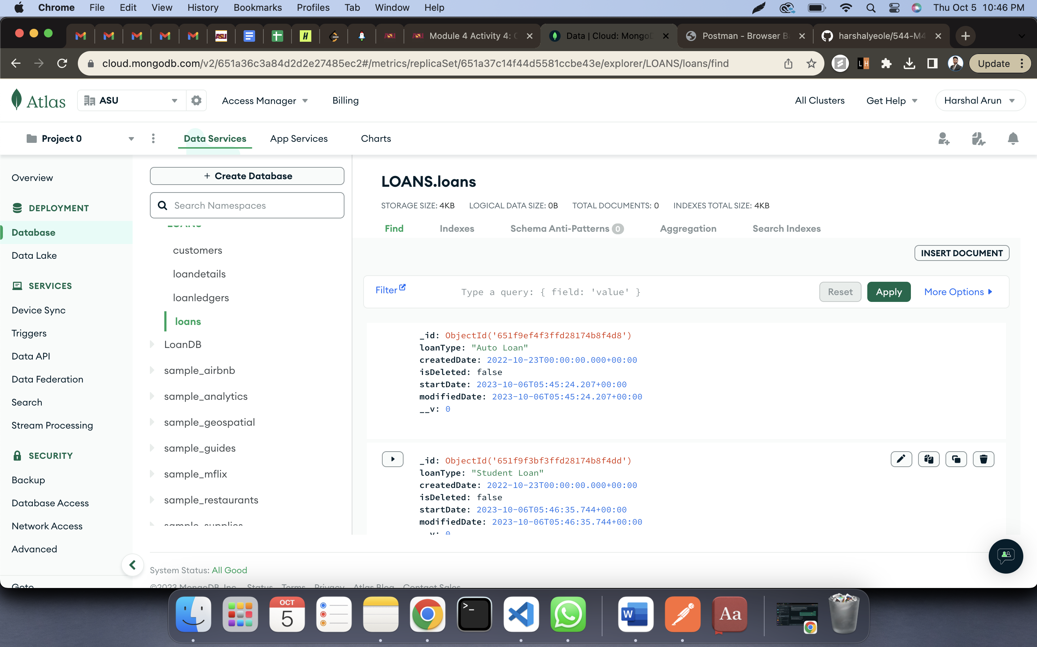

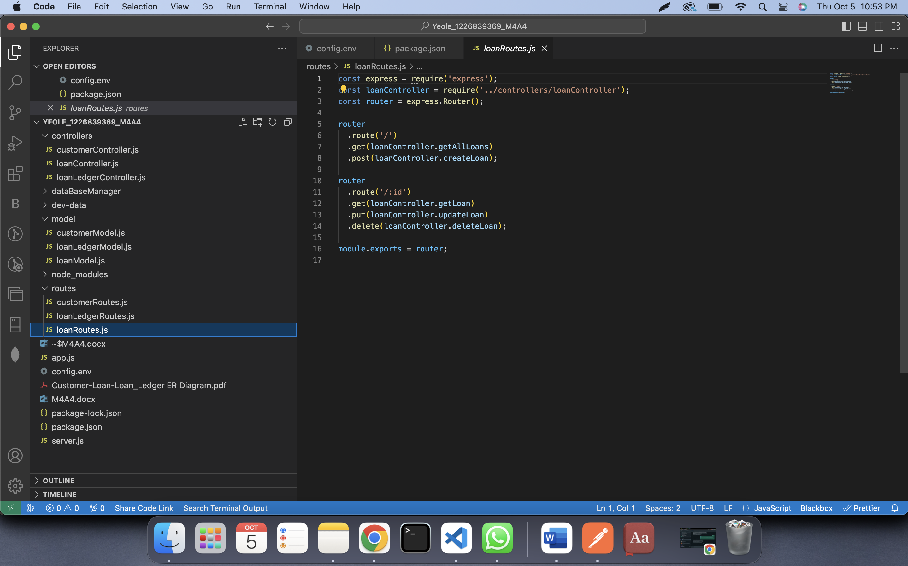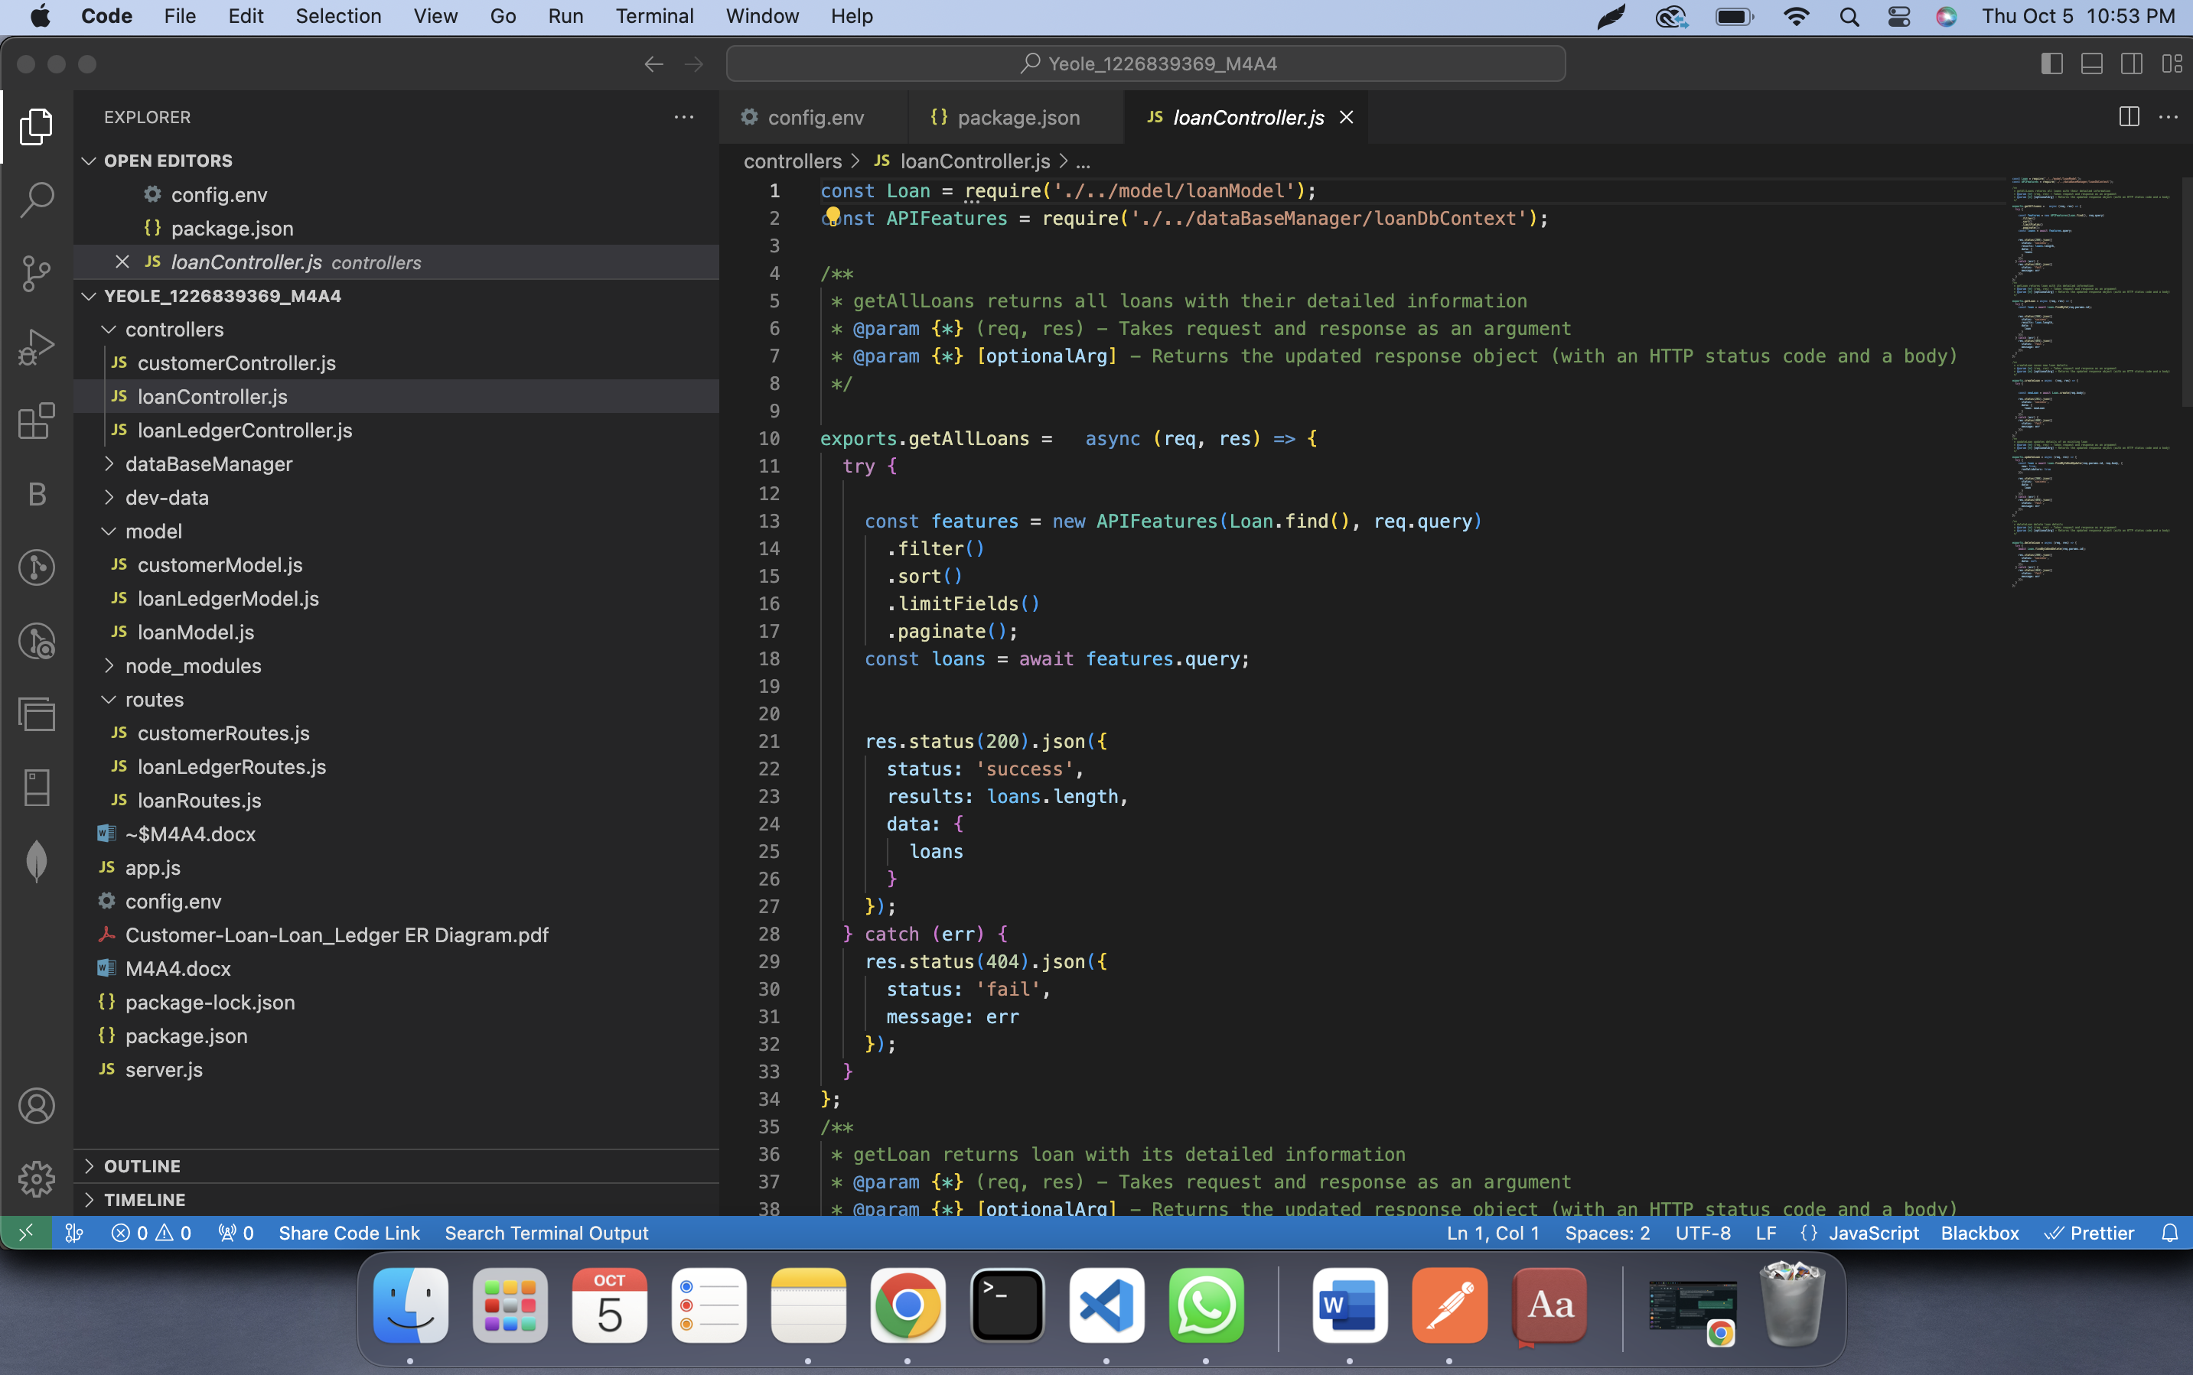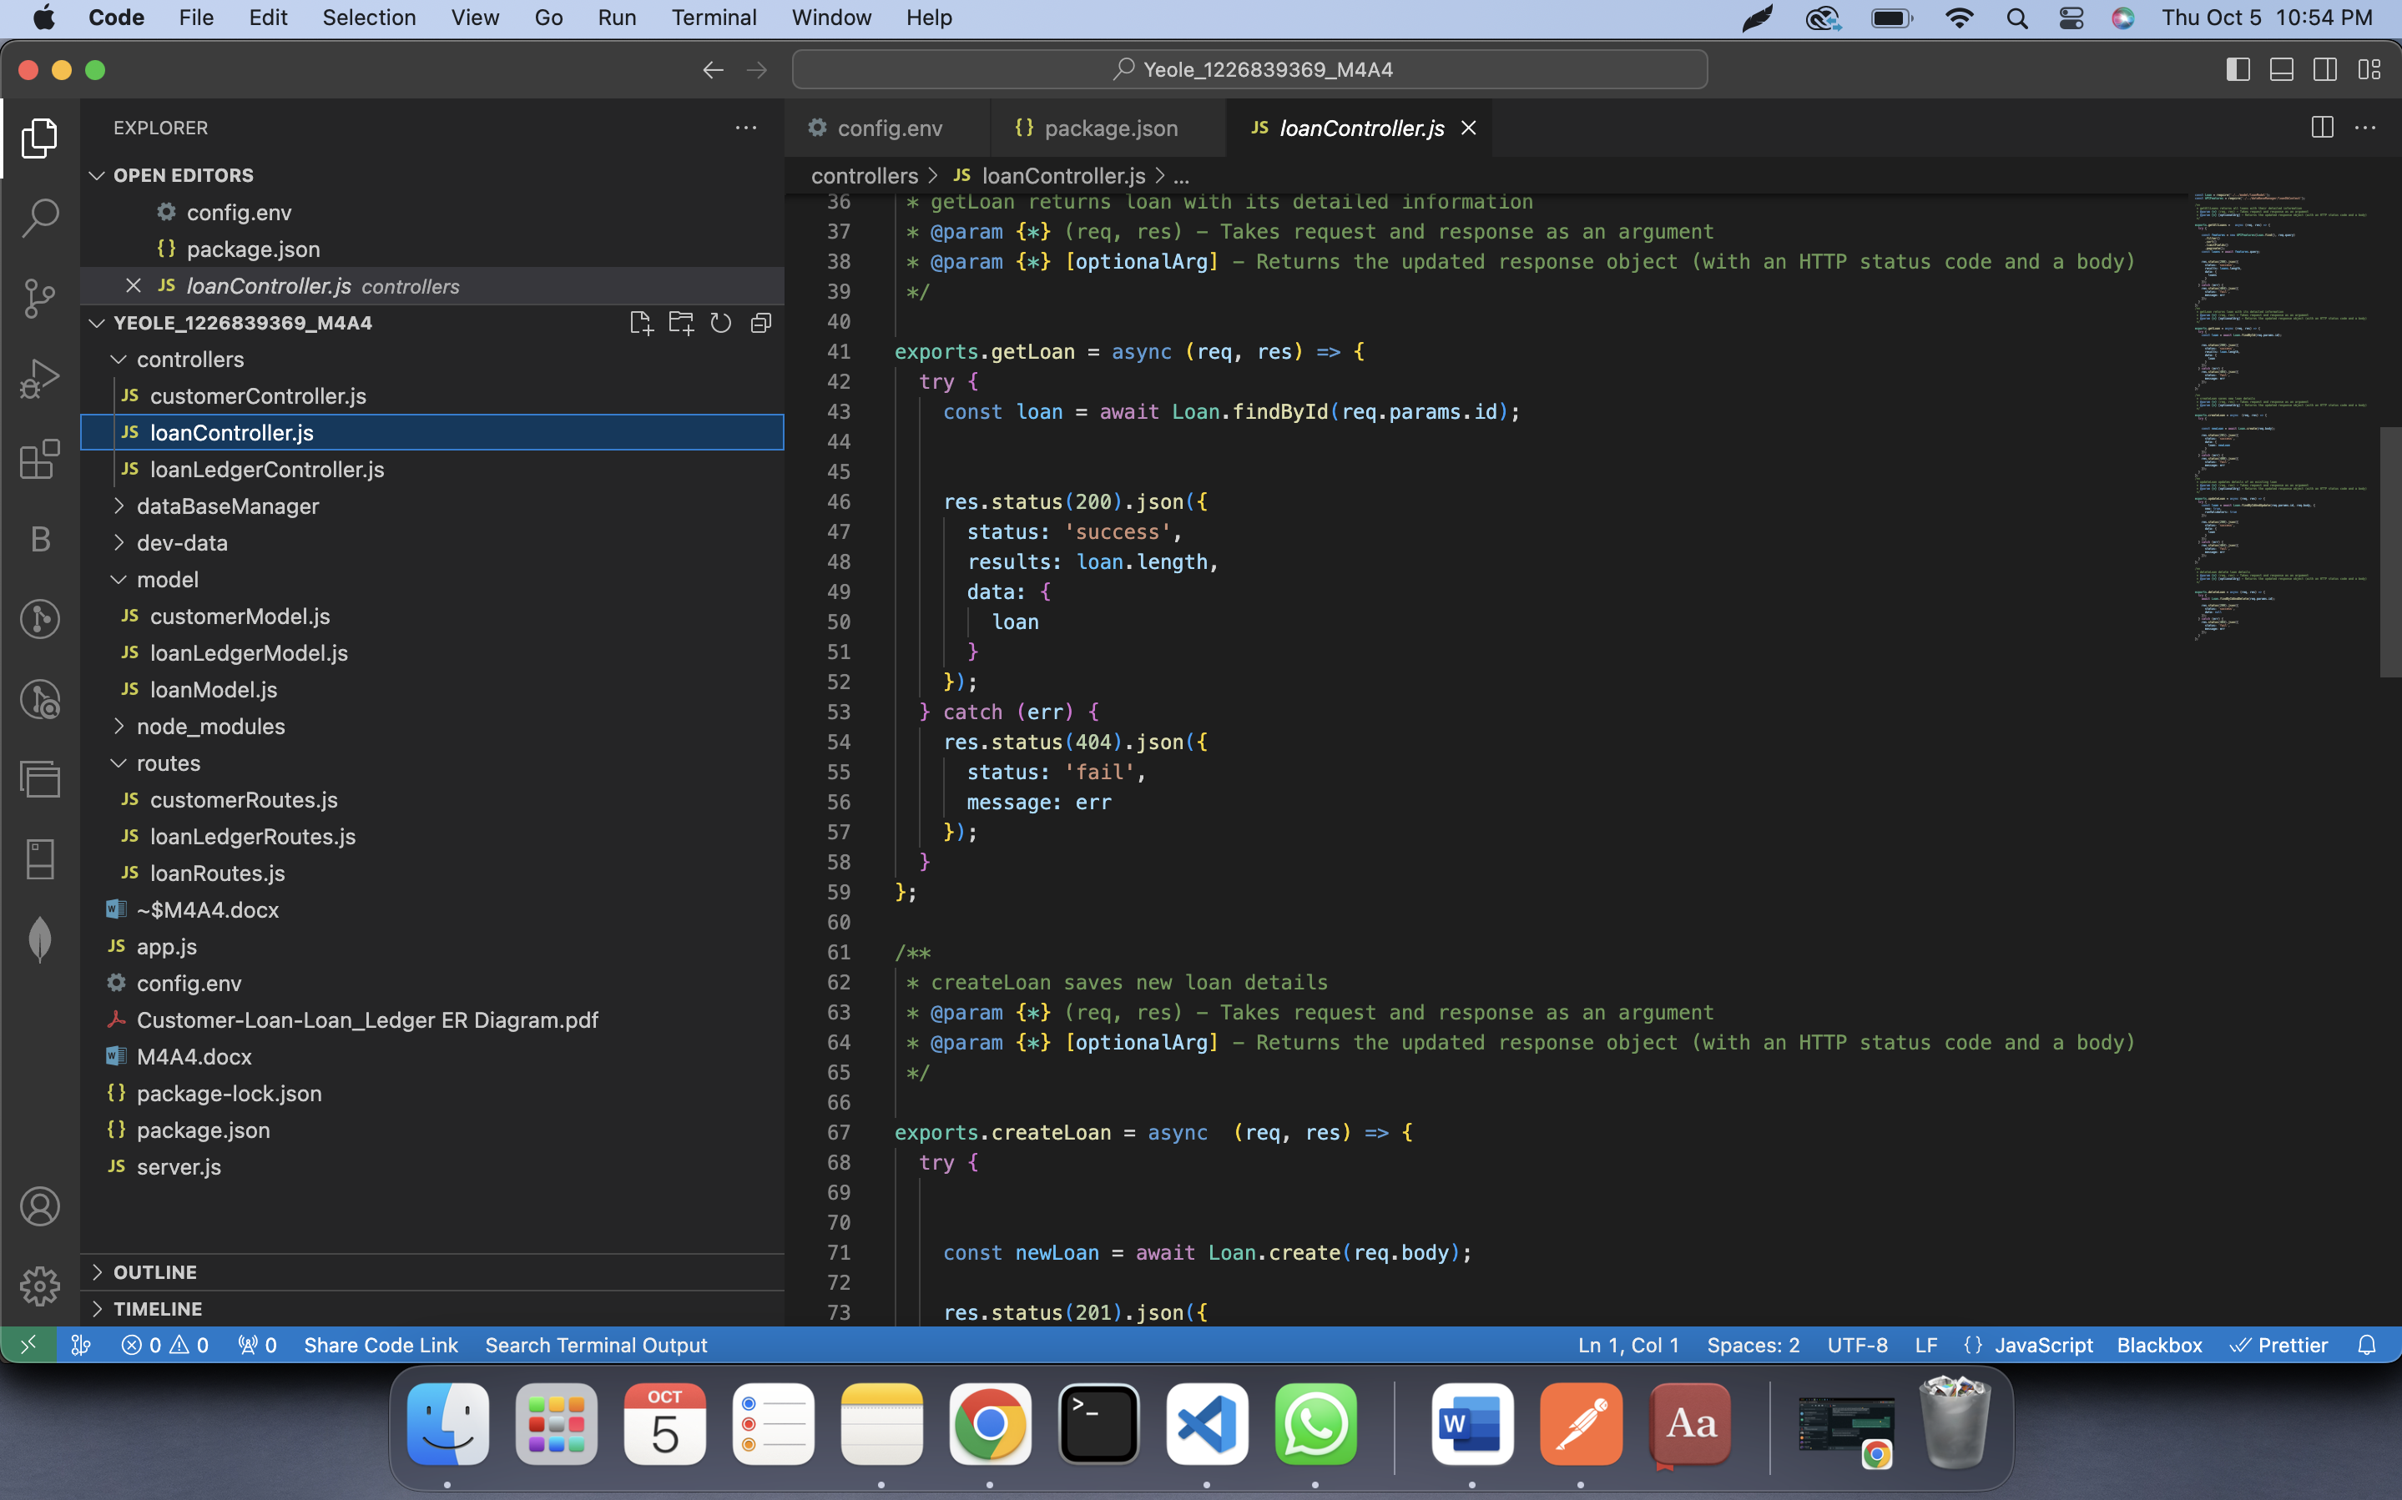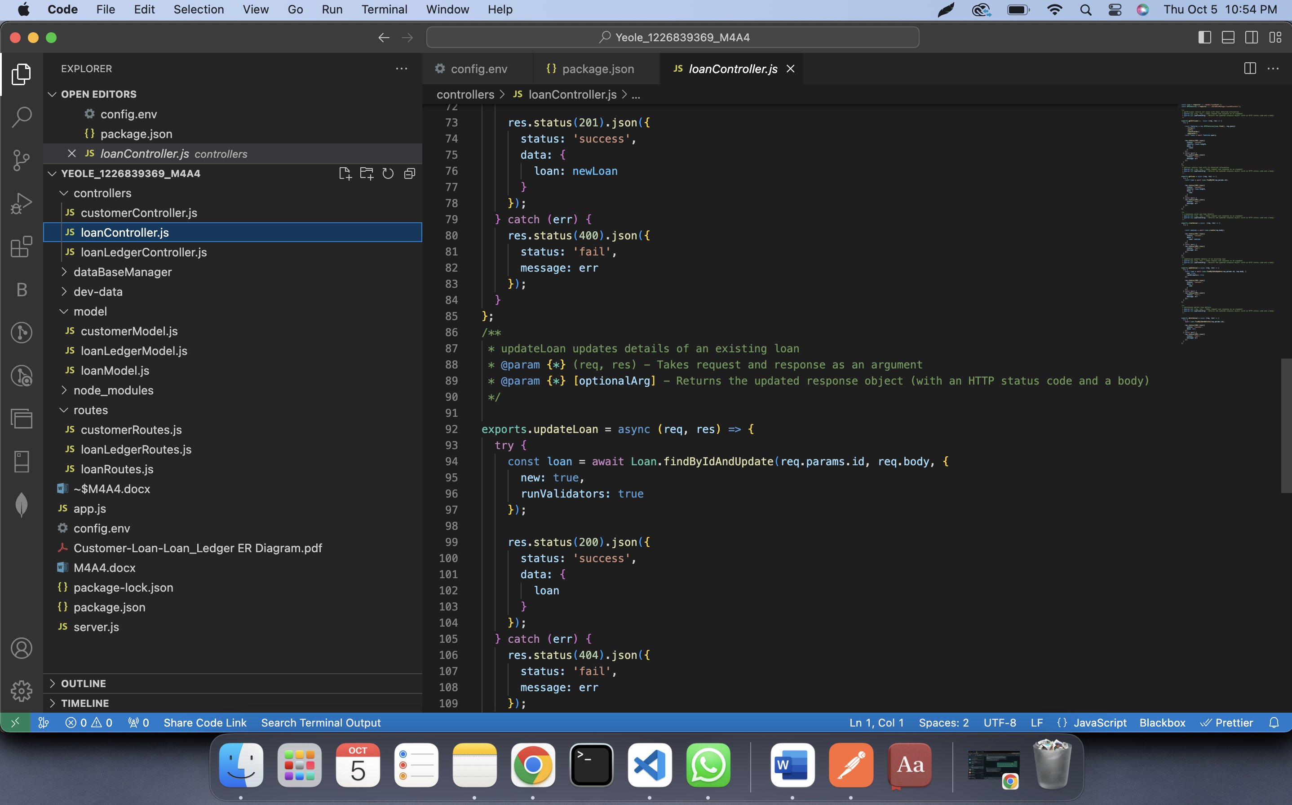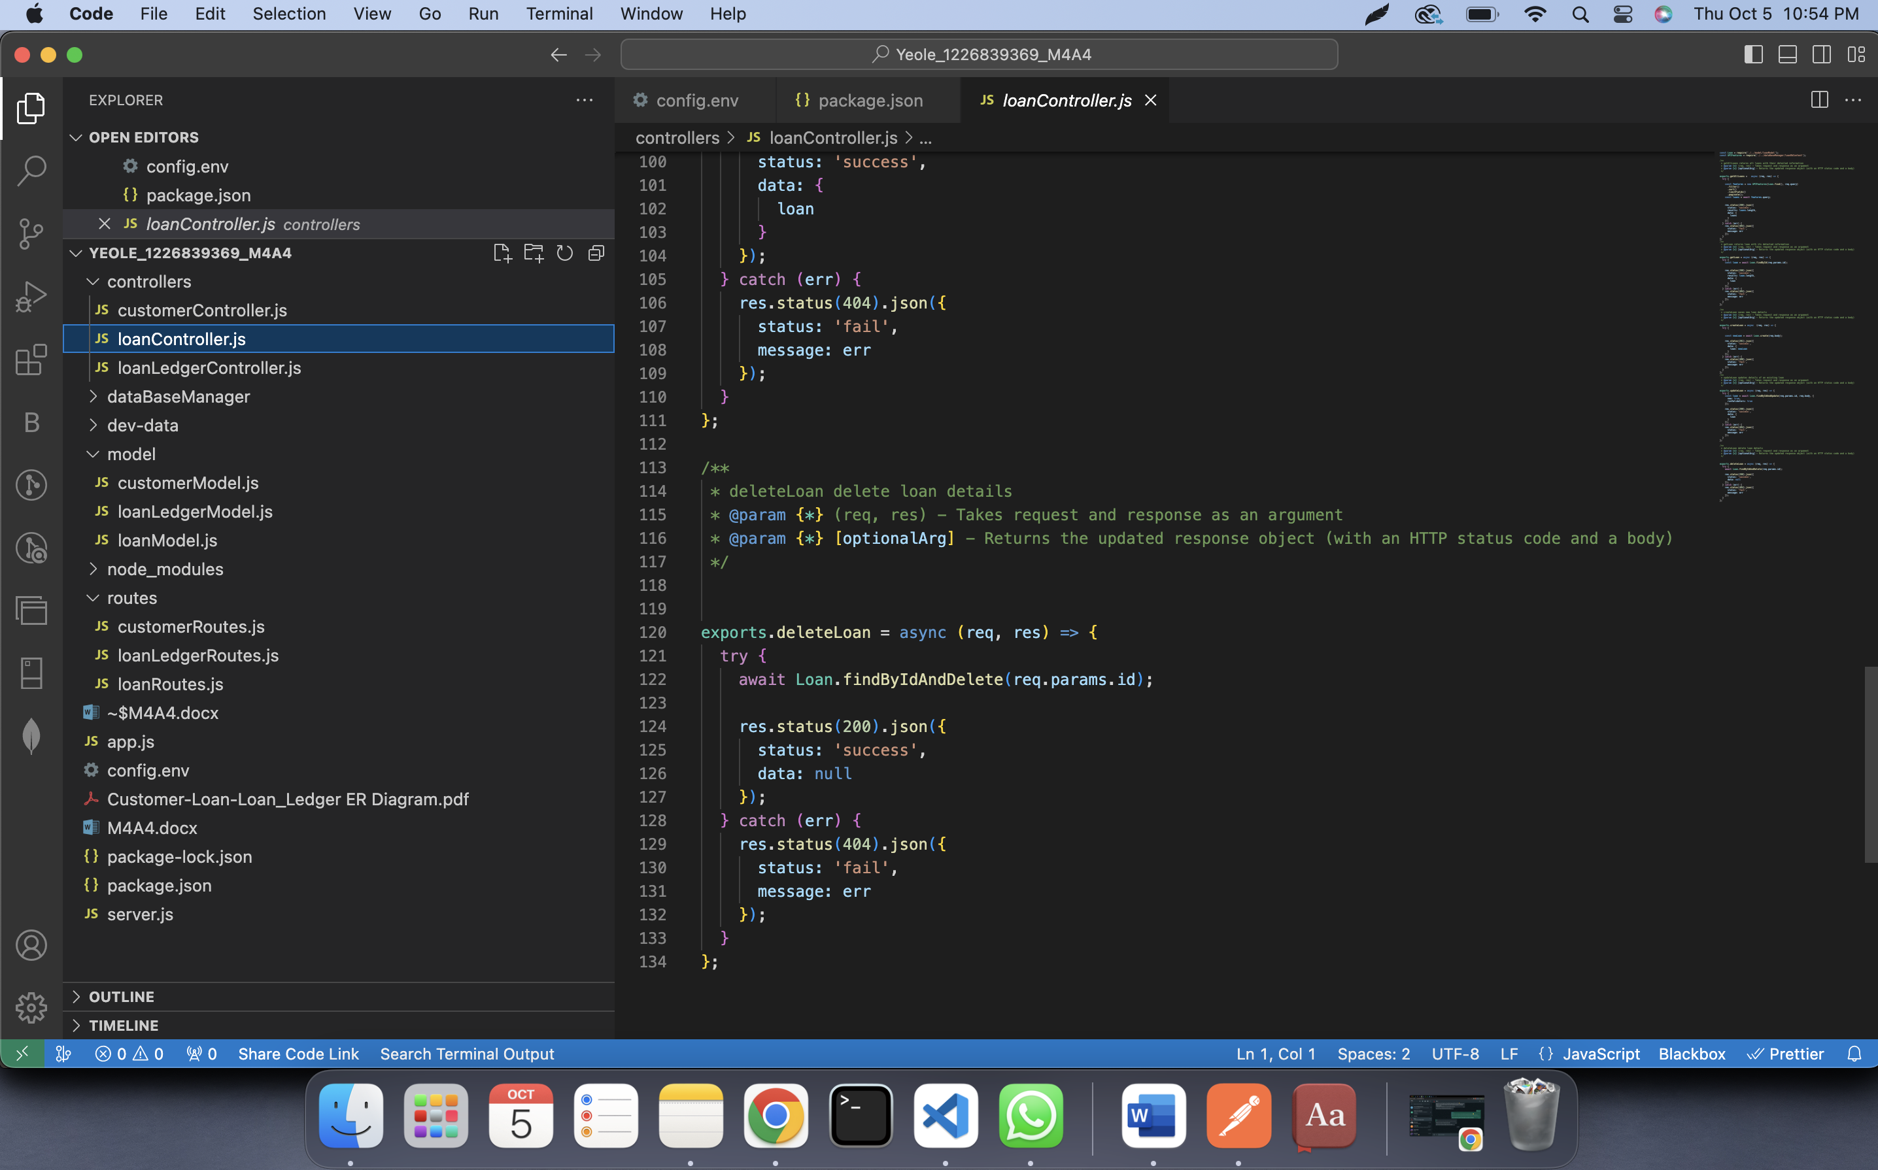

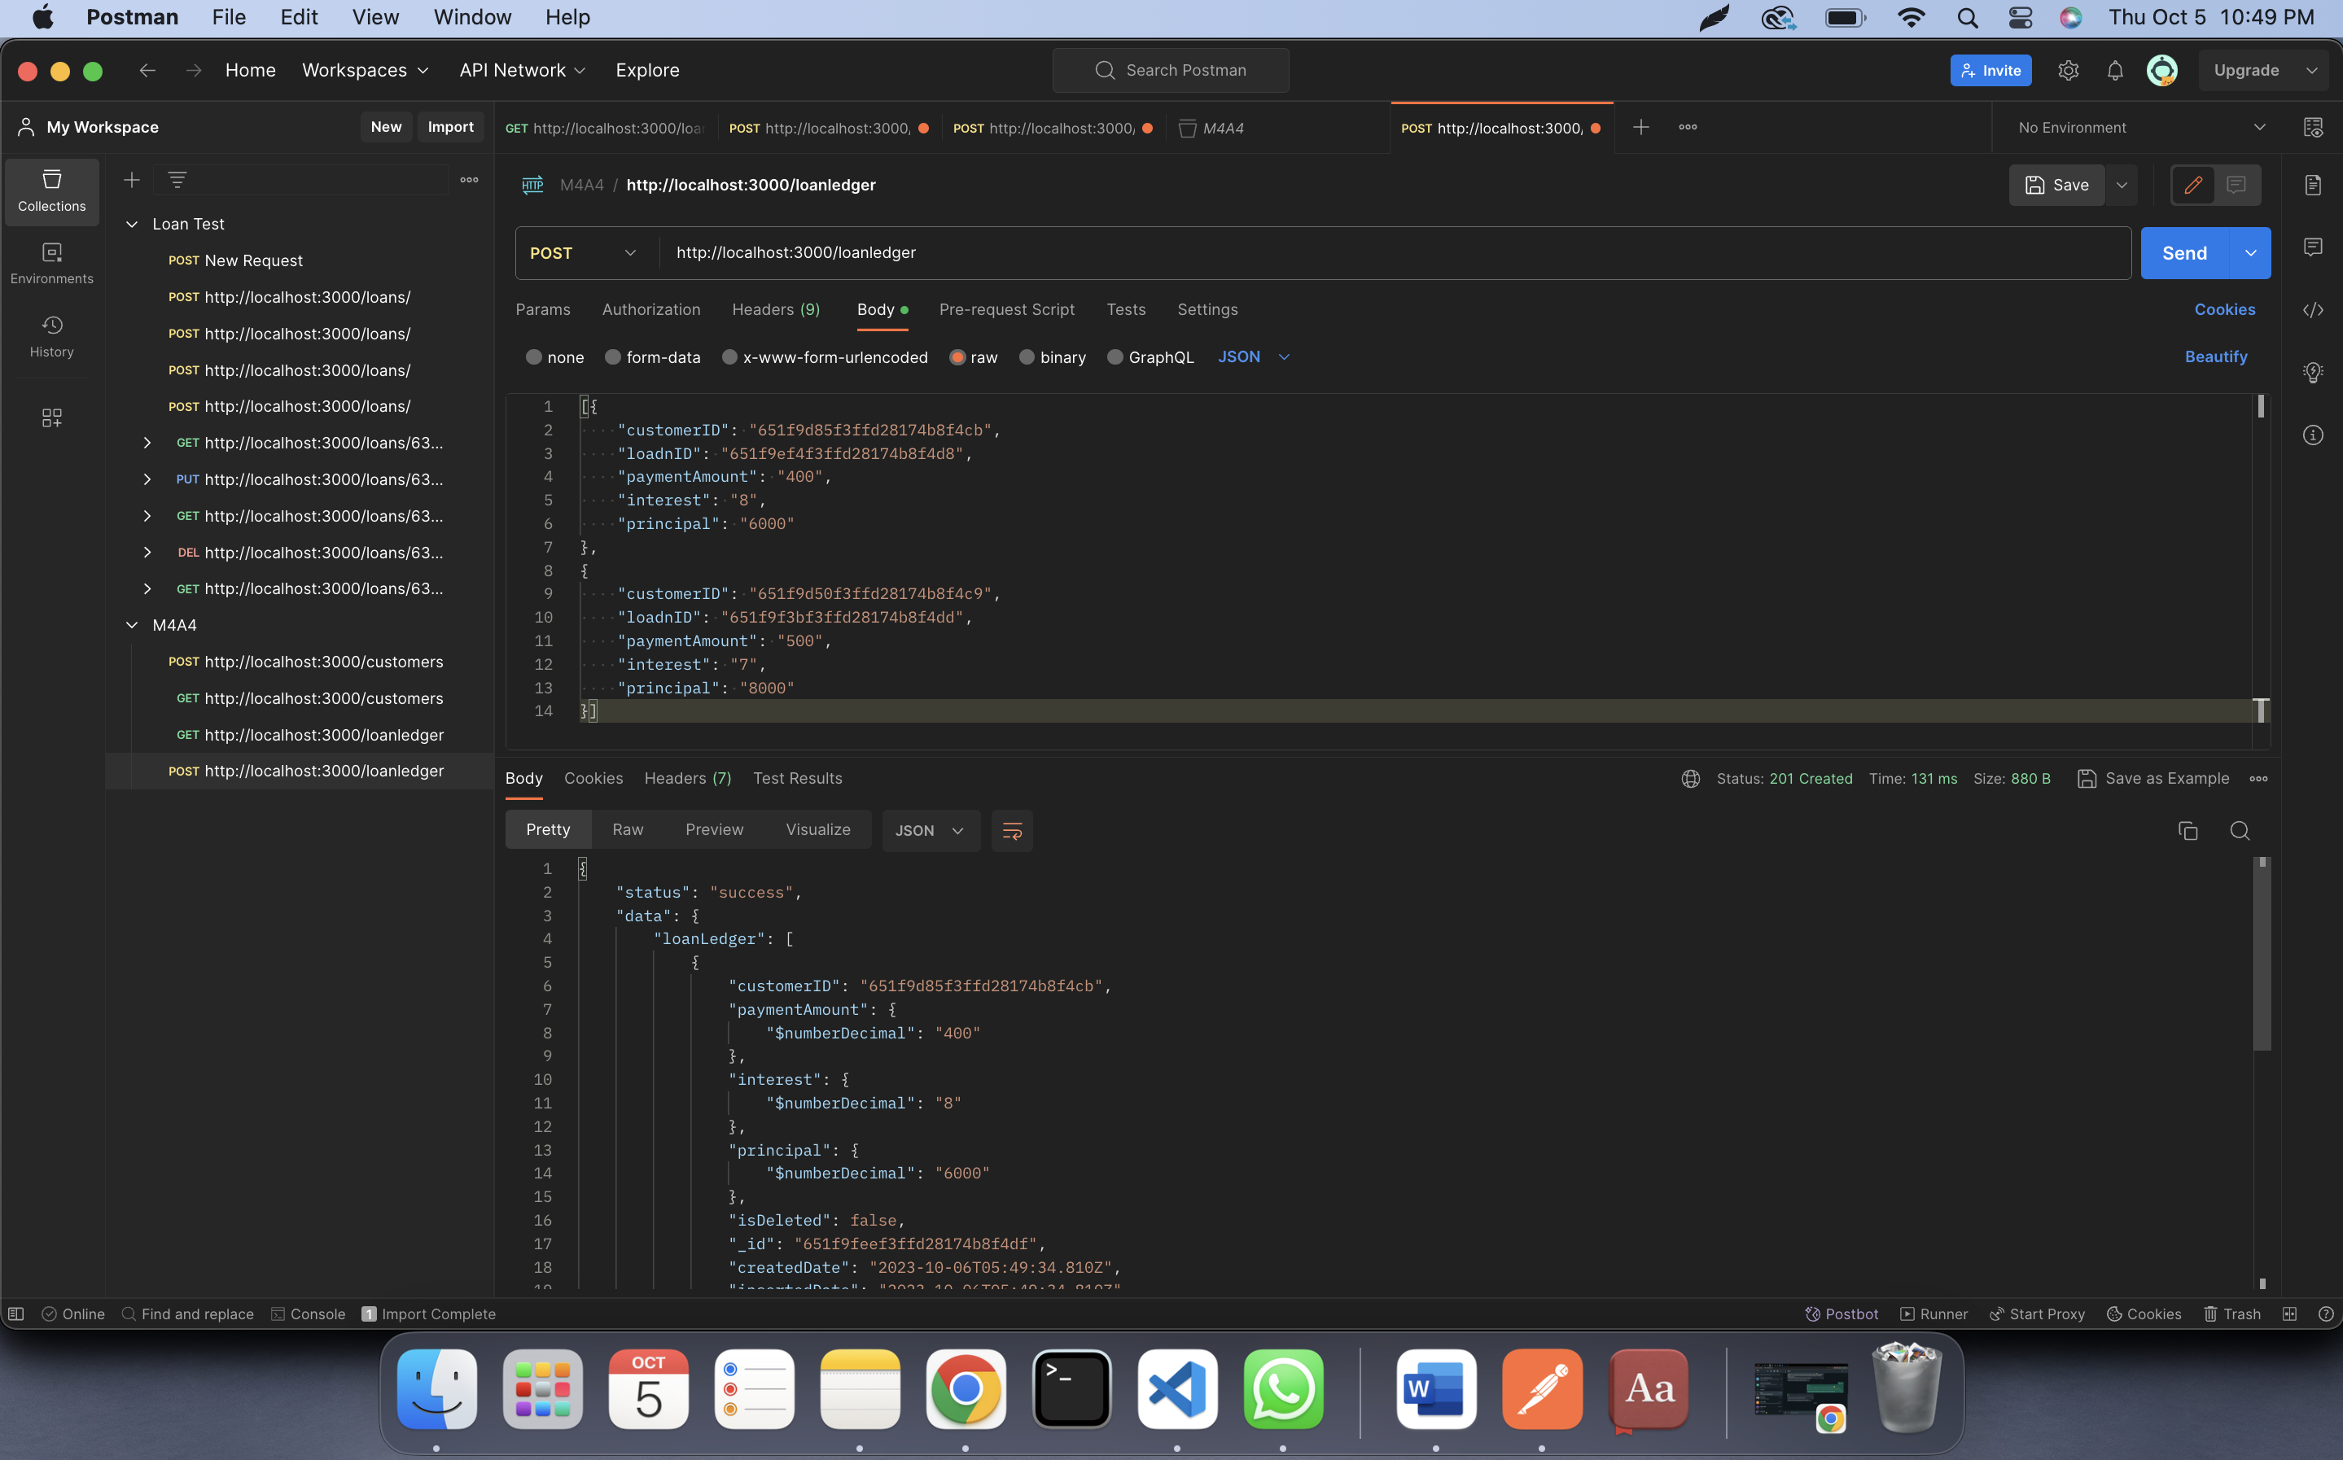

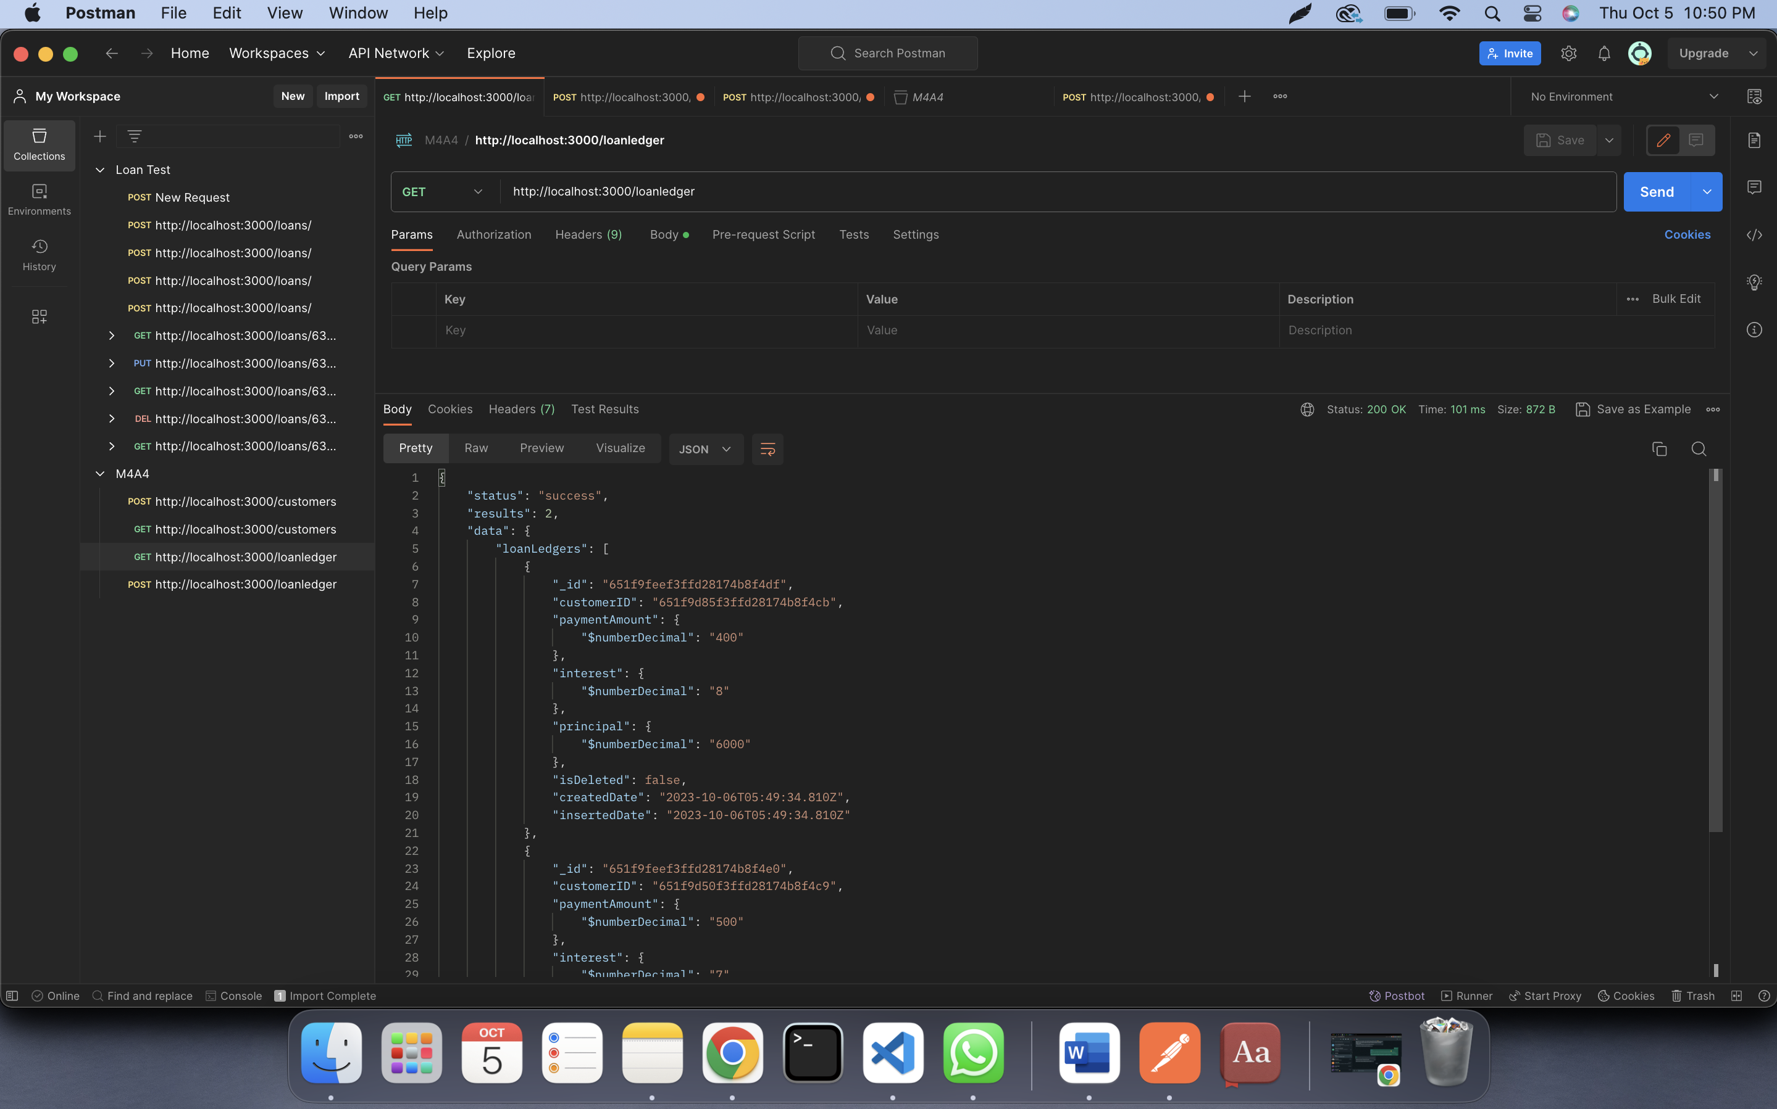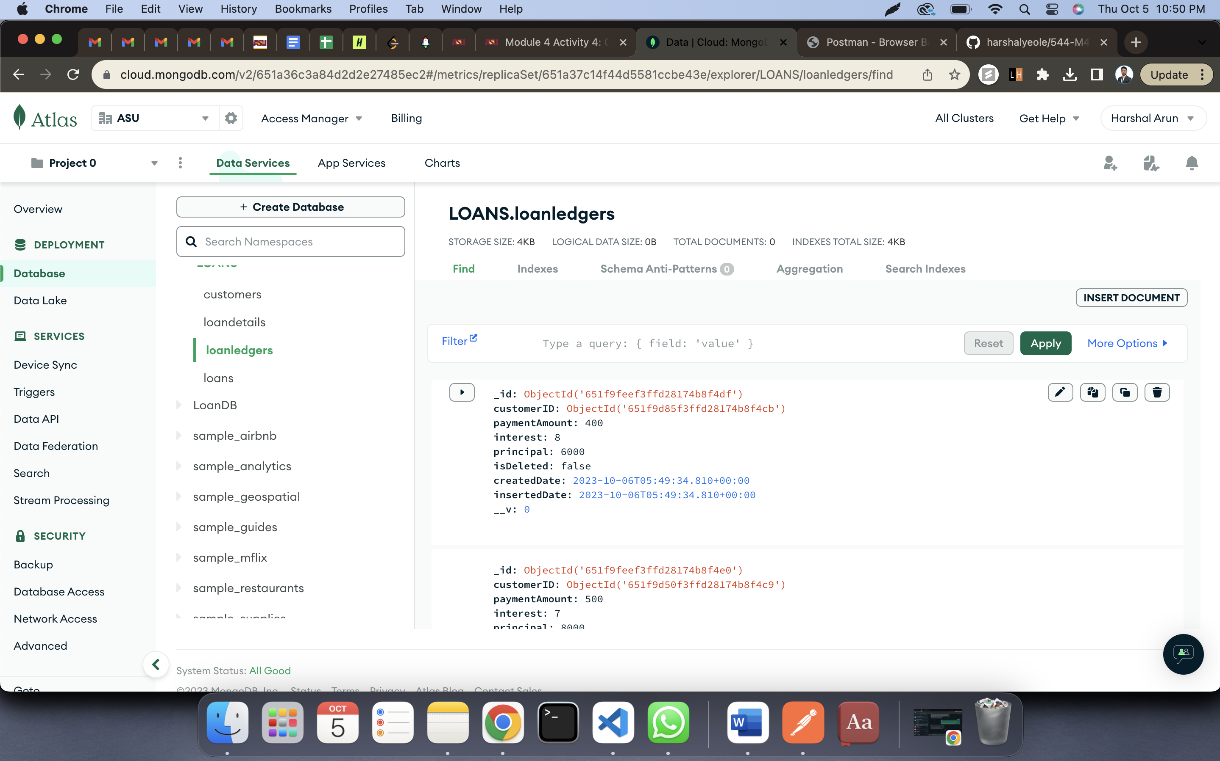

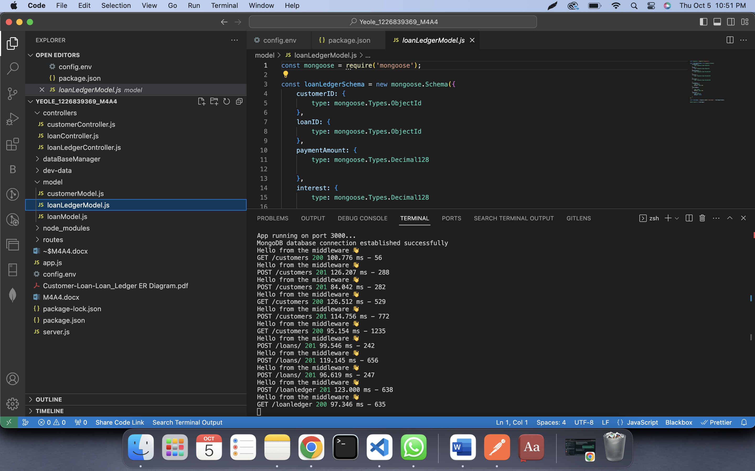

Code:

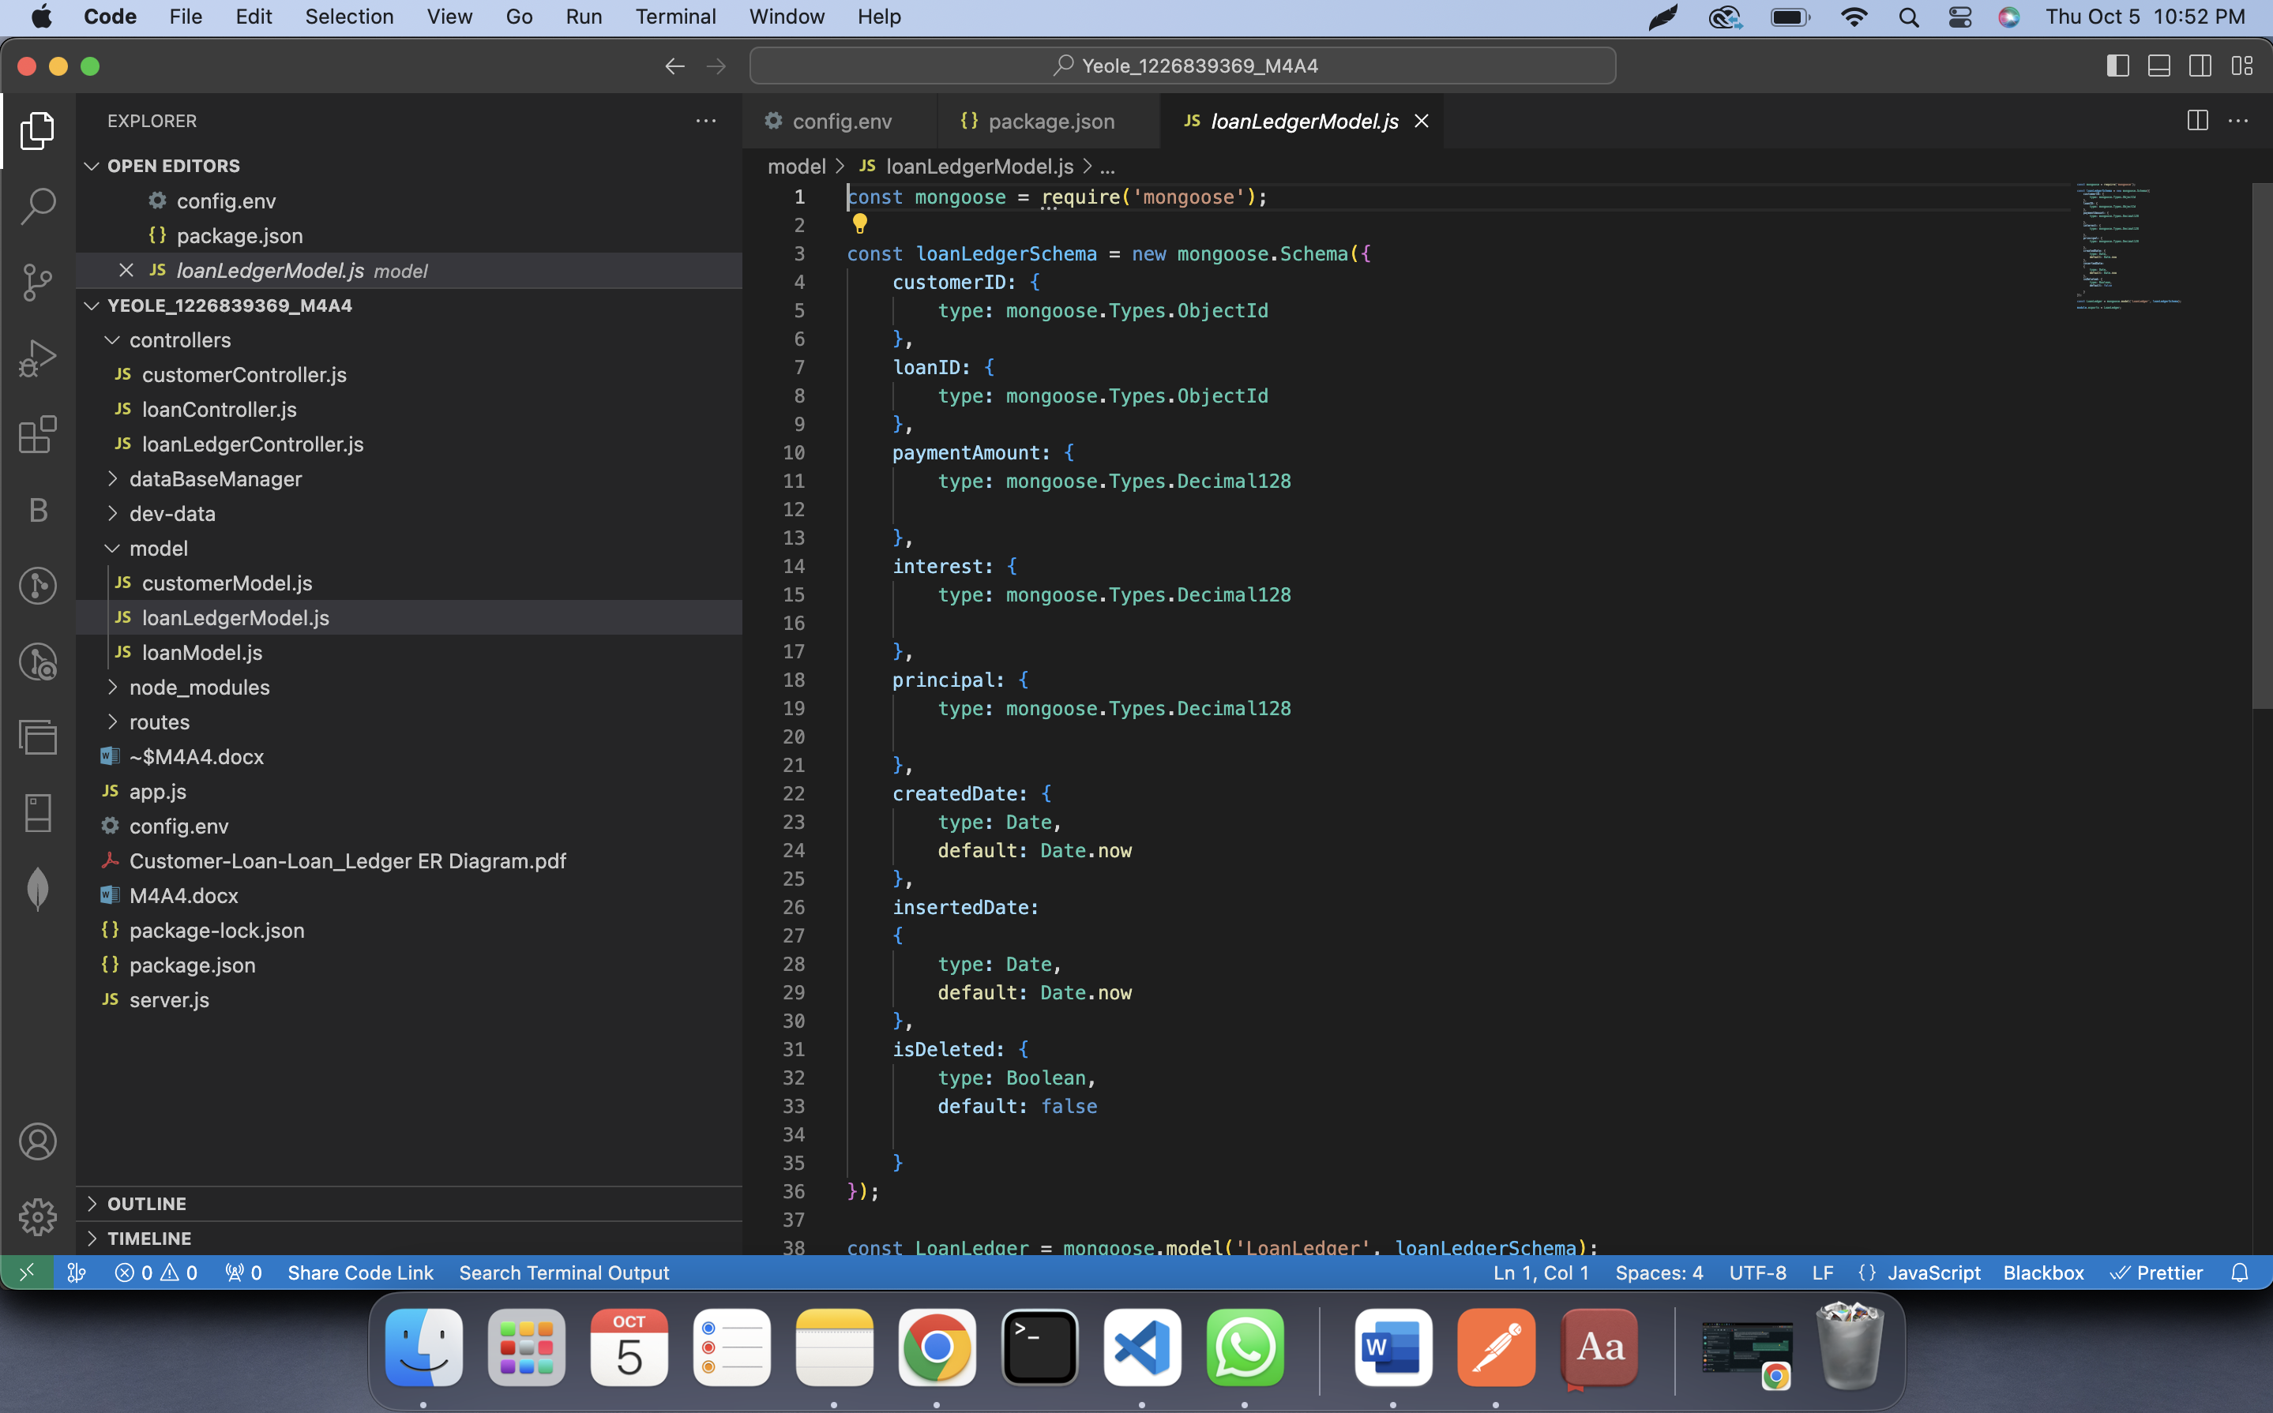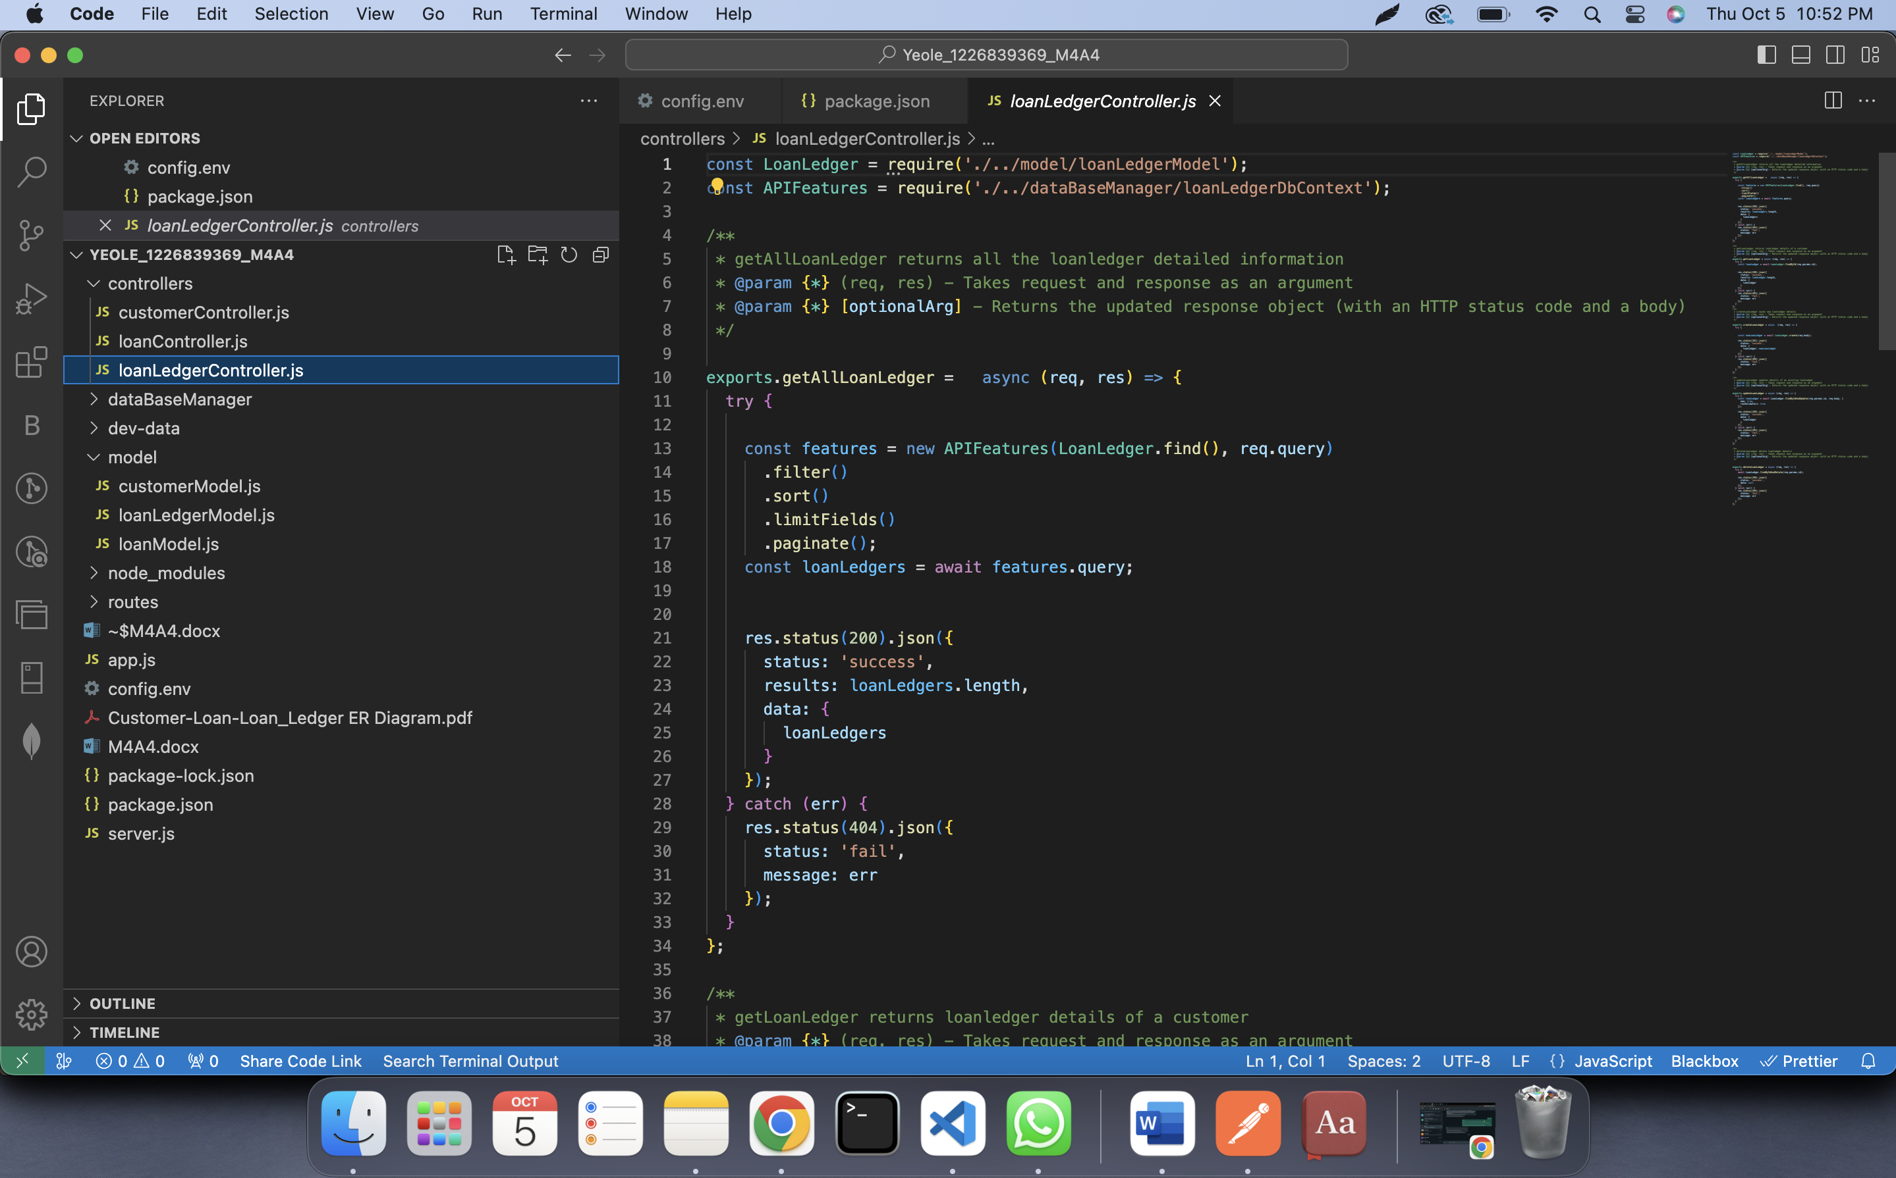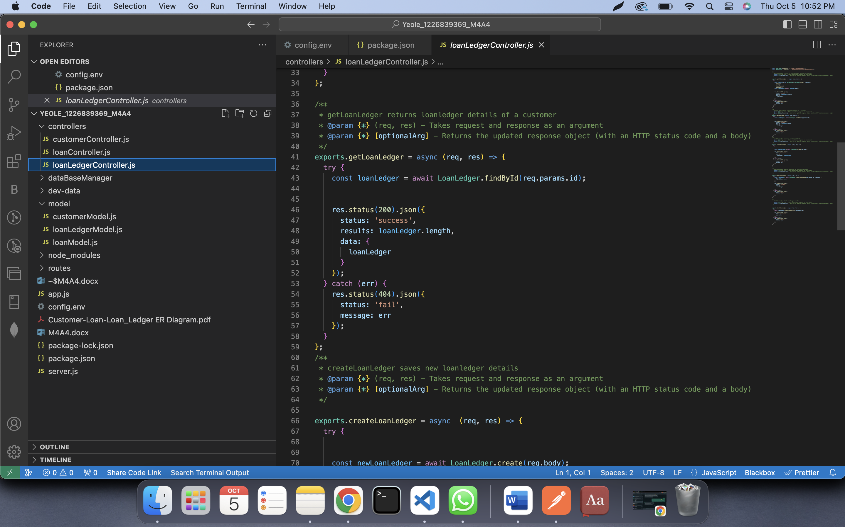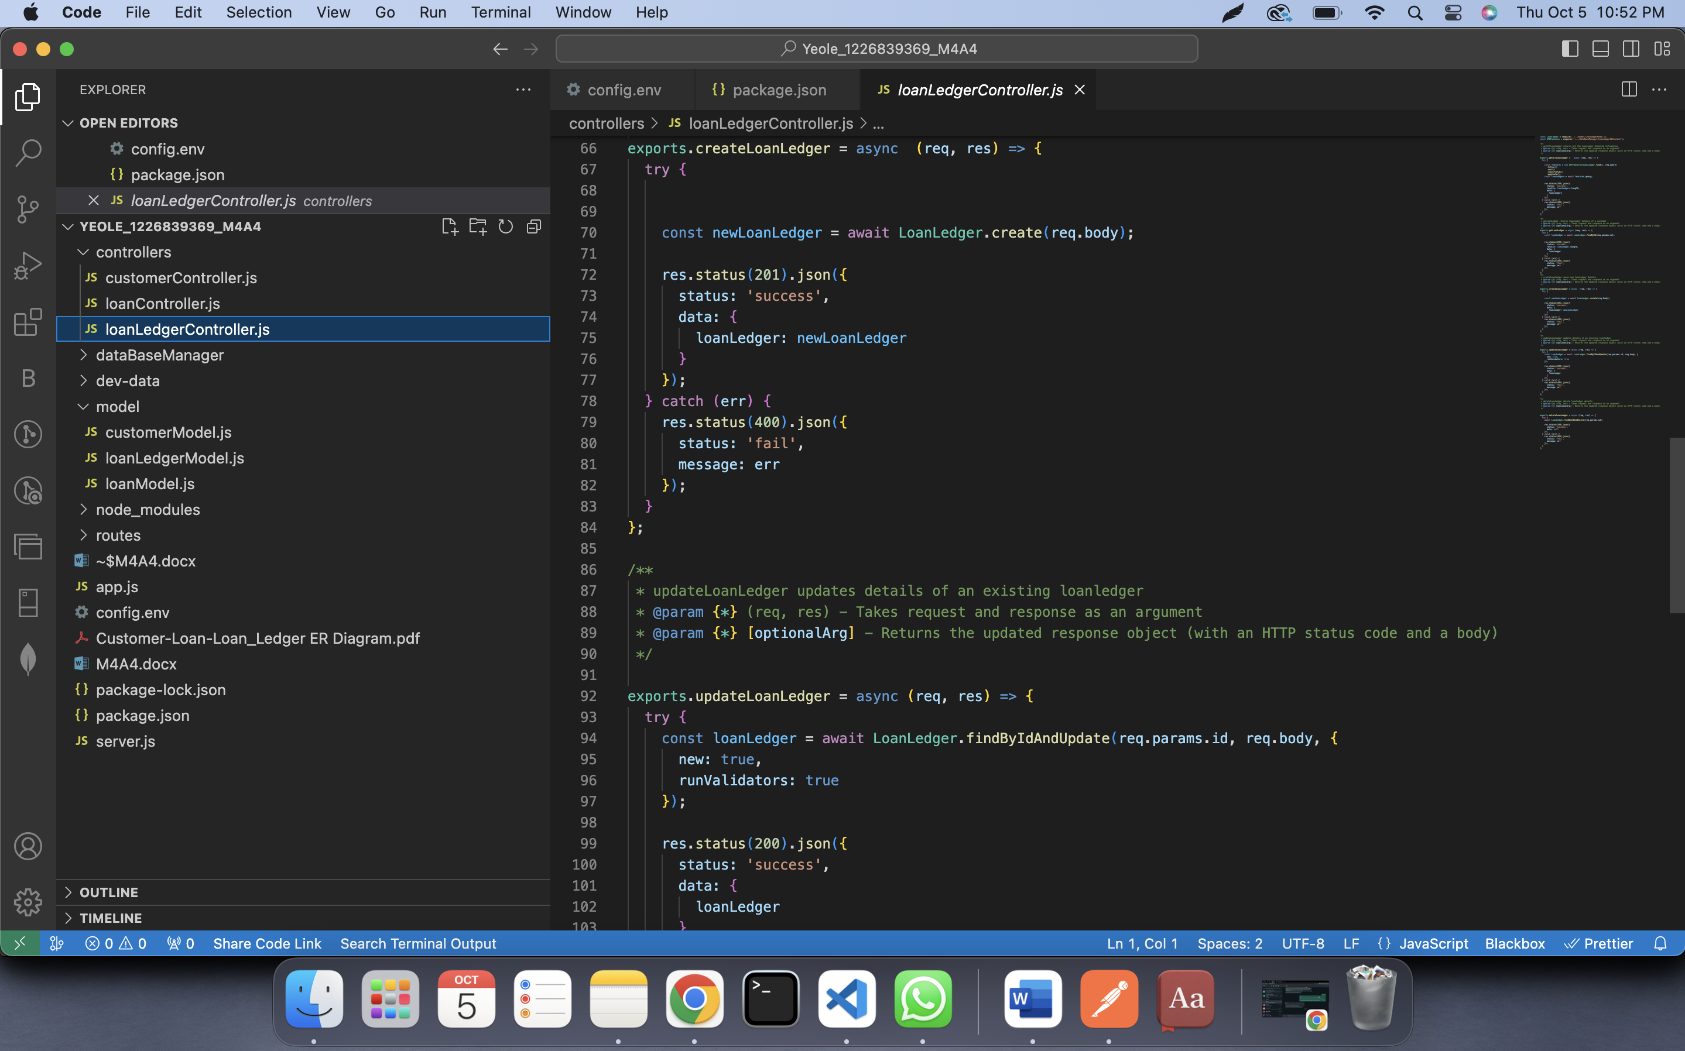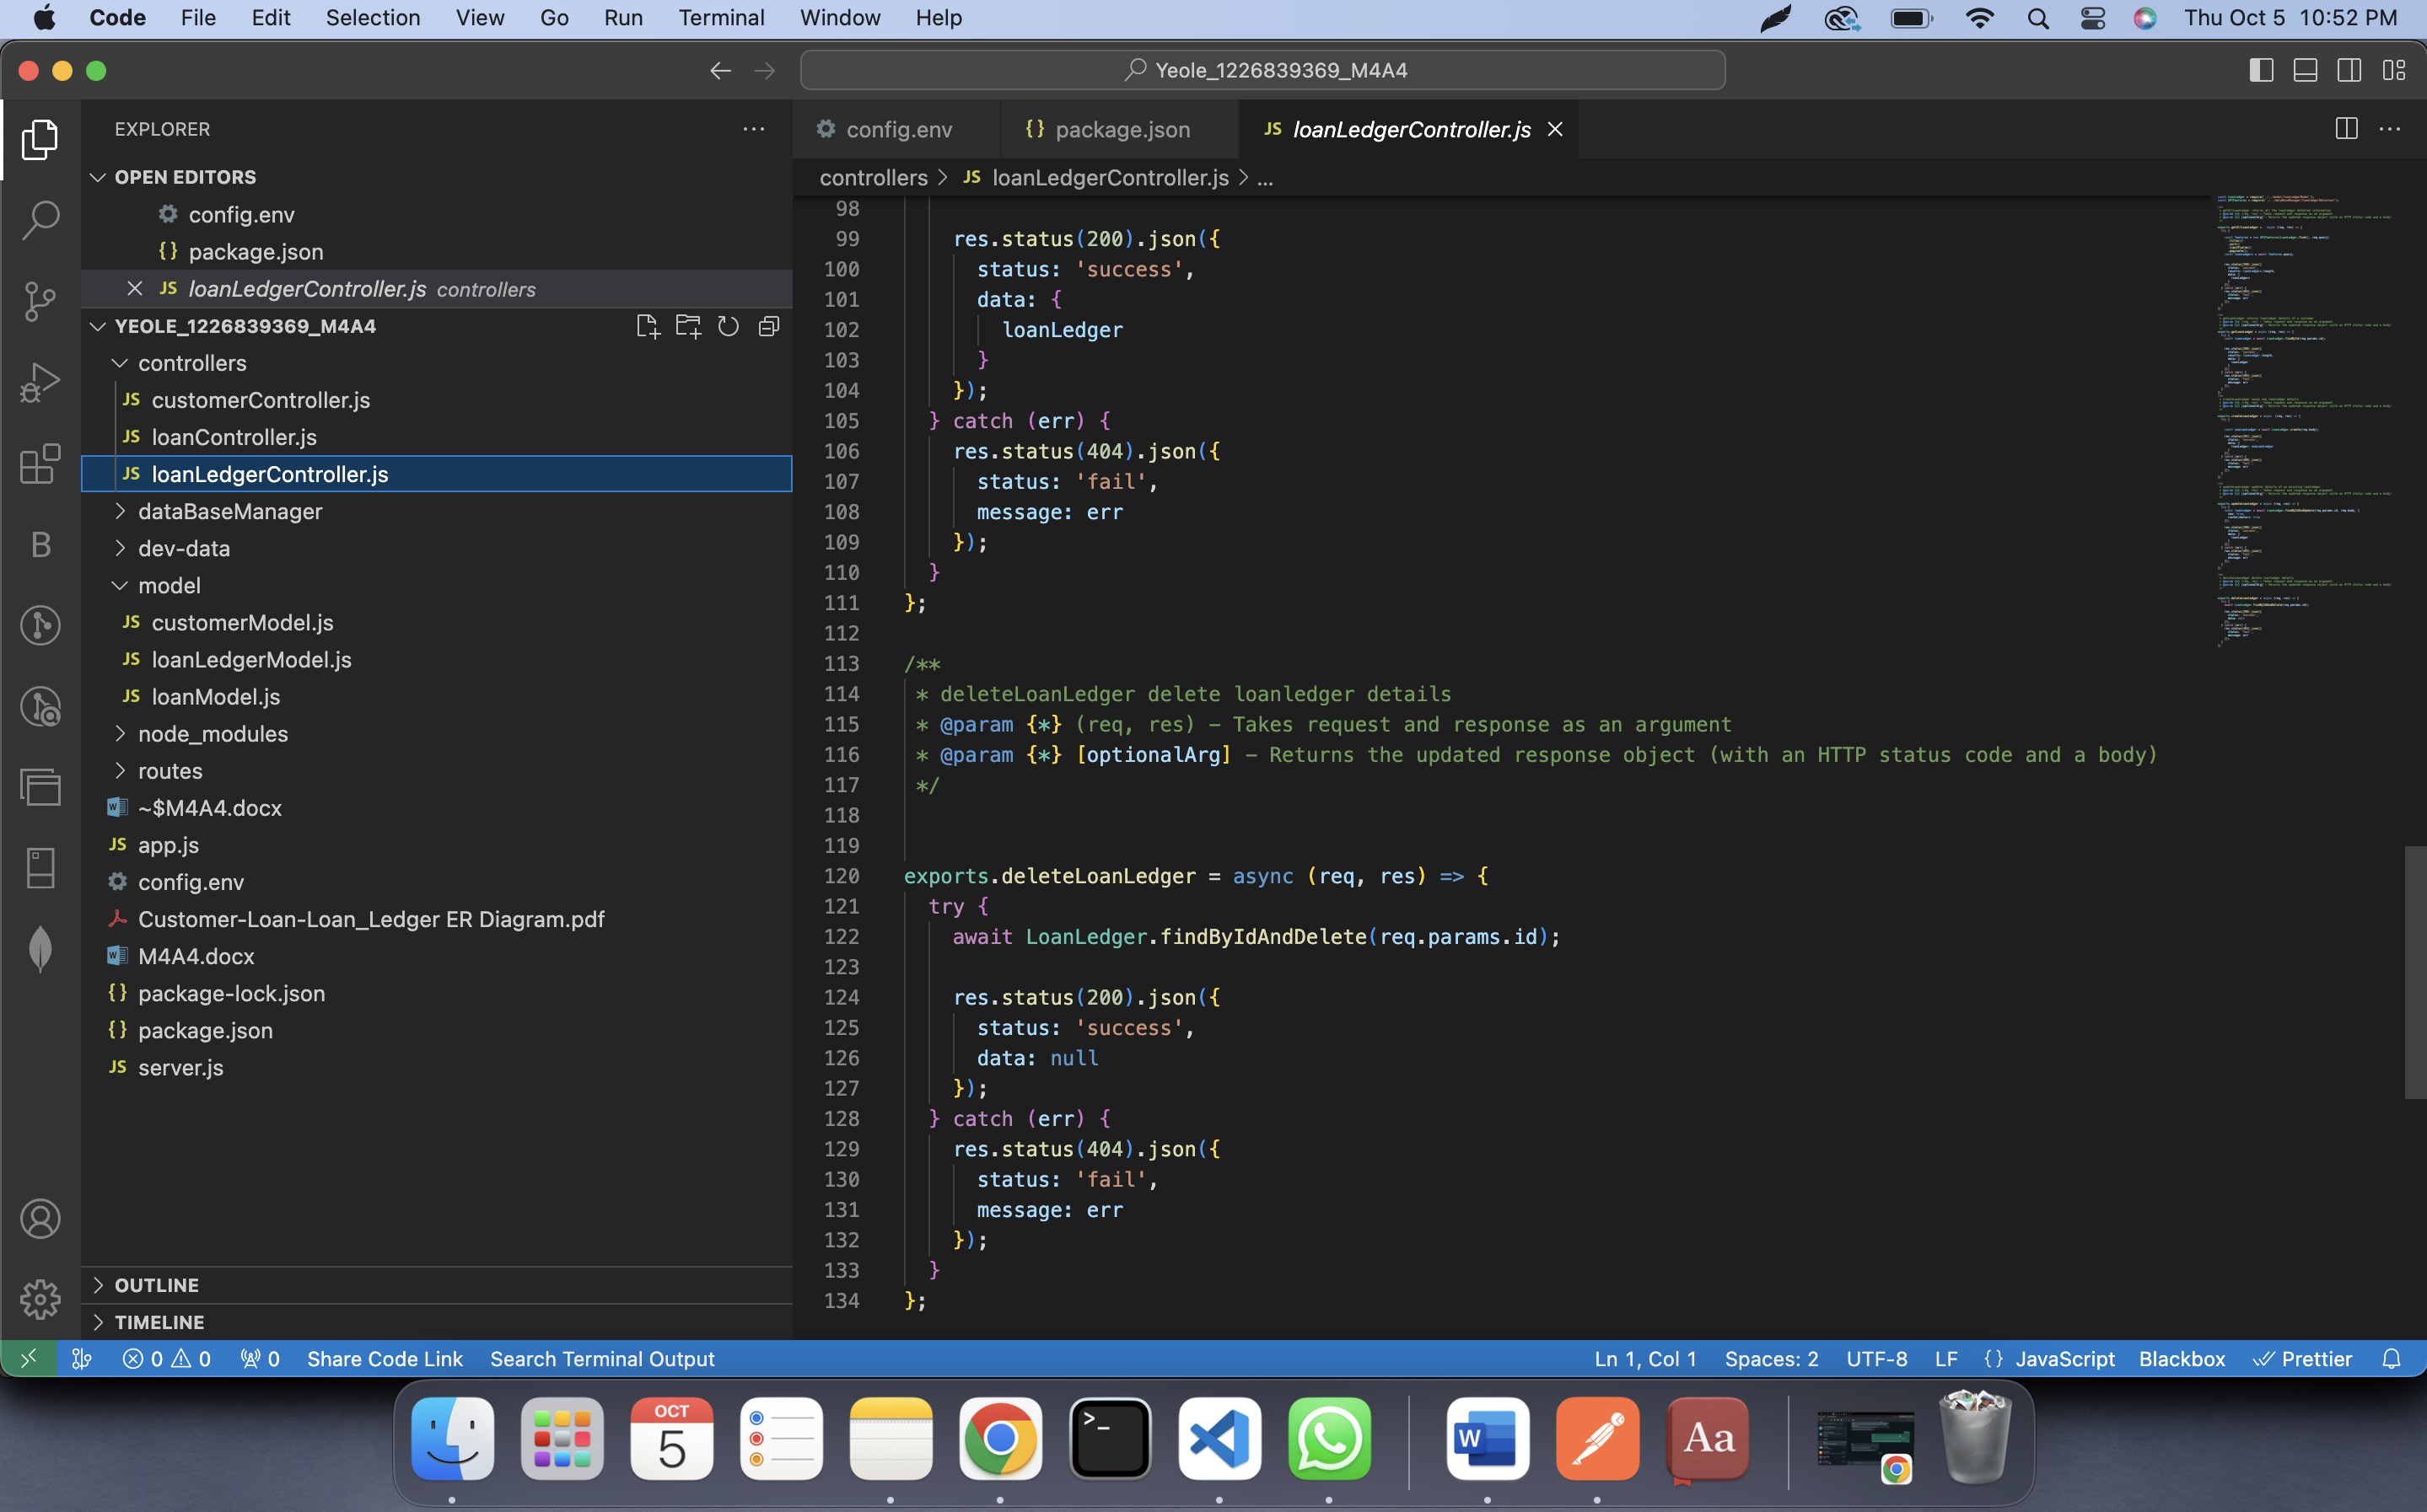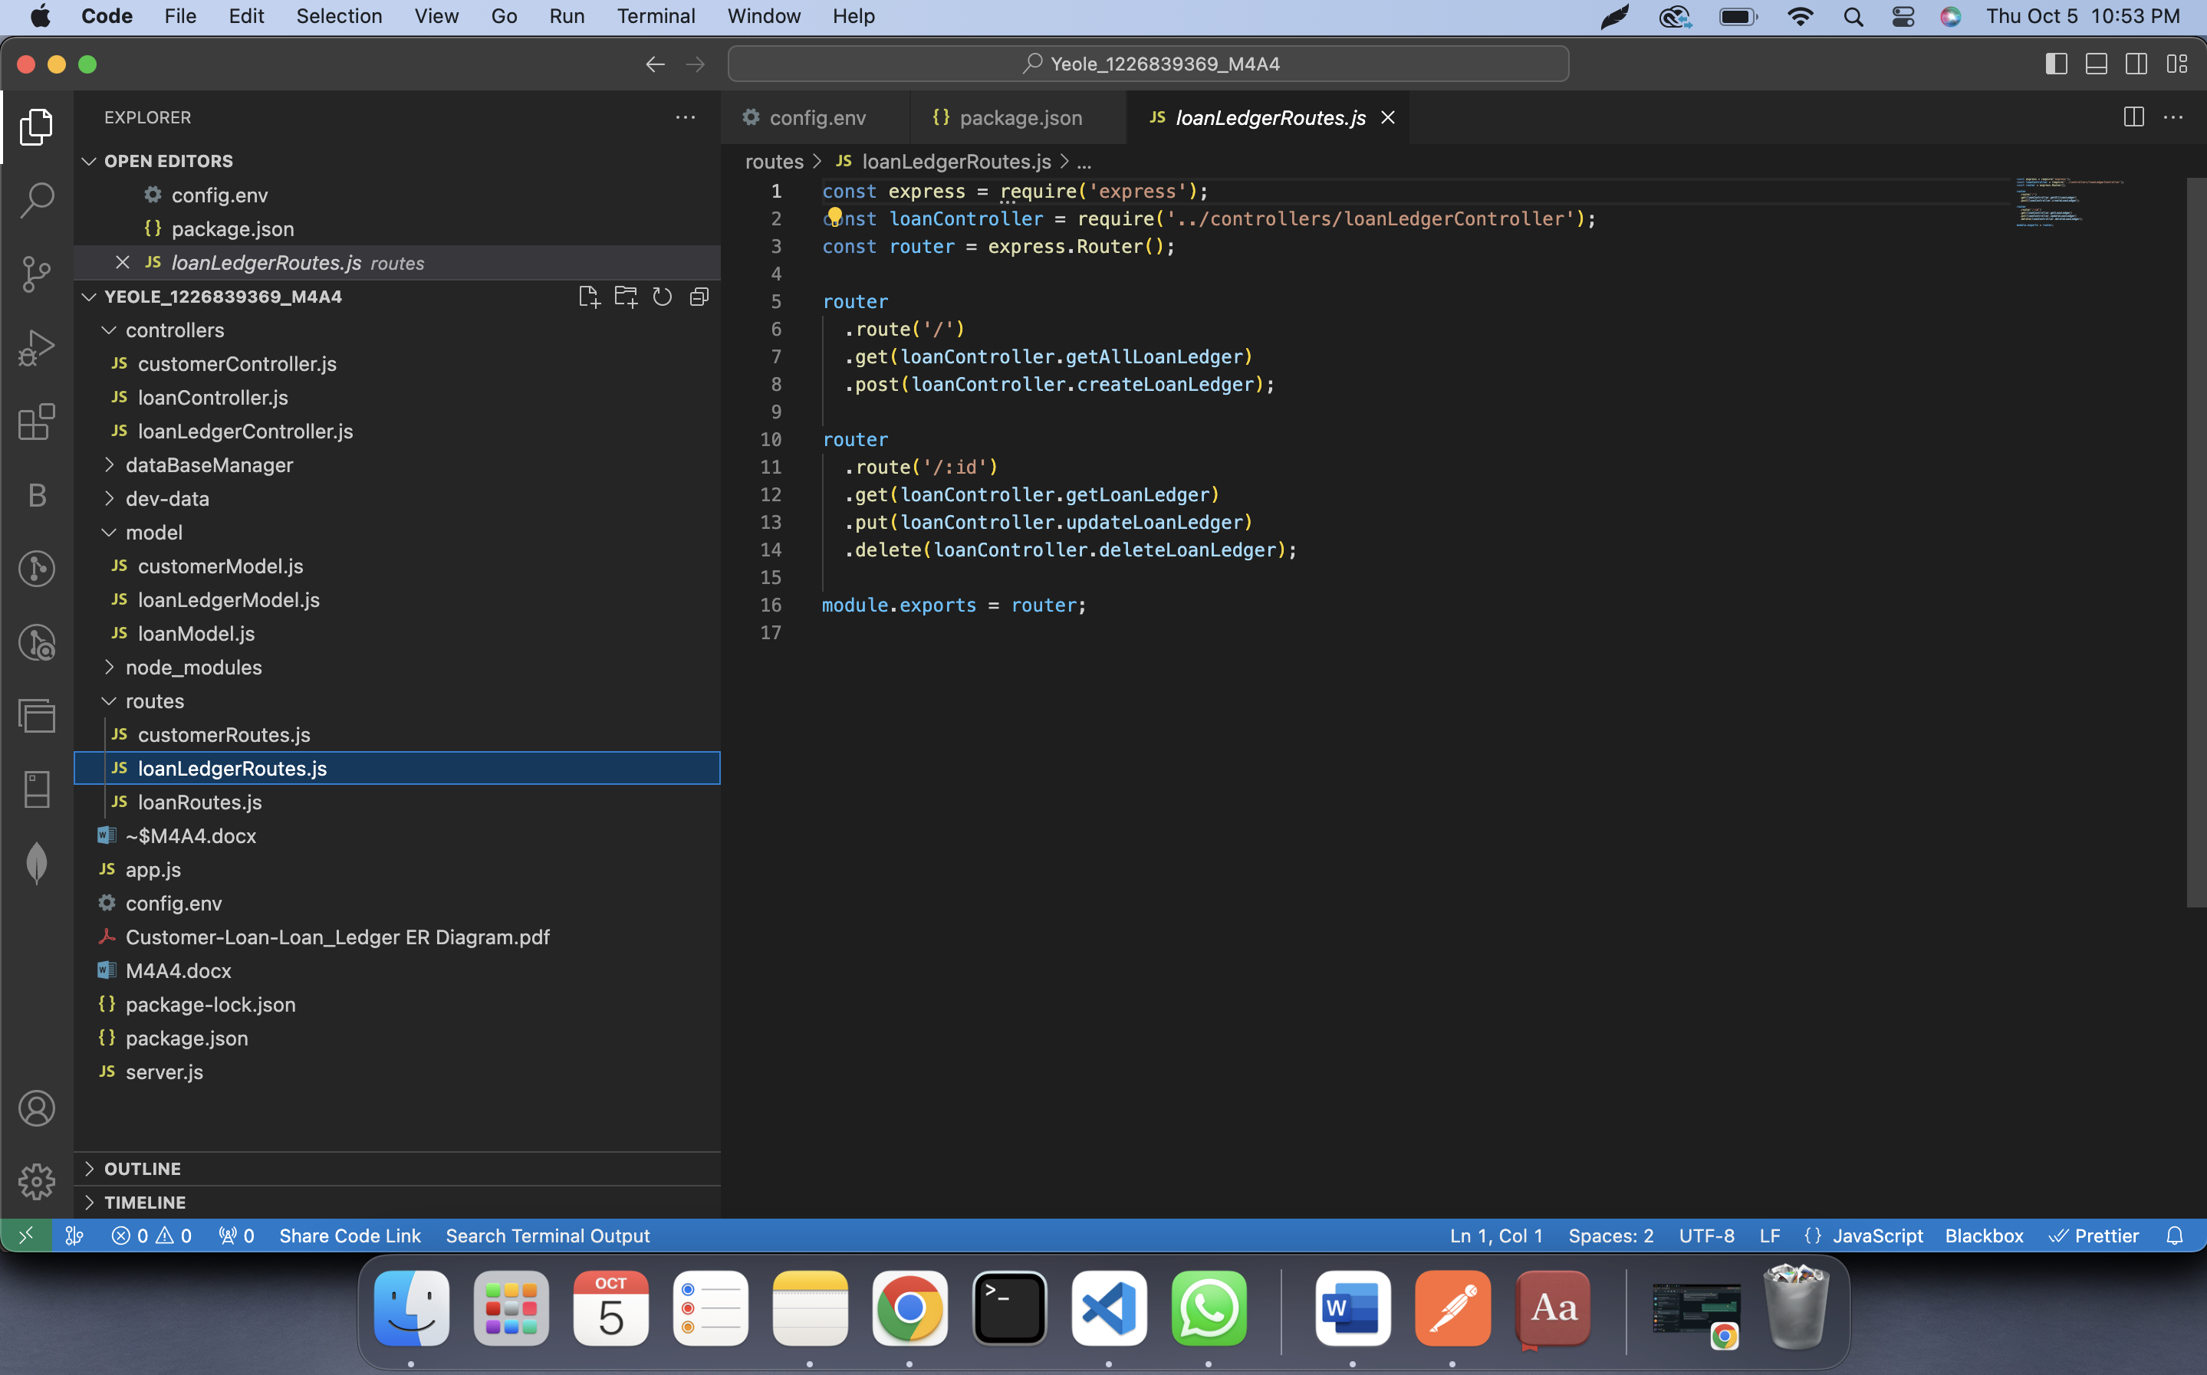

**Part 3: Requirement Storage Design Implementation: (DATABASE)**

**Create a Node.js Project to Access, and implement using Rest methods. Document and comment on all parts of the code and implementations as you see fit.**

* SELECT ( Get),
* INSERT( Post)
* UPDATE (Update)
* and DELETE (Delete)

**Part 4:** Use POSTMAN as a client application to test your App server and the Middleware.

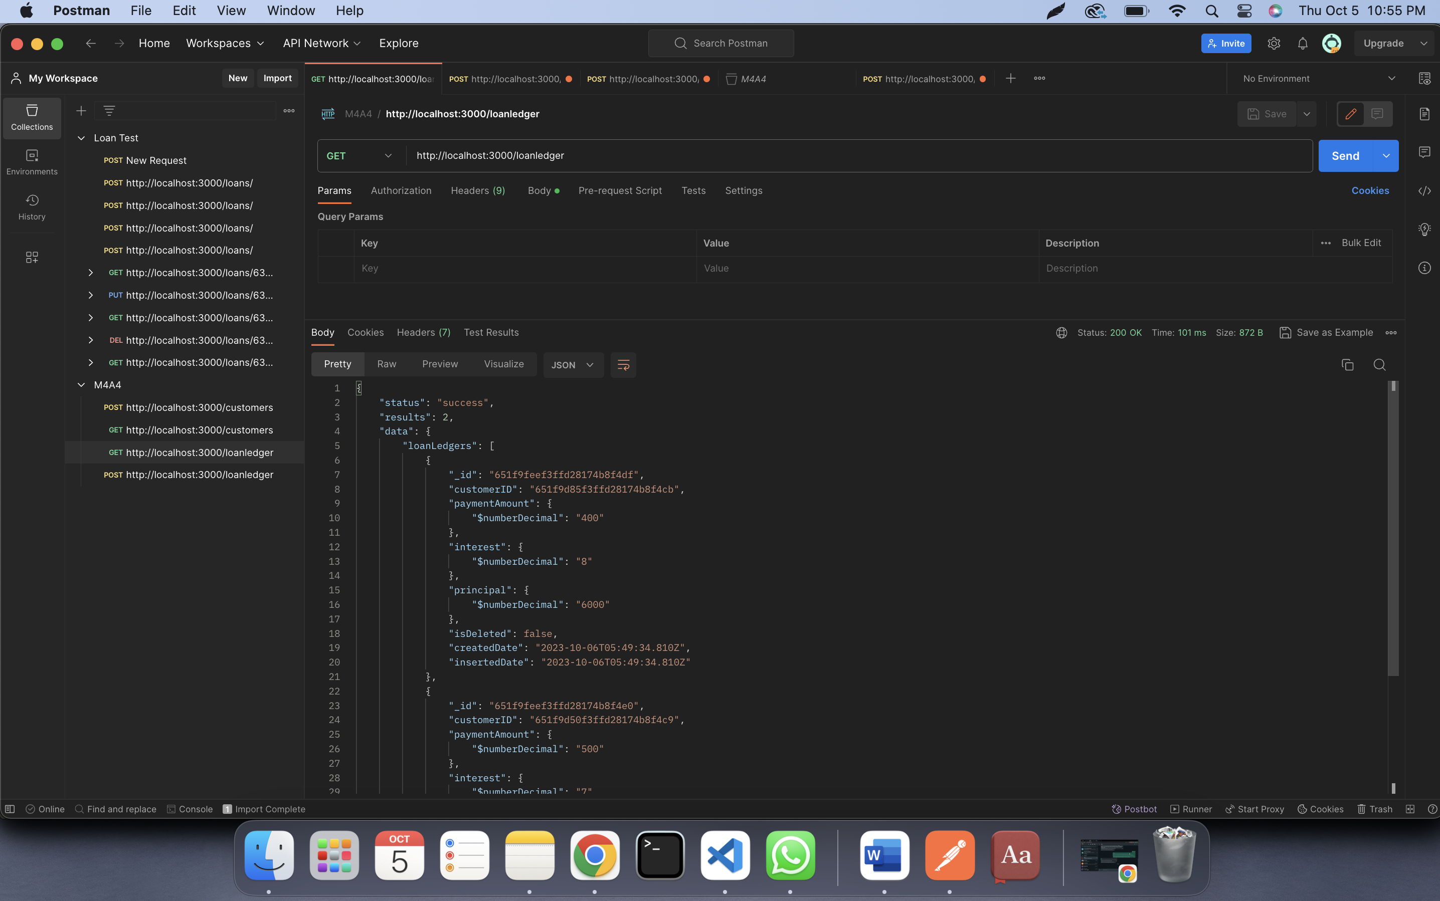

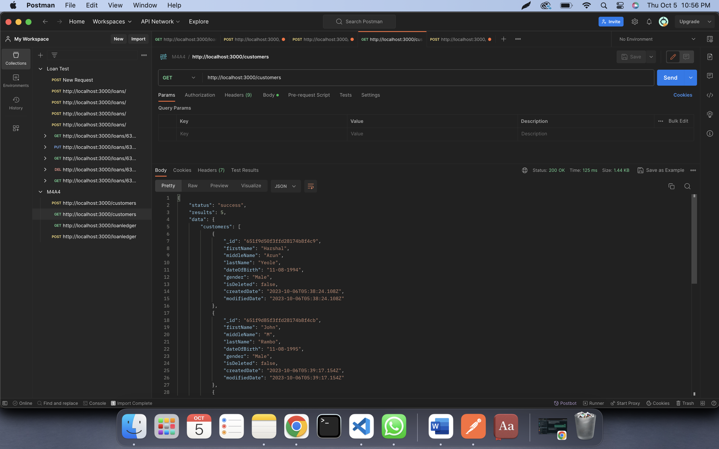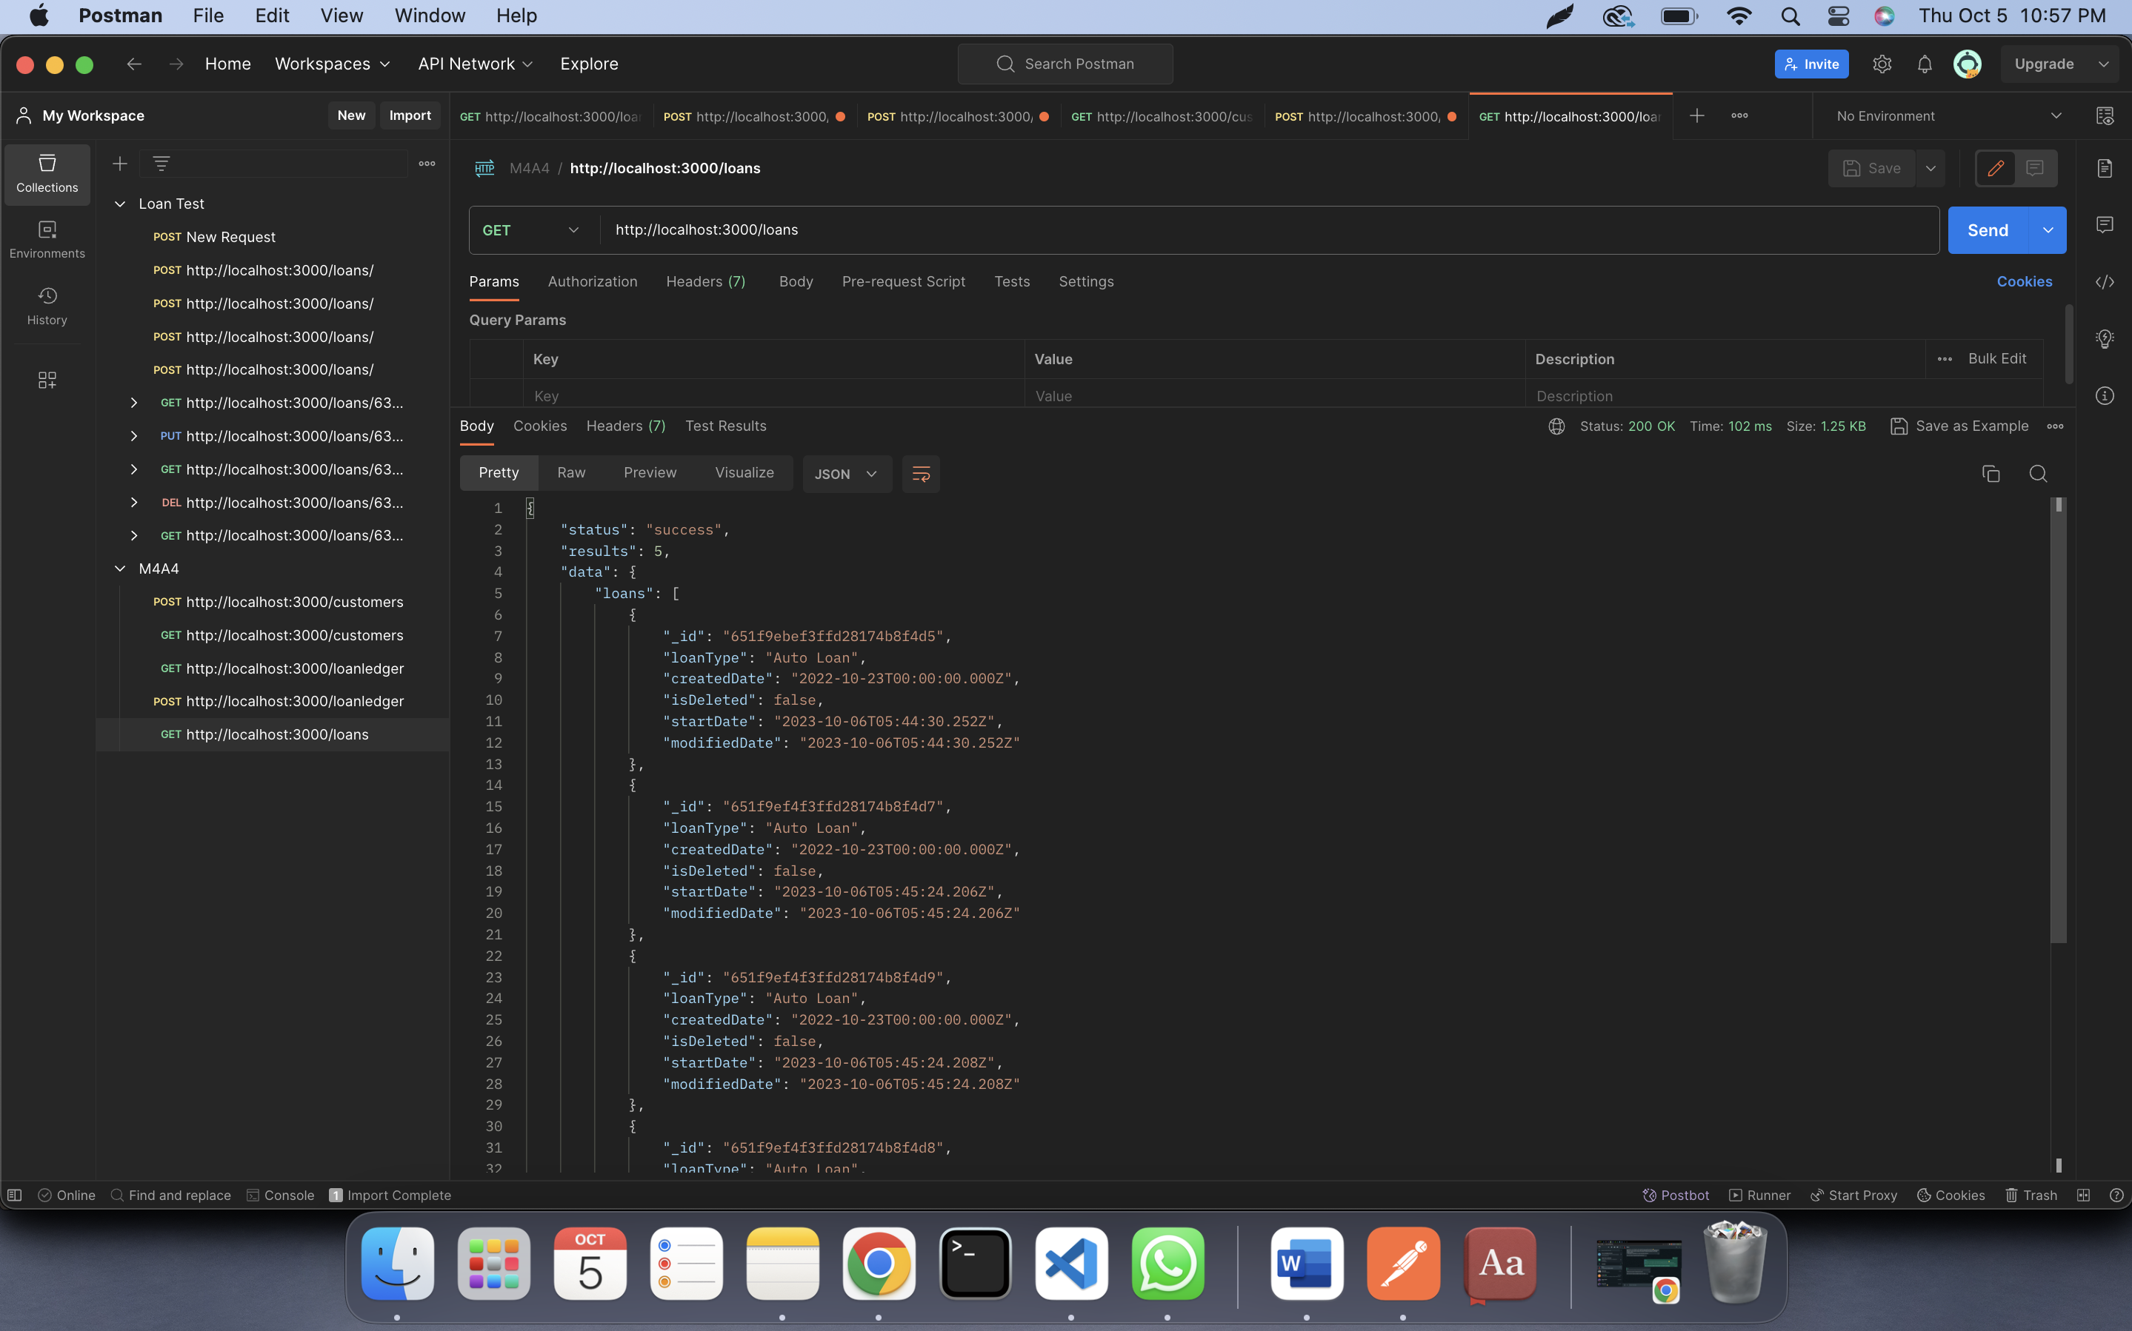

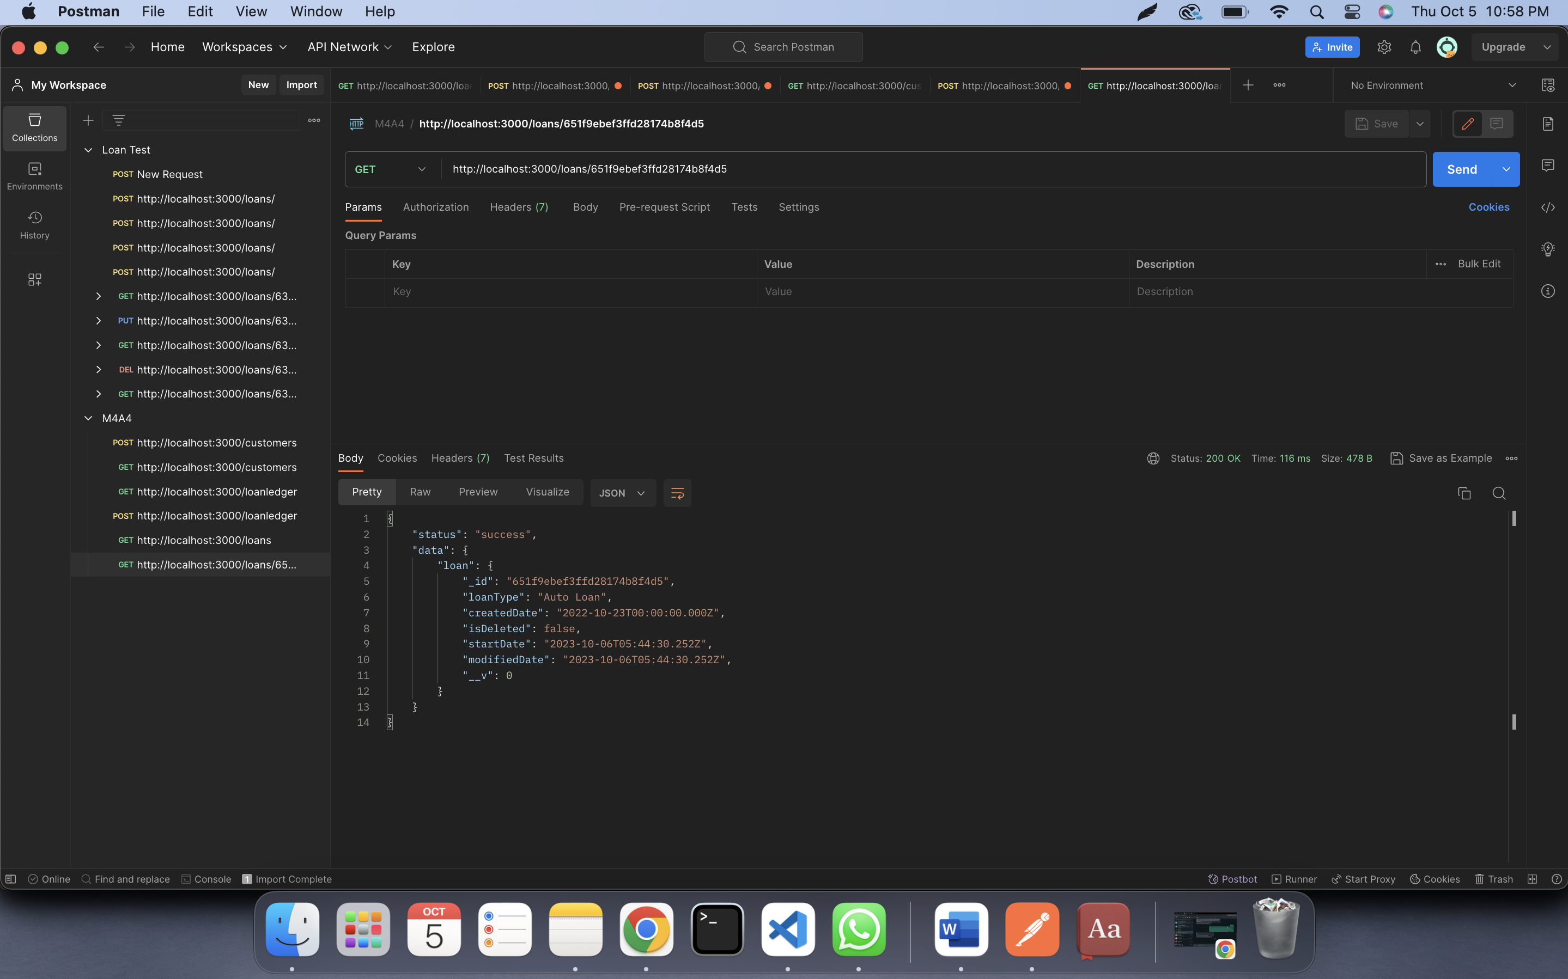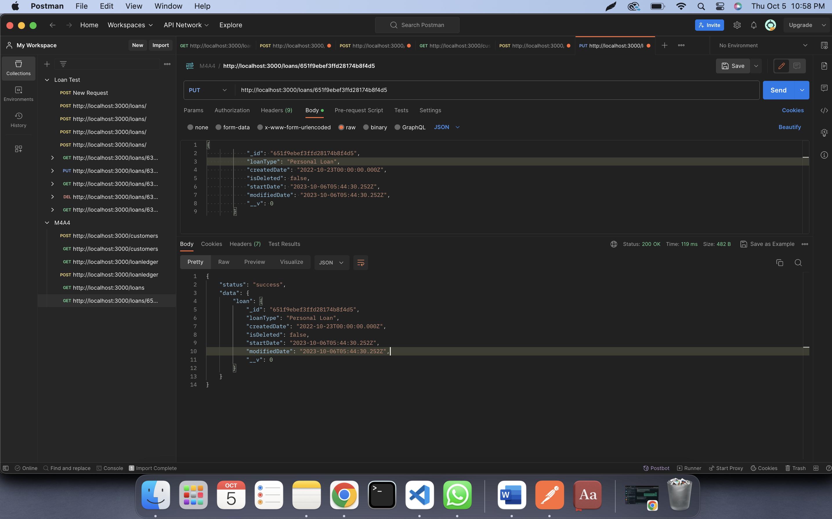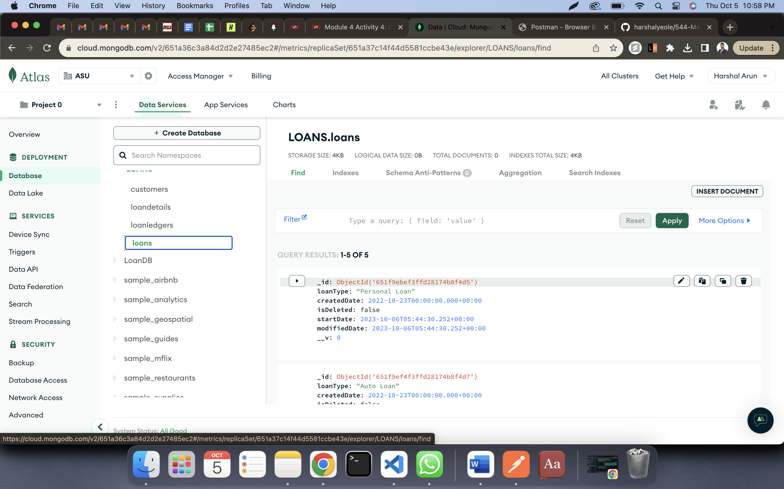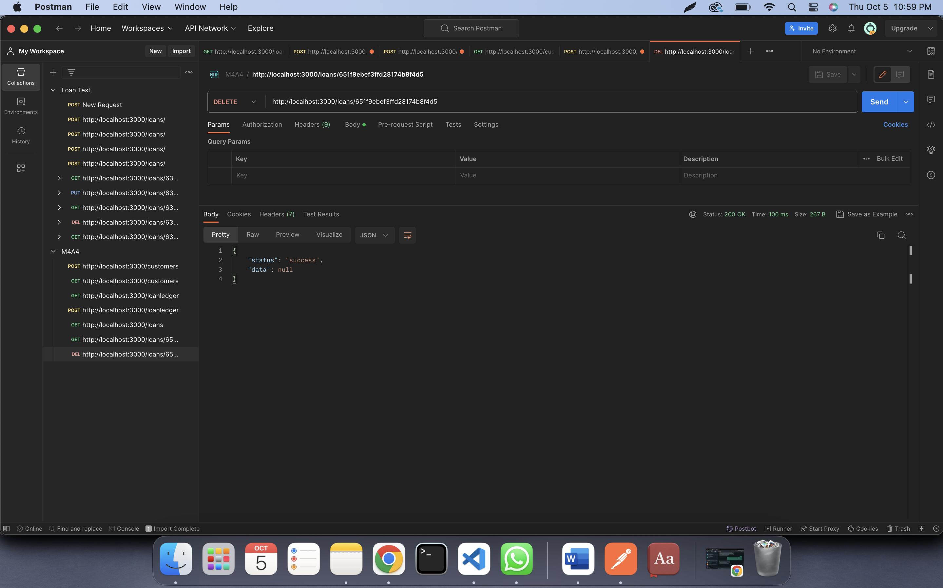

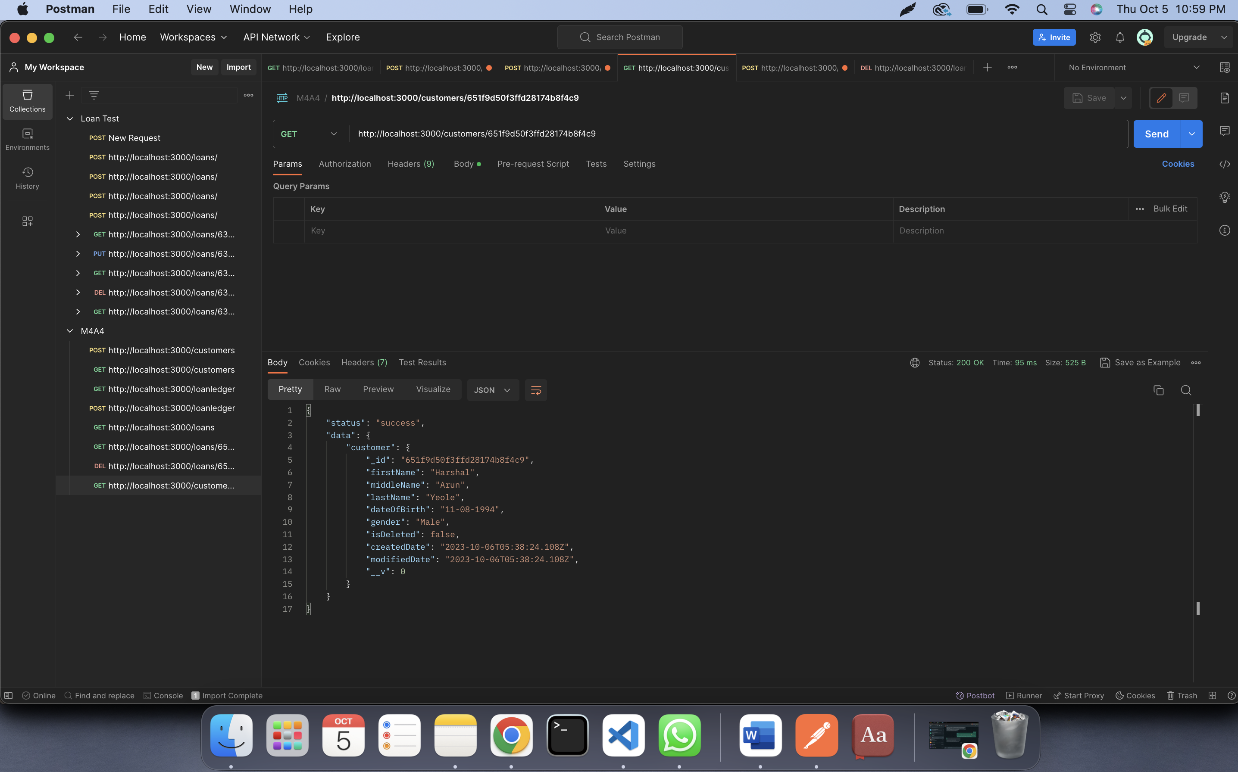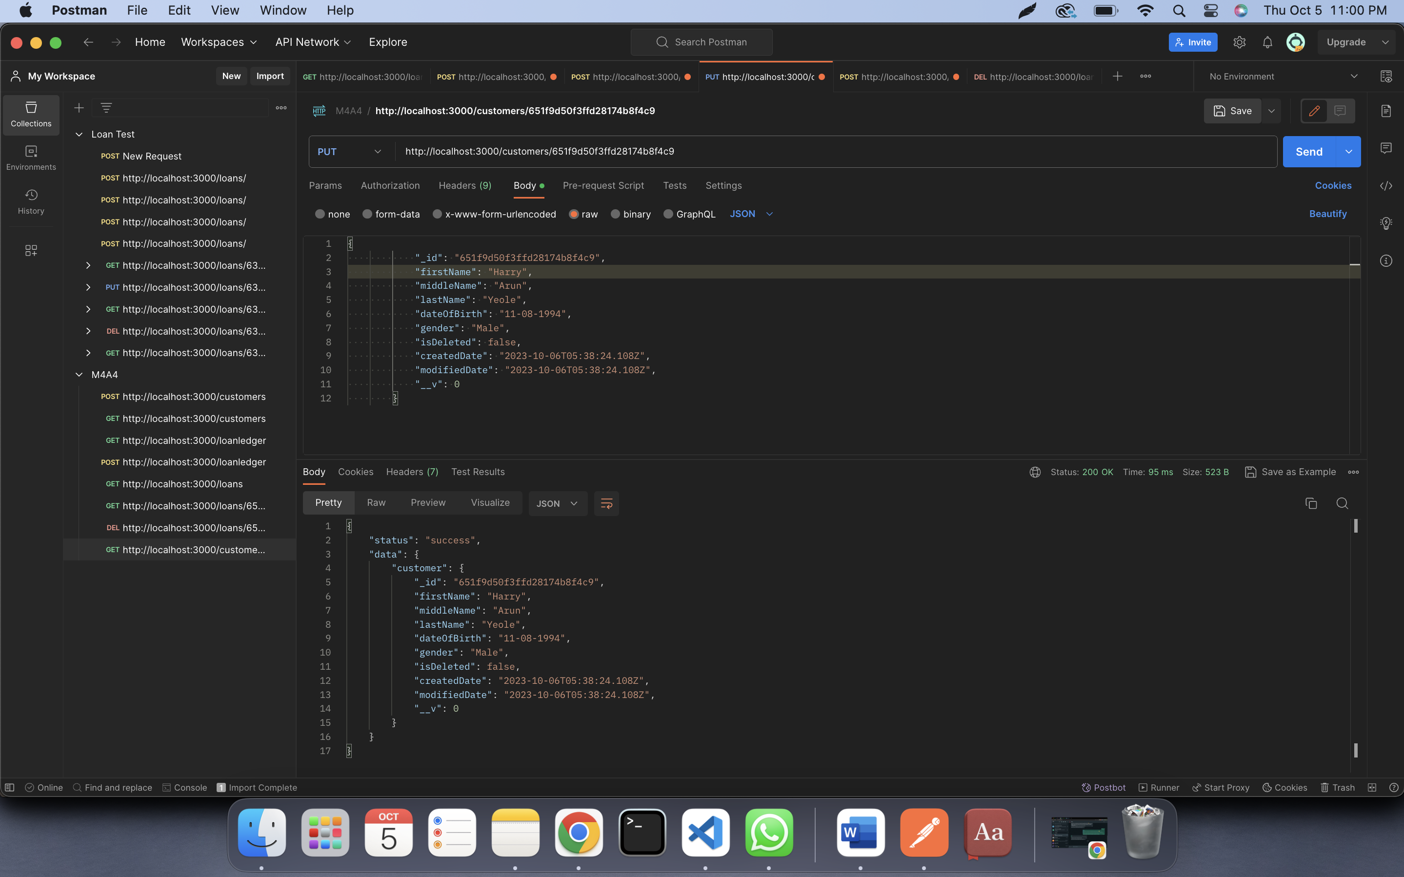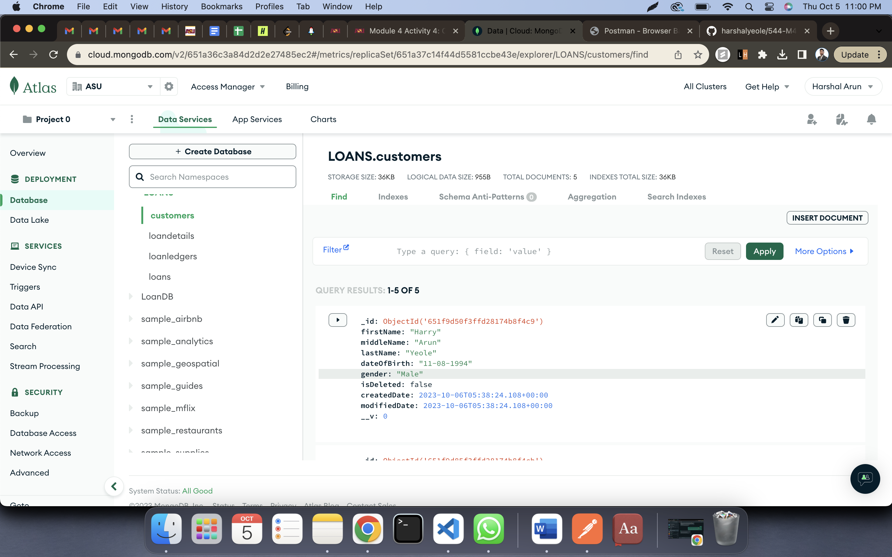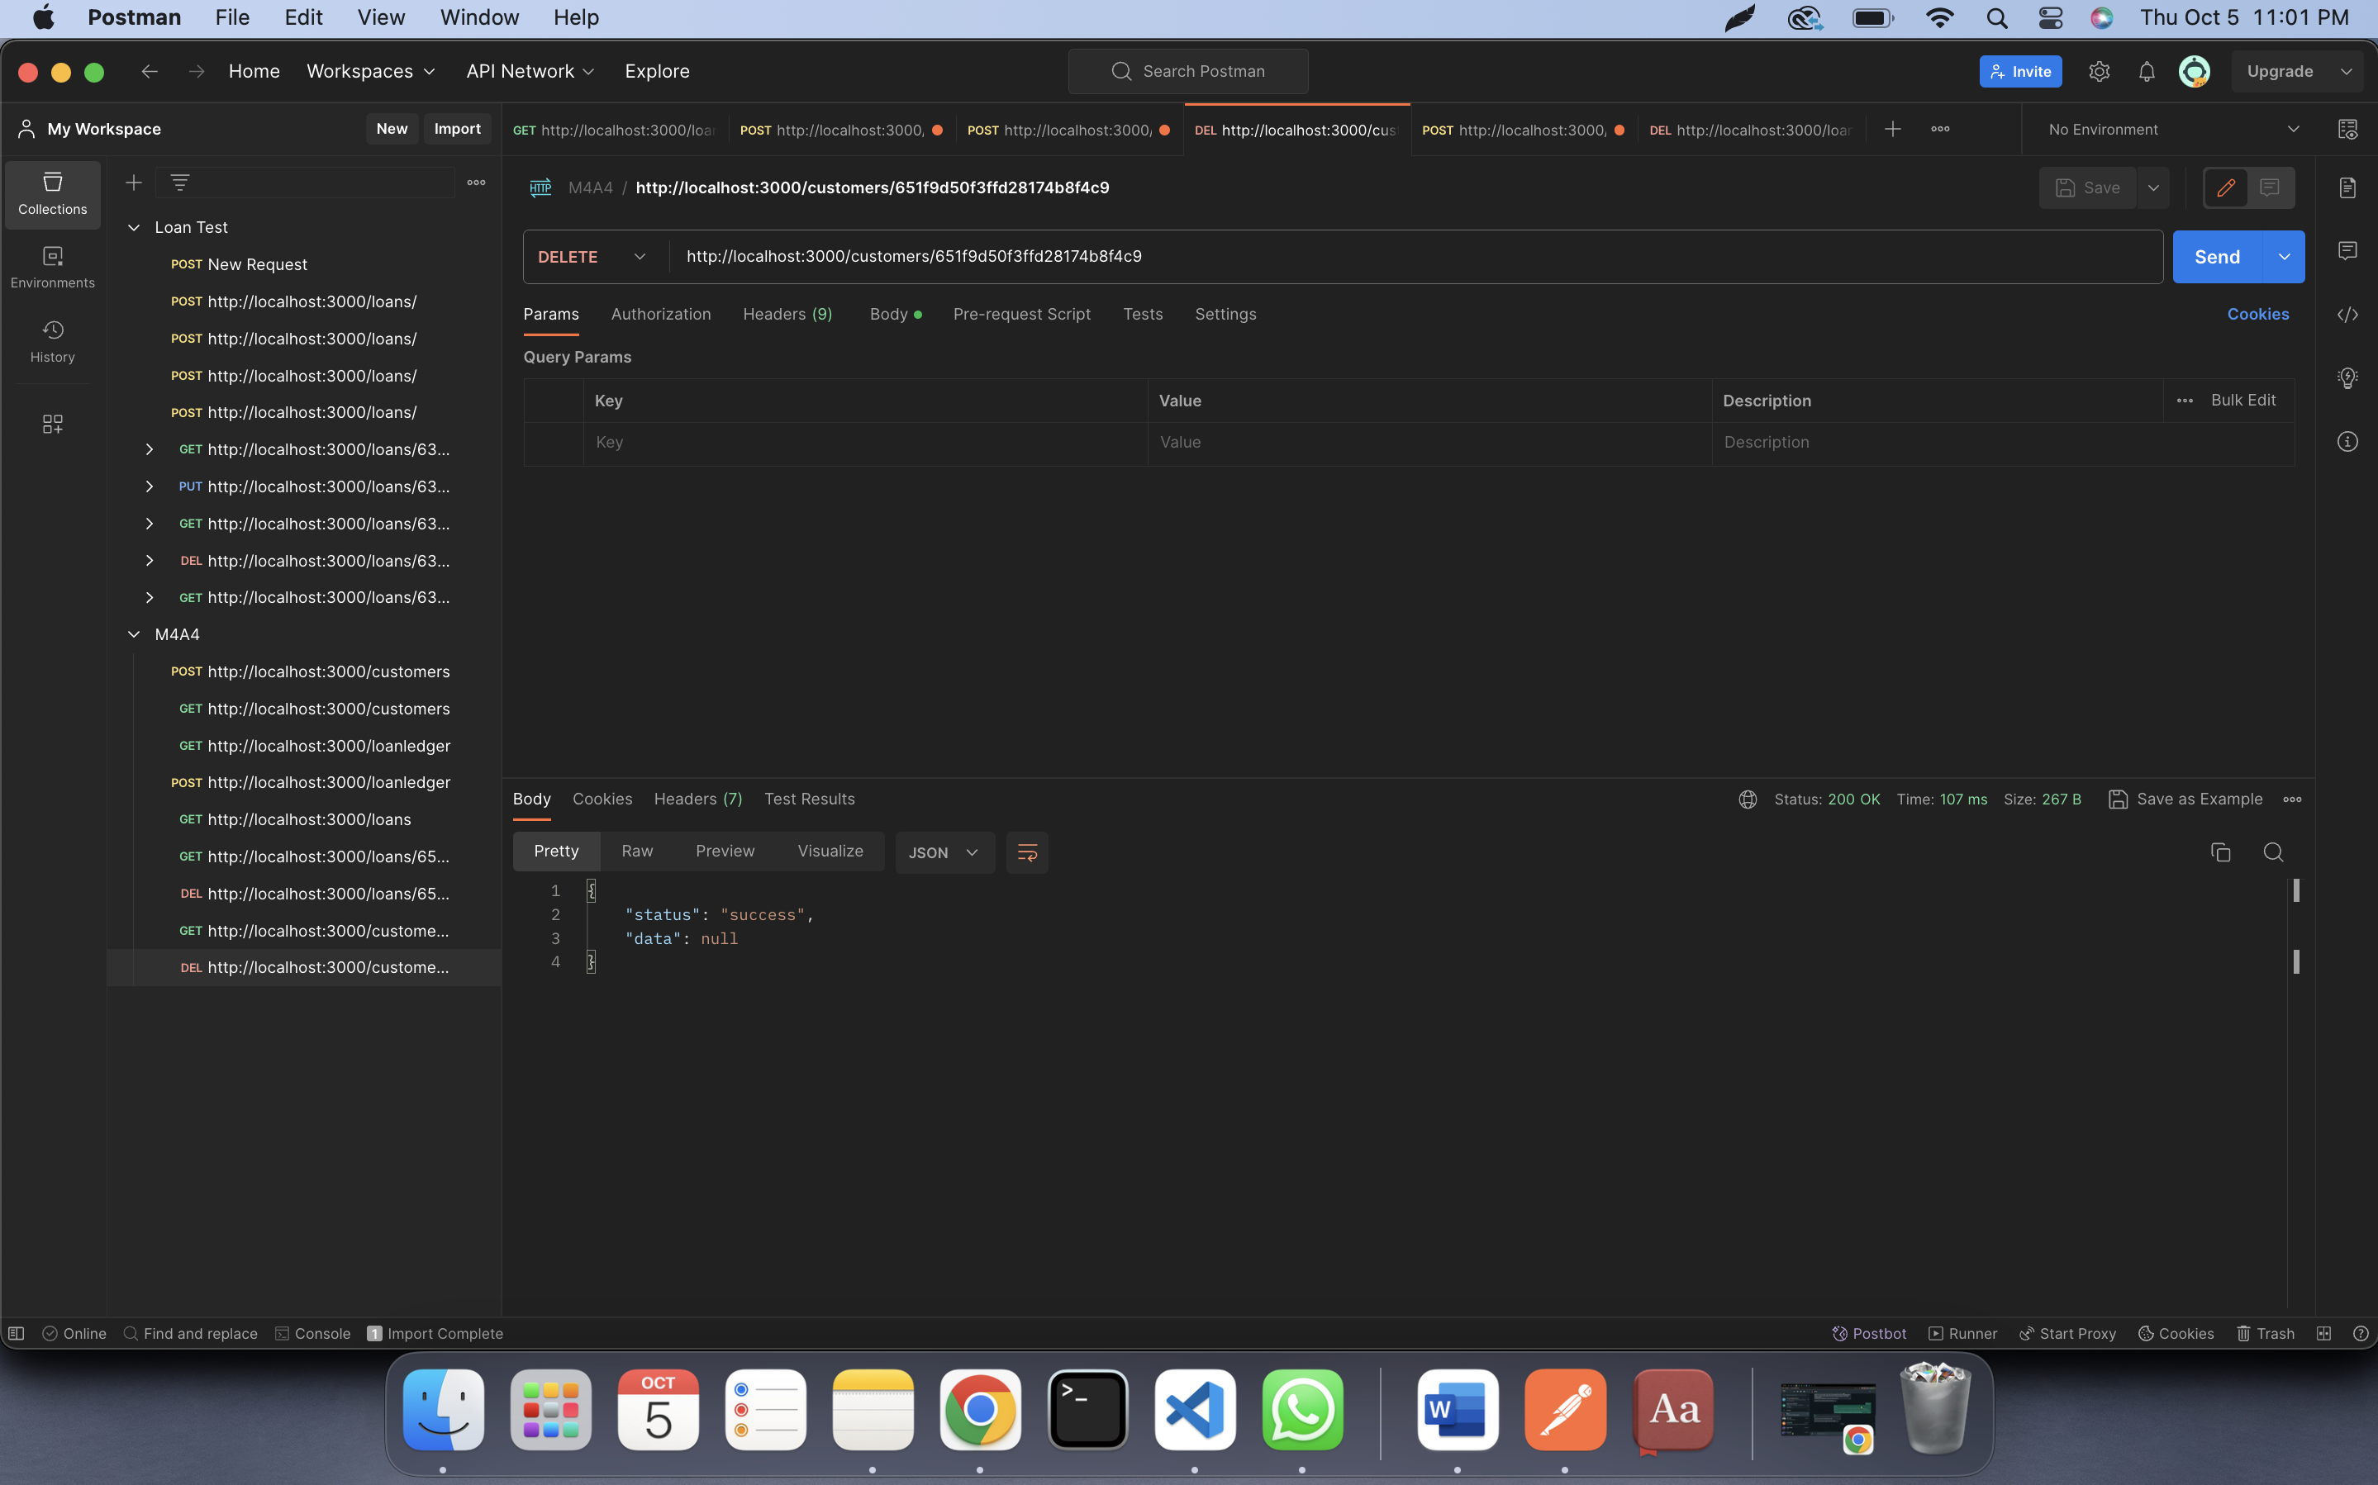

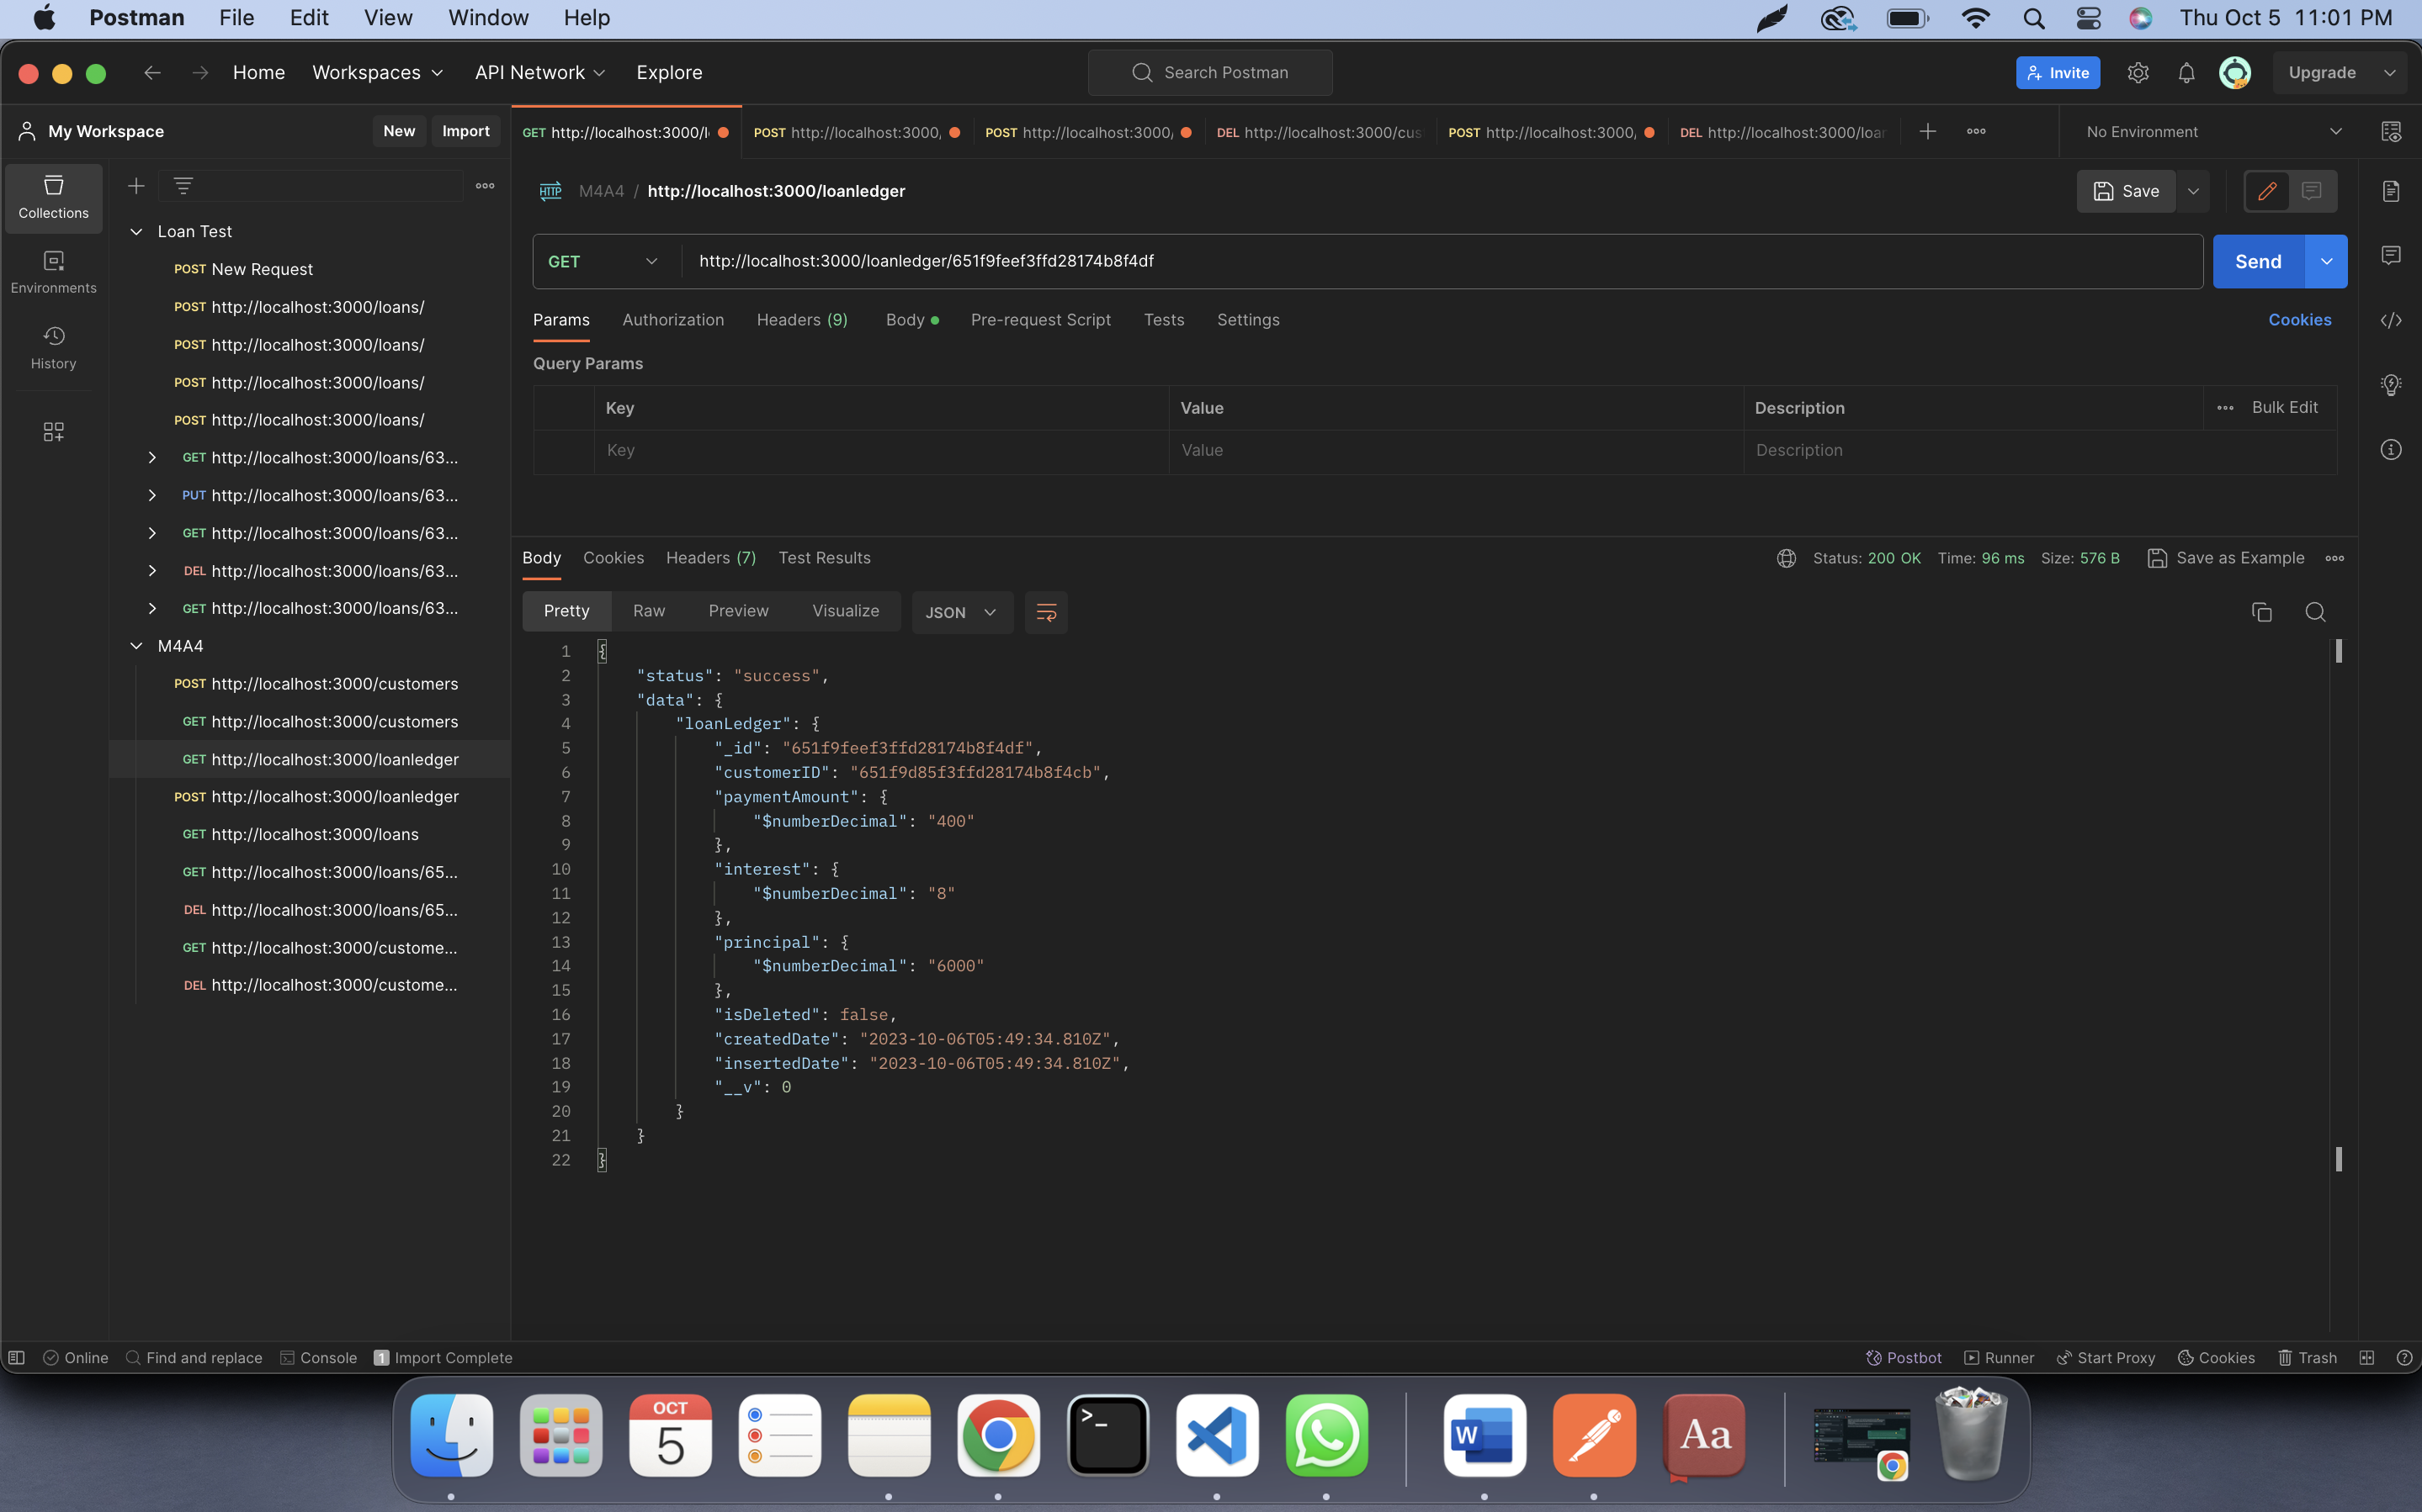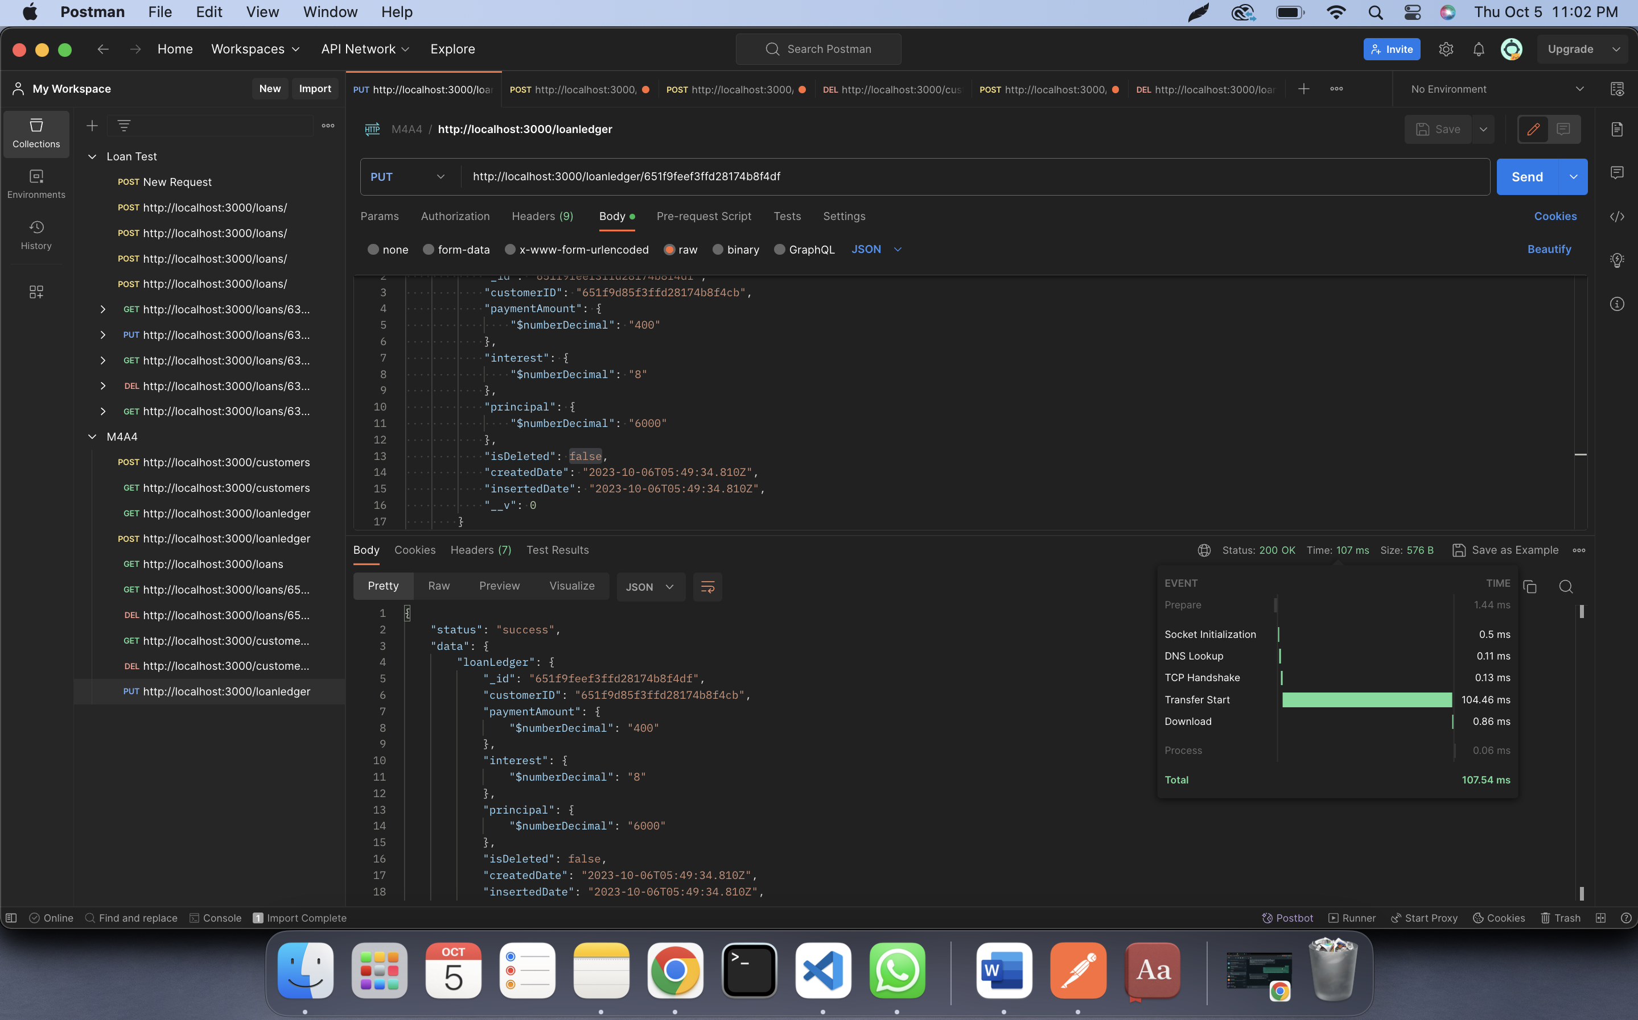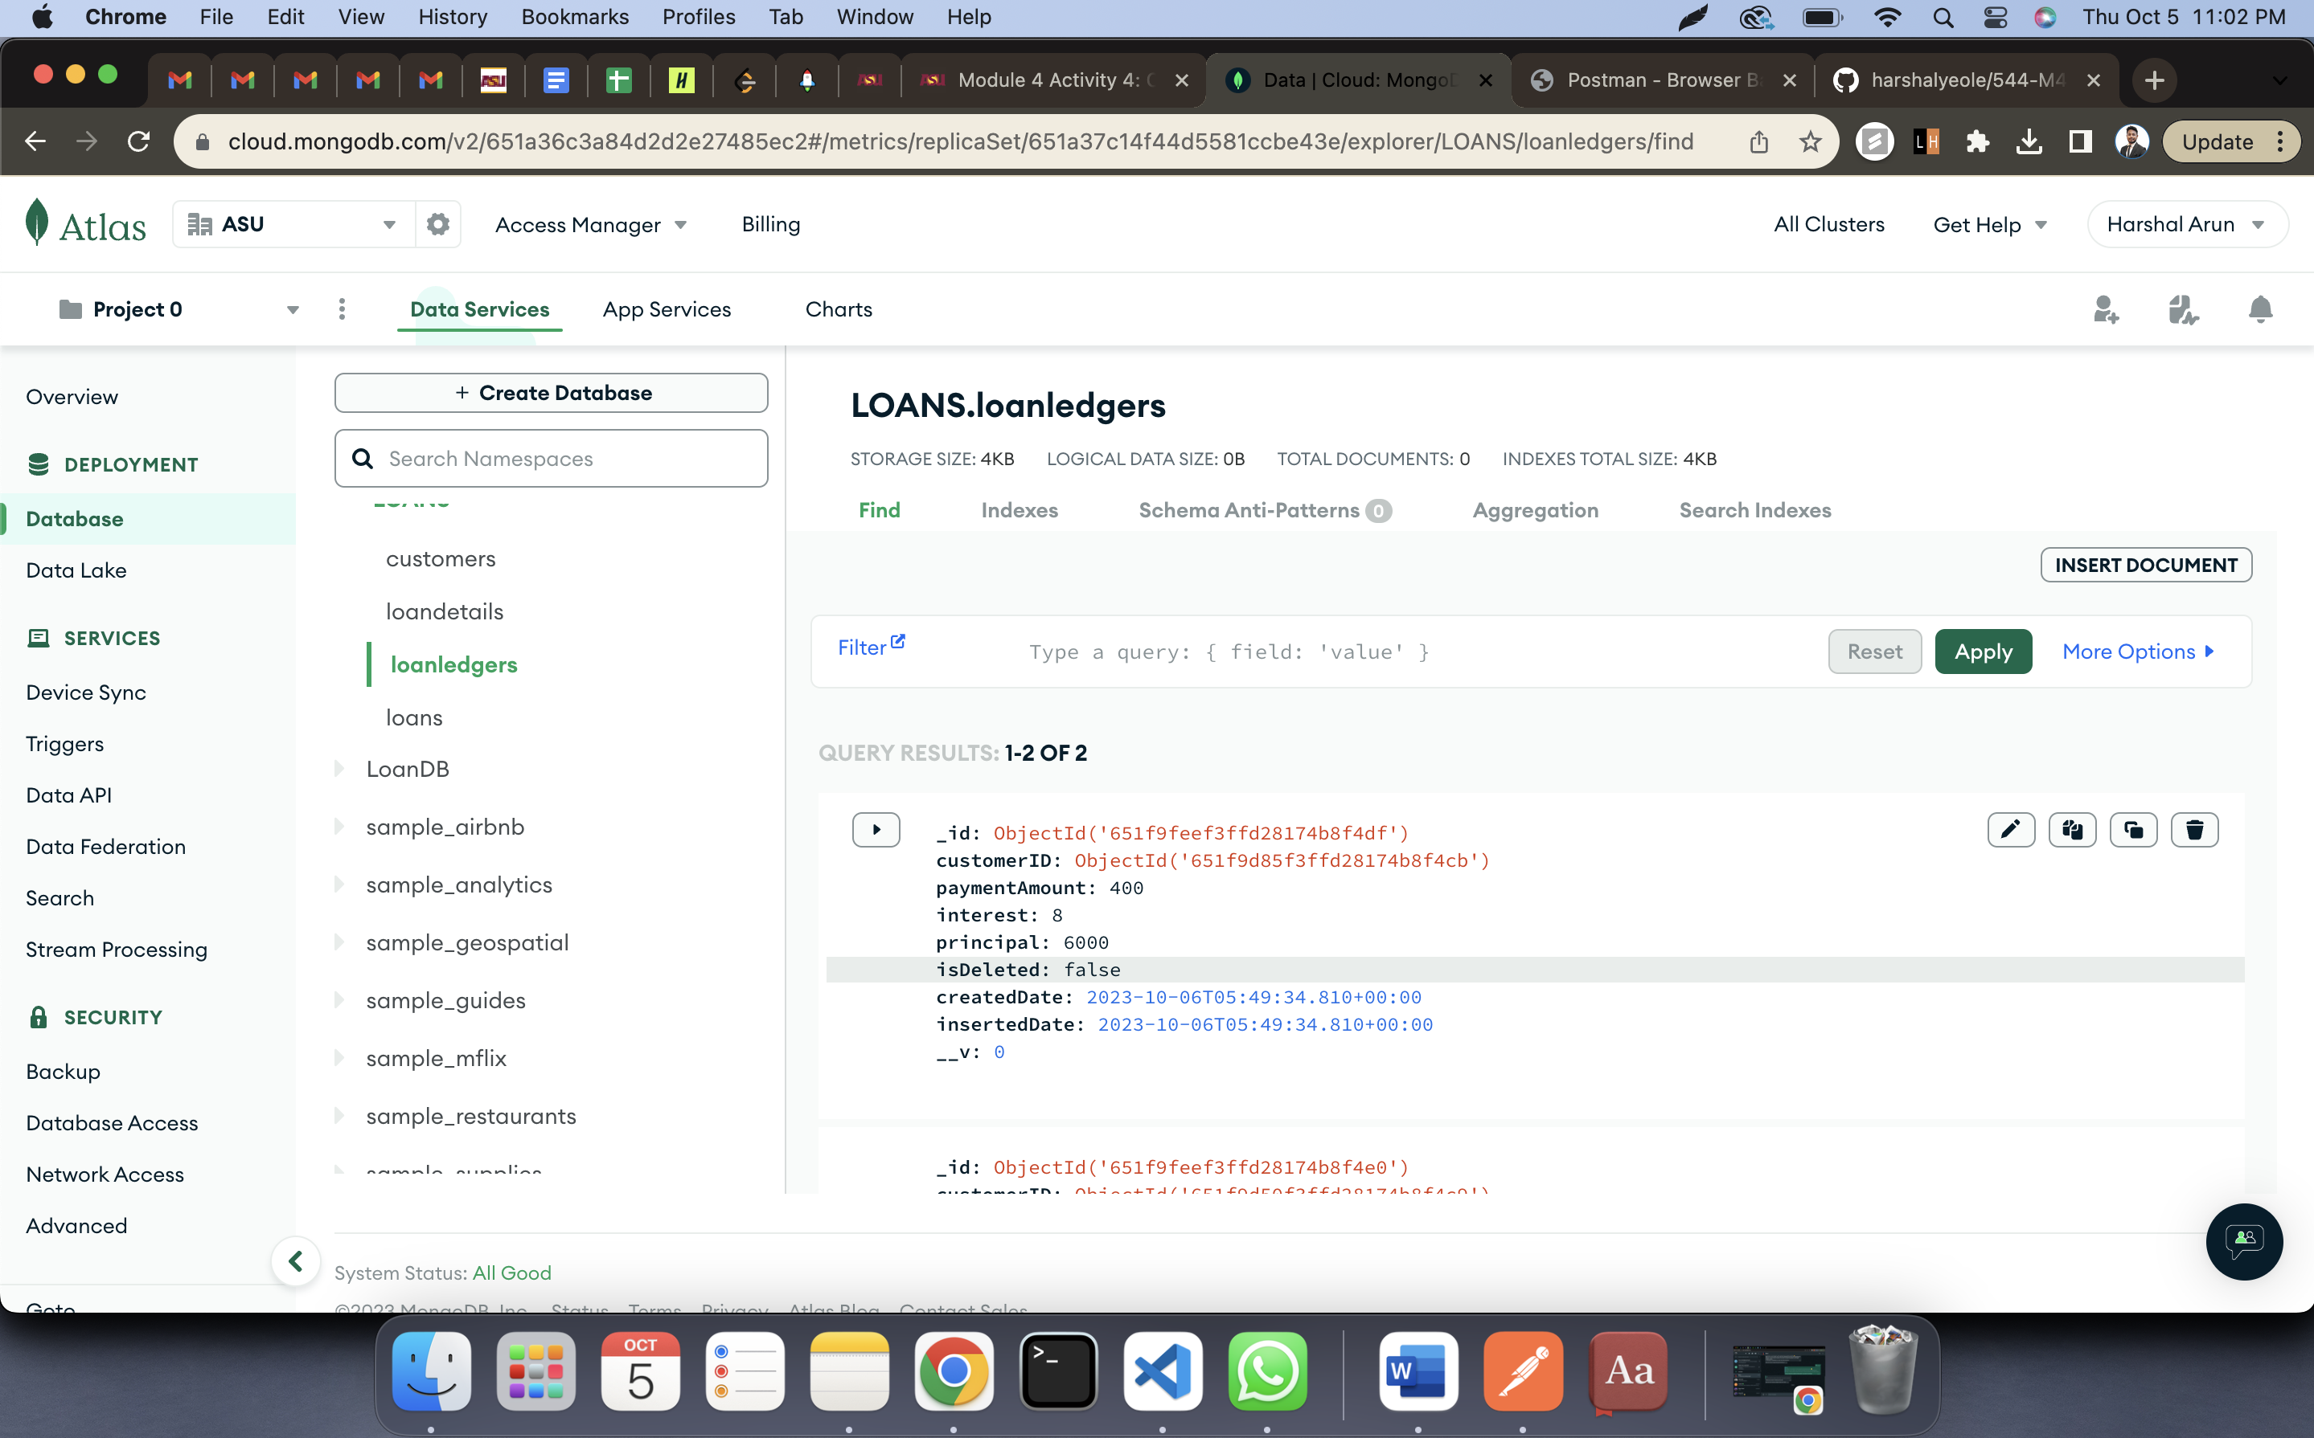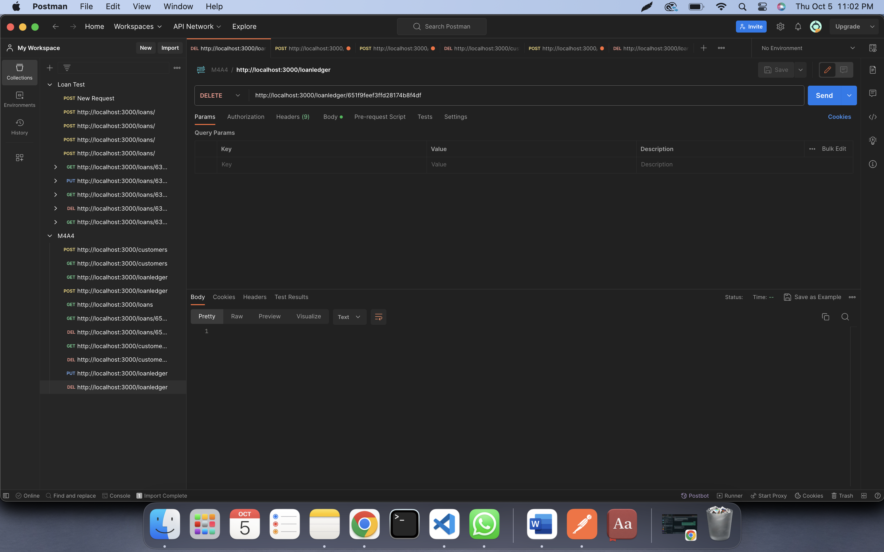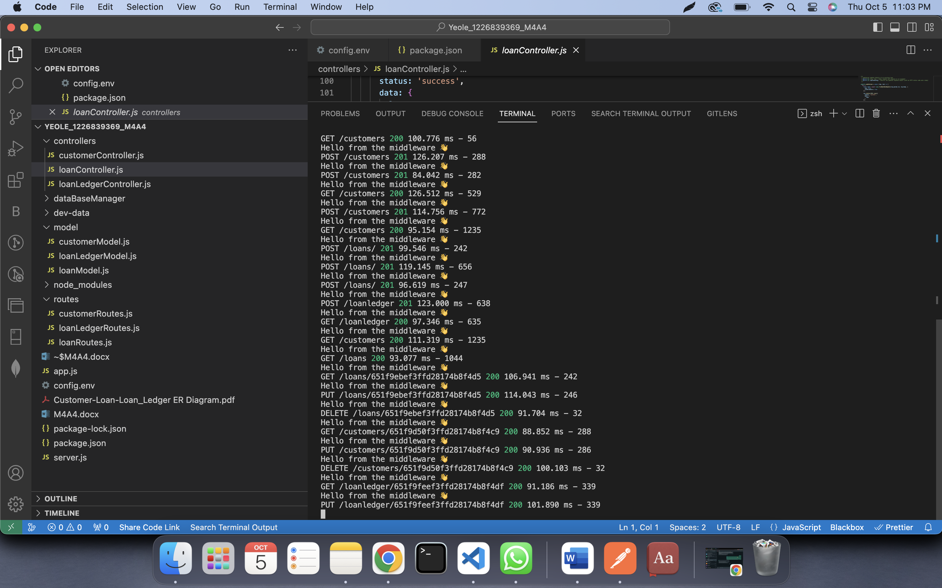

APIs:  
  
  
POST /customers  
This API helps in storing customers' information in customer collection.  
  
  
GET /customers  
Get information on all the customers stored in customers collection.  
  
POST /loans  
This API helps in storing loan information in loans collection.  
  
GET /loans  
Get information on all the loans stored in loans collection.  
  
  
POST /loanledger  
This API helps in storing customer payments to pay a loan. This information is stored in loanledger collection.  
  
GET /loanledger  
Get information on all the loanledger stored in loanledger collection.  
  
  
  
The above APIs are served using express. These APIs process the data using controllers and then use Mongoose to validate and store/read data in Mongodb database.